By

Manas Prasun Pandey

A-LSTM and XGBoost - Enhanced Digital Twin for Smart Mobility and Environmental Monitoring in Westminster, London

Submitted to

**The University of Roehampton**

In partial fulfilment of the requirements

for the degree of

**Master of Science**

**in**

**Data Science**

Declaration

I hereby certify that this report constitutes my own work, that where the language of others is used, quotation marks so indicate, and that appropriate credit is given where I have used the language, ideas, expressions, or writings of others.

I declare that this report describes the original work that has not been previously presented for the award of any other degree of any other institution.

Manas Prasun Pandey

4th August, 2025



**Acknowledgements**I would like to express my deepest gratitude to my supervisor and mentor, **Dr. Sameena Naaz**, for her unwavering support, insightful guidance, and continuous encouragement throughout the course of this project. Her expertise and mentorship have been instrumental in shaping the direction and depth of my work.

I am also sincerely thankful to **Dr. Mamoona Humayun**, whose academic leadership and thoughtful feedback provided invaluable clarity during critical stages of this dissertation. Her perspective helped me refine my approach and strengthened the overall quality of the research.

I extend my appreciation to the faculty at the University of Roehampton for creating a learning environment that fosters innovation and critical thinking. Lastly, I thank my family and friends for their constant support and motivation during this academic journey.

**Abstract**  
Urban environments face increasing challenges in managing traffic congestion and air pollution, particularly in densely populated districts such as Westminster, London. These challenges necessitate advanced systems capable of integrating real-time data and forecasting to support proactive urban planning. This project presents the development of a machine learning-enhanced Digital Twin designed to facilitate smart mobility and environmental monitoring for Westminster.

The proposed system integrates real-time and historical data from multiple open-source providers, including Transport for London (TfL), LondonAir, and OpenWeatherMap. These data streams are ingested and stored via a modular backend architecture that supports both real-time and batch processing, enabling responsive performance and comprehensive analysis. The system exposes key services through RESTful APIs, allowing seamless communication between data sources, machine learning models, and the interactive frontend interface.

Two core models power the system: an Adaptive Long Short-Term Memory (A-LSTM) network for generating synthetic traffic data and an XGBoost regressor for forecasting Air Quality Index (AQI) and individual pollutant levels. The A-LSTM model addresses the issue of sparse or unavailable traffic data by simulating realistic traffic flow based on air quality and meteorological patterns. Meanwhile, the XGBoost model forecasts pollutant concentrations using structured inputs derived from weather, traffic, and temporal features. Both models are retrained periodically, with performance metrics logged to ensure continued accuracy and adaptability.

The frontend interface, built with a 3D geospatial visualization engine, enables users to explore historical trends and simulated future scenarios. Features include interactive traffic overlays, AQI indicators, and weather visualizations. Scenario simulation tools allow users to adjust traffic conditions and observe the projected environmental impact in real time.

Evaluation of the system included scenario-based tests, such as simulating increased traffic on Oxford Street during peak hours, which led to a forecasted 12%–15% increase in NO₂ concentrations. The A-LSTM model achieved a classification accuracy of 79.27%, significantly outperforming traditional LSTM models, while XGBoost regressors achieved R² values above 0.88, with NO₂ predictions reaching 0.994.

Despite challenges such as the absence of real-time sensor validation and inconsistencies in external APIs, the system performed reliably across both technical and user-facing evaluations. The containerized deployment and public web accessibility ensure that the solution can scale and integrate into broader smart city initiatives.

In conclusion, this project demonstrates the feasibility of using machine learning and Digital Twin technologies to enhance urban foresight. It offers a practical, data-driven platform for policymakers and urban planners seeking to evaluate environmental interventions and promote sustainable, intelligent city management.

Table of Contents

Declaration 2

Table of Contents 6

List of Figures 9

List of Tables 10

Chapter 1- Introduction 11

1.1 Problem Statement 11

1.2 Aims and Objectives 13

1.3 Legal, Social, Ethical and Professional Considerations 15

1.4 Background 16

1.5 Structure of Report 20

Chapter 2- Literature & Technology Review 22

2.1 Literature Review 22

2.1.1 Machine Learning in Traffic and Air Quality Forecasting 22

2.1.2 Temporal and Spatial Correlations 22

2.1.3 Synthetic Data Generation with LSTM 23

2.1.4 Ensemble and Hybrid Methods 23

2.1.5 Feature Importance and Interpretability 24

2.1.6 Suitability of A-LSTM and XGBoost 24

2.2 Technology Review 25

2.2.1 FastAPI (Python) 25

2.2.2 Data Ingestion and Streaming 25

2.2.3 Machine Learning Models (A-LSTM, XGBoost) 25

2.2.4 CesiumJS and 3D Visualization 26

2.2.5 Supporting Tools and Integration (Out of scope) 26

2.3 Review Summary 26

Chapter 3- Implementation 27

3.1 Design 27

3.1.1 Architecture Design 27

3.1.2 Use Case Diagram 28

3.1.3 Data Sources and Ingestion 31

3.1.4 Machine Learning and Prediction 31

3.1.5 REST APIs and Service Layer 36

3.1.6 Front-End Visualization 36

3.1.7 Database Design – ERD 36

3.1.8 Supporting Infrastructure (Suggested in design but out of scope for the project) 39

3.2 Develop 39

3.2.1 Containers with required services 39

3.2.2 IDE for development 43

3.2.3 Repository and version control 45

3.2.4 Creating Tables in Database 46

3.2.5 Data Ingestion Pipeline (Producer / Consumer) 49

3.2.6 Deep Learning and ML Models 52

3.2.7 REST API (Python Fast API) 58

3.2.8 FrontEnd (ASP.Net core MVC with CesiumJS and ChartJS 62

3.3 Deployment (On Premise) 66

3.3.1 Running Core Services 67

3.3.2 Running Messaging and Streaming Services 67

3.3.3 Running Real-time Ingestion Services 68

3.3.4 Caching and Feature Store 68

3.3.5 API Backend and Frontend UI 69

3.3.6 Volumes 69

3.3.7 Exposing FronEnd Port from Docker to Web using Cloudflared Tunnelling 70

Chapter 4 - Evaluation and Results 73

4.1 Related Works 73

4.2 Evaluation Strategy 73

4.3 Evaluation of Machine Learning Models 74

4.4 Scenario Simulation and Forecast Validation 77

4.5 Usability and Functional Evaluation 79

4.6 Limitations 82

Chapter 5 – Conclusion 84

5.1 Future Work 85

5.2 Reflection 86

References 89

Appendices 91

Appendix A: Project Proposal 92

Appendix B: Project Management 93

Appendix C: Artefact/Dataset 94

Appendix D: Screencast 95

List of Figures

Figure 3.1.1 : System Architecture 27

Figure 3.1.2 Use Case Diagram 28

Figure 3.1.4 (a) A-LSTM Model Architecture 32

Figure 3.1.4 (b) :XGBoost Model Architecture 34

Figure 3.1.7: ERD – Entity Relationship Diagram 38

Figure 3.2.1.1: Kafdrop/Kafka with topics for streaming 40

Figure 3.2.1.2(a) Redis store for Feature columns 42

Figure 3.2.1.2(b) Redis store for Target Columns 42

Figure 3.2.3 : Github Repository 45

Figure 3.2.8: Frontend project directory structure 63

Figure 3.3.6: Running components as containers in docker using docker-compose.yml 70

Figure 4.2(a): A-LSTM classification metrics 75

Figure 4.2(b) XGBoost regressor metrics for AQI 75

Figure 4.2(c) XGBoost regressor metrics for PM10 76

Figure 4.2(d) XGBoost regressor metrics for PM2.5 76

Figure 4.2(e) XGBoost regressor metrics for SO2 76

Figure 4.2(f) XGBoost regressor metrics for NO2 76

Figure 4.2(g) XGBoost regressor metrics for CO 77

Figure 4.2(h) XGBoost regressor metrics for O3 77

Figure 4.4 Forecast Screen with elements 79

Figure 4.4 Forecast screen with traffic density as yellow dots 80

Figure 4.4 Forecast parameters to guide scenarios 80

Figure 4.4 A-LSTM metrics on chart for interative visualization 81

Figure 4.4 XGBoost regressor metric chart for interactive visualization 81

Figure 4.4 Navigation buttons for the application 82

List of Tables

# Chapter 1- Introduction

As urbanization accelerates, cities face mounting challenges in ensuring sustainable mobility and environmental health. Digital Twin technology, which creates real-time digital replicas of physical environments, offers a transformative approach to urban management by integrating live data streams with 3D simulations. This proposal presents a project to develop a Machine Learning-enhanced Digital Twin for the Westminster district in London, focusing on smart mobility and environmental monitoring.

London's Westminster is a densely populated urban area characterized by complex traffic flows and significant air quality concerns. The availability of open APIs from Transport for London (TfL) and environmental monitoring networks like LondonAir provides an excellent foundation for integrating data into a dynamic Digital Twin. This system aims to visualize and simulate real-time traffic patterns and environmental conditions, offering insights for policy-making, emergency planning, and sustainability analysis.

The motivation for this project lies in the growing need for cities to transition toward data-driven governance and climate-responsive infrastructure. By enhancing the Digital Twin with machine learning models, the project will provide predictive insights into traffic congestion and air quality dynamics. Additionally, a robust frontend will enable real-time interaction and scenario simulations, empowering stakeholders to explore and assess the potential impact of urban interventions.

This project seeks to bridge the gap between real-time data availability and its application in decision-making platforms, contributing to both theoretical discourse and practical implementation of intelligent, predictive urban management systems.

## 1.1 Problem Statement

Urban environments like Westminster face the dual challenge of managing increasing transportation demand and mitigating environmental impacts. Traffic congestion contributes significantly to air pollution, with pollutants such as nitrogen dioxide (NO2) and particulate matter (PM2.5) exceeding recommended levels in many parts of London. These issues not only degrade the quality of life for residents but also pose serious public health risks.

Although data from Transport for London (TfL) and LondonAir are available in real-time, they are currently underutilized for integrated analysis and predictive modeling. City planners often rely on retrospective studies and fragmented datasets, which limits their ability to make proactive decisions. There exists a gap in leveraging this real-time data within an interactive and responsive system that could provide actionable insights into urban mobility and environmental trends.

A Machine Learning-enhanced Digital Twin that integrates real-time transport and environmental data could significantly enhance the city’s ability to model, predict, and respond to urban dynamics. For instance, by simulating the impact of road closures, vehicle flow restrictions, or introducing green zones, authorities could forecast changes in air quality and congestion. Such a system would serve not only as a monitoring dashboard but also as a decision-support tool for scenario analysis based on data-driven forecasts.

The key issues this project aims to address are:

* The lack of integrated, real-time platforms combining mobility and environmental data.
* The absence of predictive capabilities for traffic congestion and air quality forecasting.
* The difficulty in visualizing and interacting with urban data and policy simulations.
* The need for accessible, user-friendly tools for non-technical stakeholders in urban planning.

By targeting these gaps, the proposed Machine Learning-enhanced Digital Twin will contribute to more informed, responsive, and sustainable urban governance. The inclusion of an interactive frontend will ensure accessibility and empower users to explore dynamic urban scenarios effectively.

## 1.2 Aims and Objectives

**Aim**: To develop a real-time Machine Learning-enhanced Digital Twin for Westminster, London that integrates smart mobility and environmental data to support predictive urban decision-making.

**Objectives:**

* 1. **Data Acquisition and Integration:**
* Collect and integrate live traffic data from TfL APIs and historical congestion data.
* Acquire real-time and historical air quality data from LondonAir API.
* Merge datasets with meteorological data for enhanced pollution forecasting.
* Harmonize datasets for training machine learning models.
  1. **System Architecture and Development:**
* Design a modular backend with Python (FastAPI) for data ingestion and storage.
* Implement Machine Learning models:
  + Traffic Prediction: Gradient Boosting or XGBoost to forecast congestion levels.
  + Air Quality Prediction: Random Forest Regressor or LSTM models.
* Set up a relational or NoSQL database to store historical, real-time, and predictive data.
  1. **Frontend Development:**
* Develop a frontend using JavaScript frameworks and CesiumJS for 3D visualization.
* Create an interactive dashboard to visualize live data overlays and prediction outputs.
* Build a simulation interface to allow users to modify parameters and view scenario outcomes.
  1. **Simulation and Scenario Analysis:**
* Integrate ML models into the frontend to allow users to simulate interventions.
* Visualize predicted outcomes for traffic flow and air quality based on user-defined scenarios.
  1. **Evaluation and Validation:**
* Train/test split, cross-validation for ML models.
* Compare model predictions against real-world outcomes.
* Conduct usability testing and gather user feedback on system effectiveness.
  1. **Documentation and Reporting:**
* Full system documentation including ML model details, API guides, and user manual.
* Complete dissertation draft with detailed evaluation and findings.

**Research Questions:**

* How can real-time mobility and environmental data be effectively integrated into a unified, predictive Digital Twin system?
* What are the measurable benefits of using machine learning models in urban decision-making?
* How can interactive frontend interfaces enhance the usability and effectiveness of Digital Twin platforms?

**Methodology:**

* Literature Review: Explore existing works on Digital Twins and predictive modeling in smart cities.
* Data Engineering: API pipelines, historical data compilation, and preprocessing.
* Machine Learning Model Development: Implement and evaluate traffic and air quality forecasting models.
* Frontend Development: Build an interactive simulation dashboard with 3D visualization.
* Evaluation: Assess model performance and user satisfaction through systematic testing.

## 1.3 Legal, Social, Ethical and Professional Considerations

This project involves the use of publicly available datasets, which significantly reduces legal risks. However, responsible data handling and adherence to privacy norms remain critical. Data sourced from TfL and LondonAir are anonymous and aggregated, ensuring compliance with GDPR and UK Data Protection laws. The system will also implement secure API handling practices and adhere to appropriate licensing frameworks for all open-source tools and libraries used.

From a social perspective, the project aims to promote inclusivity by making advanced urban data analytics and simulation tools accessible to a broad audience, including non-technical stakeholders such as policymakers, planners, and the general public. The frontend interface will be designed in accordance with accessibility standards (e.g., WCAG 2.1) to ensure usability for people with varying abilities and backgrounds. Transparent visualizations of both observed and predicted data will empower citizens and urban administrators to make informed, data-driven decisions.

Ethically, the project commits to maintaining clarity between observed data and Machine Learning-driven predictions, highlighting uncertainties and model limitations where applicable. Attention will be given to minimizing biases in the data and ensuring that model outputs do not inadvertently reinforce socio-economic inequalities or favor particular districts over others. Predictive models will be validated on diverse datasets to promote fairness and accountability.

Professionally, the project will follow best practices in software engineering, data science, and AI ethics. Version control, modular code architecture, unit testing, and detailed documentation will be prioritized to ensure the system's reproducibility and scalability. Ethical guidelines from professional bodies such as the IEEE and ACM will be consulted to ensure integrity throughout the project lifecycle. Stakeholder feedback will be systematically gathered and incorporated into iterative system refinements.

## 1.4 Background

The growing complexity of urban life, driven by population density, environmental challenges, and infrastructure strain, has necessitated more intelligent systems for city planning and management. In response to this, the concept of a Digital Twin (DT) has gained prominence in urban technology discourse. Initially developed in the manufacturing and aerospace sectors for performance optimization and predictive maintenance, Digital Twin systems are now being adapted for smart city applications, offering cities a powerful tool for data integration, visualization, predictive modeling, and policy simulation.

A Digital Twin refers to a dynamic, virtual representation of a physical entity, continuously updated with real-time data from sensors, historical records, and environmental inputs. In the urban context, a DT can represent roads, buildings, traffic systems, pollution layers, and utility infrastructures, enabling the analysis of what is happening in a city and predicting what might happen under various scenarios. The potential of Digital Twins in city governance has been widely acknowledged in both academia and policy planning, especially for transportation and environmental monitoring—two pressing concerns for metropolitan areas like London.

**Evolution of Digital Twin Applications in Smart Cities**

The application of Digital Twin technology to smart cities has evolved rapidly in the past decade. Early work focused on static urban models or simulations using historical data. However, the recent advent of ubiquitous IoT devices, open APIs, and powerful visualization engines such as CesiumJS and Unity3D has allowed real-time, interactive Digital Twins to become feasible.

Batty et al. (2020) and other urban systems theorists have identified Digital Twins as critical tools for simulating and managing city dynamics. They argue that urban environments are inherently complex systems where changes in one part (e.g., road closures) can cascade to impact other areas (e.g., pollution levels, commute times). A DT, by integrating these components, becomes a platform not only for observation but for experimentation with hypothetical interventions. This paradigm shift—from static analysis to live, actionable simulation—is crucial in managing modern urban problems.

**Smart Mobility, Traffic Modeling, and Machine Learning Integration**

Traffic congestion remains one of the most visible and detrimental outcomes of poor urban planning. In London, particularly in dense boroughs like Westminster, traffic congestion not only delays commuters and reduces economic productivity but significantly contributes to elevated air pollution levels. According to Transport for London (TfL), the average traffic speed in central London during peak hours continues to decline, indicating a worsening problem.

TfL provides real-time APIs covering bus locations, tube schedules, incidents, and road status. These datasets are frequently utilized in smart mobility studies to optimize routing, analyze congestion patterns, and estimate journey times. Research published in the *IEEE Transactions on Intelligent Transportation Systems* has demonstrated the effectiveness of using DTs integrated with traffic APIs to model mobility trends and forecast bottlenecks. However, recent developments show that Machine Learning (ML) algorithms, such as XGBoost and Random Forests, significantly enhance predictive capabilities by learning complex temporal patterns in traffic data.

A 2023 study titled *A Digital Urban Twin Enabling Interactive Pollution Predictions and Enhanced Planning* (arXiv) introduced a model that simulated the effects of rerouting buses on NO₂ levels in South London using ML models. Their findings show that integrating ML into DT systems provides more accurate, real-time predictions, enabling dynamic policy interventions.

**Environmental Monitoring, Air Quality, and Predictive Modelling**

Air pollution is another critical issue for Westminster, where levels of nitrogen dioxide (NO₂) and PM2.5 frequently breach safe thresholds set by the World Health Organization (WHO). According to the LondonAir API, Westminster’s busy corridors like Oxford Street and Victoria Embankment consistently record pollution spikes due to vehicular emissions.

Environmental monitoring within a Digital Twin is achieved by integrating real-time pollution sensor data, meteorological data, and geographic context (such as building layouts and traffic intensity). Thomas et al. (2021) in *Frontiers in Sustainable Cities* propose a layered architecture where pollution data is processed alongside mobility and weather data to produce real-time pollution heatmaps. Machine Learning techniques, such as Long Short-Term Memory (LSTM) networks and Random Forest Regression, are increasingly applied to model and forecast pollutant concentration levels dynamically.

An enhanced Digital Twin system integrating ML can predict air quality under different intervention scenarios, such as implementing low-emission zones or adjusting traffic patterns. These forecasts allow policymakers to assess the effectiveness of proposed changes before implementation, supporting proactive, evidence-based urban planning.

**Interoperability, Visualization, and Frontend Development**

A Digital Twin must combine disparate data streams—each in different formats and frequencies—into a unified system. A modular architecture is often adopted, where data ingestion, storage, analysis, and visualization layers are decoupled but synchronized. For spatial data, OpenStreetMap (OSM) provides road networks and points of interest, while CityGML datasets offer 3D building geometry and semantic information.

Tools such as QGIS and PostGIS are used for geospatial preprocessing, while backend services are built using frameworks like FastAPI. Real-time data from TfL and LondonAir APIs is stored in time-series databases or accessed via asynchronous REST endpoints. Machine Learning models are developed using scikit-learn, TensorFlow, or XGBoost libraries, enabling real-time traffic and pollution forecasting.

The frontend plays a crucial role in making complex simulations accessible to users. CesiumJS supports WebGL-based rendering of large-scale city models with time-dynamic datasets. Paired with React.js, the frontend can offer an interactive dashboard where users can visualize real-time and predictive traffic and pollution data, modify parameters, and simulate “what-if” scenarios through a user-friendly interface. This democratizes access to advanced simulation tools, enabling better public engagement and transparent decision-making.

**Challenges and Limitations**

Despite the promise, Digital Twin implementation with Machine Learning faces several challenges:

1. **Data Granularity**: Pollution sensors and traffic data are often sparse, requiring sophisticated interpolation and data augmentation techniques.
2. **Computational Cost**: Training ML models on large datasets and rendering real-time 3D visualizations demand high computational resources.
3. **Interoperability Issues**: Combining geospatial, time-series, and predictive data requires rigorous standardization and validation.
4. **Stakeholder Engagement**: Ensuring the platform is usable and accessible to non-technical stakeholders requires careful frontend design and user education.
5. **Model Generalization**: ML models trained on historical data must generalize well to future, unseen scenarios, which can be challenging in highly dynamic urban environments.

Addressing these limitations is an active area of research. Successful prototypes typically adopt incremental deployment strategies, starting with smaller-scale implementations and gradually scaling up.

**Gap in Existing Research**

Although several studies focus on Digital Twins for traffic management or environmental monitoring individually, few attempt to integrate both domains into a cohesive, real-time system enhanced by Machine Learning. Even fewer projects emphasize the development of an interactive, user-friendly frontend capable of real-time scenario simulation.

Moreover, most existing systems focus on retrospective simulations or historical data analysis rather than real-time predictive capabilities. The proposed dissertation project aims to bridge these gaps by building a live, interactive Digital Twin for Westminster that combines real-time traffic and pollution data, Machine Learning-based forecasting, and 3D visualization.

**Contribution and Innovation**

The proposed project will contribute both academically and practically by demonstrating:

* The technical feasibility of integrating real-time transport and air quality data into a Machine Learning-enhanced Digital Twin.
* The design and deployment of a modular architecture that supports scalable data ingestion, storage, ML modeling, and 3D visualization.
* A user-facing interface that supports scenario simulation for real-world policy exploration (e.g., traffic rerouting or green zone planning).
* Insights into the relationship between transport interventions and environmental outcomes, supported by predictive analytics.

These contributions are expected to be highly relevant for smart city researchers, urban planners, transport authorities, and environmental agencies seeking to leverage AI and Digital Twin technology for sustainable urban management.

## 1.5 Structure of Report

This report is structured into five comprehensive chapters to document the research, implementation, and evaluation of a Machine Learning-enhanced Digital Twin for Westminster, London.

* **Chapter 1 – Introduction** outlines the motivation, problem statement, and objectives of the project. It also addresses legal, ethical, and professional considerations and sets the context for the study.
* **Chapter 2 – Literature and Technology Review** presents an in-depth review of relevant academic studies and technical tools. It evaluates various machine learning approaches for traffic and air quality forecasting and justifies the selection of A-LSTM and XGBoost models, along with supporting technologies like FastAPI, Kafka, and CesiumJS.
* **Chapter 3 – Implementation** describes the system architecture and the design and development of backend services, machine learning models, data pipelines, and the interactive frontend. It also details database schemas, containerization strategy, and deployment procedures.
* **Chapter 4 – Evaluation and Results** provides a comprehensive evaluation of model accuracy, system functionality, and scenario simulations. It includes performance metrics, visual analytics, and user feedback to validate the system's effectiveness.
* **Chapter 5 – Conclusion** summarises the project's outcomes, discusses limitations, suggests directions for future work, and reflects on lessons learned throughout the development process.

This structure ensures a logical flow from theoretical foundation to practical implementation and critical evaluation.

# Chapter 2- Literature & Technology Review

## 2.1 Literature Review

Urban air pollution and traffic congestion represent significant challenges for sustainable development. With increasing urbanization and vehicular growth, real-time monitoring and forecasting have become crucial for effective environmental and traffic management. Traditional statistical techniques, while foundational, often struggle to capture the complex, non-linear, and dynamic patterns inherent in environmental and traffic datasets. Consequently, the integration of machine learning (ML) models has emerged as a viable solution.

### 2.1.1 Machine Learning in Traffic and Air Quality Forecasting

The utility of ML in traffic congestion and air pollution prediction has been widely explored. Various algorithms, such as Random Forests (RF), Support Vector Machines (SVM), Decision Trees (DT), and Neural Networks (NN), have shown significant predictive capabilities. In [4], the authors stress that while traditional models like autoregressive integrated moving average (ARIMA) offer baseline forecasting capabilities, they fall short in capturing intricate temporal dependencies in real-world datasets.

Several studies underscore the suitability of ensemble methods and deep learning models in these domains. For instance, [5] highlights the superior accuracy of ML models like XGBoost and LSTM in air quality forecasting, especially for pollutants such as PM2.5, NO₂, and CO. XGBoost's ability to handle missing data, multicollinearity, and feature interactions makes it particularly effective in modeling real-world pollutant data. Similarly, [7] supports the use of regression-based and tree-based models for predicting various air quality indicators, citing improved accuracy and resilience in diverse urban conditions.

### 2.1.2 Temporal and Spatial Correlations

Temporal and spatial dependencies are critical to understanding and forecasting environmental conditions. As pointed out in [9], AQI prediction benefits substantially from models that can incorporate both spatial and temporal features. The fusion of spatial correlation forecasting with temporal correlation forecasting improves overall model robustness and predictive precision. For instance, air pollution readings from neighboring stations can be valuable predictors when spatial relationships are properly encoded.

LSTM networks are particularly adept at handling long-range temporal dependencies, making them suitable for predicting time series data in both traffic and air quality domains. In [6], deep learning approaches such as LSTM and GRU have demonstrated superior performance over classical models in forecasting future traffic flow based on historical sequences. These architectures retain memory of past observations, a crucial property when dealing with congestion patterns that exhibit diurnal and weekly cycles.

### 2.1.3 Synthetic Data Generation with LSTM

Due to limited labelled datasets in many urban contexts, synthetic data generation has become an essential tool. Traditional LSTM-based models have shown potential in capturing time series structures and generating traffic flow and density metrics. However, recent advancements highlight the superiority of Adaptive LSTM (A-LSTM), which incorporates multi-layer configurations, refined memory gating mechanisms, and optimized hyperparameters. Raheja and Malik [10] demonstrated that A-LSTM outperforms conventional LSTM, SVR, and hybrid SVR-LSTM models in forecasting pollutants such as PM2.5, PM10, and NO₂. A-LSTM achieved lower MAE and RMSE values and outperformed on precision, recall, and F1-score metrics. Its enhanced ability to retain long-term dependencies makes it particularly effective for generating synthetic traffic data in scenarios with sparse sensor coverage or incomplete data streams.

### 2.1.4 Ensemble and Hybrid Methods

The ensemble paradigm combines multiple weak learners to form a strong predictive model. In [8], a bagging ensemble approach was used to combine various base learners, improving both traffic and air quality predictions. Hybrid schemes that utilize ML models in conjunction with preprocessing techniques like Principal Component Analysis (PCA), or that combine different predictors, have also demonstrated increased robustness.

XGBoost, a gradient-boosting ensemble algorithm, has been particularly effective in forecasting AQI values. As stated in [5], its capability to handle missing data and nonlinear relationships enables it to outperform traditional regression models in noisy urban environments. In the context of this study, XGBoost was used to forecast multiple pollutants simultaneously, using predictors including weather conditions and synthetic traffic metrics.

### 2.1.5 Feature Importance and Interpretability

Interpreting ML model outputs is essential for building trust and ensuring applicability in policy and planning. XGBoost and other tree-based models inherently support feature importance analysis. Studies like [7] reveal that weather variables (temperature, humidity, and wind) and traffic conditions are major contributors to AQI predictions. Being able to identify key predictors can help urban planners and environmental agencies prioritize interventions.

The use of interpretable models also facilitates the transition of research prototypes into practical tools for governmental and industrial stakeholders. Feature importance metrics derived from XGBoost, for instance, can help identify high-impact areas and optimize sensor placements.

### 2.1.6 Suitability of A-LSTM and XGBoost

Combining A-LSTM and XGBoost creates a powerful forecasting framework. A-LSTM is well-suited for temporal modelling, especially for generating synthetic traffic metrics where temporal coherence is necessary. On the other hand, XGBoost efficiently models multivariate pollutant data using a wide range of predictors, including weather, traffic, and historical AQI data.

This bifurcated use — A-LSTM for synthetic data generation and XGBoost for AQI forecasting — aligns with the strengths of each algorithm, as supported by multiple studies [5][6][8][9][10].

## 2.2 Technology Review

Creating a real-time ML-powered digital twin for Westminster involves integrating technologies across data ingestion, modelling, and visualization. Our selected tools ensure responsiveness, scalability, and alignment with recent literature.

### 2.2.1 FastAPI (Python)

FastAPI is used for our backend API due to its high performance, async support, and seamless integration with Python ML libraries. It hosts endpoints for real-time data queries, forecasting, and scenario simulations. FastAPI’s interactive documentation and lightweight architecture make it ideal for rapid development and external integration.

### 2.2.2 Data Ingestion and Streaming

Real-time data is streamed from Transport for London, LondonAir, and OpenWeatherMap. Apache Kafka buffers these inputs, and Python workers process and push them to Redis, serving as a short-term feature store. Redis holds synchronized, recent data snapshots for inference. Historical data is stored in PostgreSQL for training. This hybrid approach combines fast, real-time streaming with reliable archival storage and supports time-aligned feature vectors—critical for predictive accuracy [6].

### 2.2.3 Machine Learning Models (A-LSTM, XGBoost)

Our twin uses XGBoost and A-LSTM models. XGBoost forecasts AQI and traffic based on structured inputs, offering interpretability and low latency. A-LSTM, designed for sequential data, is used for generating synthetic traffic metrics where temporal coherence is key. Models are trained on historical data and served via FastAPI for real-time inference. A scheduler monitors model performance and triggers automated retraining, ensuring adaptability to evolving conditions—an approach supported in [4] and [5].

### 2.2.4 CesiumJS and 3D Visualization

CesiumJS powers the 3D front-end, enabling an immersive map-based interface of Westminster. Users can visualize real-time traffic and air quality, simulate interventions (e.g., road closures), and view forecast outcomes. REST APIs and Web Sockets deliver data and updates. CesiumJS supports timeline animations, helping users replay past events or preview future scenarios. Layer toggles allow multi-dimensional insight, enhancing usability for non-technical stakeholders [3].

### 2.2.5 Supporting Tools and Integration (Out of scope)

All components run in Docker containers for consistent deployment. Monitoring tools like Prometheus and Grafana track system health. GDPR-compliant data handling ensures privacy through pseudonymization and consent management. Our architecture follows a modular microservices design, allowing easy integration of future analytics or data sources, in line with smart city system recommendations [4].

## 2.3 Review Summary

The literature and technology review confirms the feasibility of a machine learning-enhanced digital twin for urban planning. Foundational studies [1][3] highlight the value of real-time monitoring and virtual simulations, while research on forecasting [4][5][6][7][8] supports the use of models like XGBoost and LSTM.

System architecture for the proposed solution should reflects these insights, integrating real-time data ingestion, predictive modelling, and 3D visualization into one cohesive platform. FastAPI enables efficient communication, while CesiumJS provides intuitive exploration. Notably, the use of A-LSTM for synthetic traffic data generation from pollutant inputs—guided by studies [8][9][10]—adds robustness in data-sparse scenarios. Overall, this project translates academic research into a practical tool for managing Westminster’s traffic and air quality with foresight and precision.

# Chapter 3- Implementation

## 3.1 Design

### 3.1.1 Architecture Design

The architecture of the proposed Digital Twin for Westminster is designed to support real-time, intelligent forecasting of urban traffic and air quality through seamless integration of data ingestion, machine learning, and 3D visualization components. It leverages modular, scalable technologies to ensure flexibility, maintainability, and responsiveness.

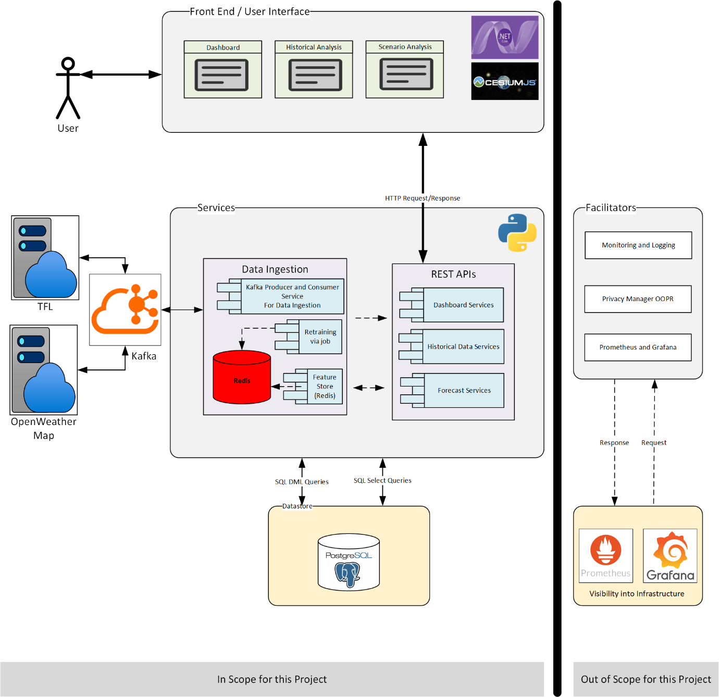

Figure 3.1.1 : System Architecture

The sub sections that follow, tries to justify the above architecture design in detail.

* Data Ingestion describes the design of ingestion pipeline to save data in real time.
* Machine Learning and Prediction describes the design of the models used for generating synthetic data for traffic and another model that is used for forecasting.
* Design of REST API and Service Layer
* Frontend Design

### 3.1.2 Use Case Diagram

Use case describes the actions that user will perform to interact with the system. There are 3 main scenarios for the project that are shown in the below diagram (figure 1.2) and description after.

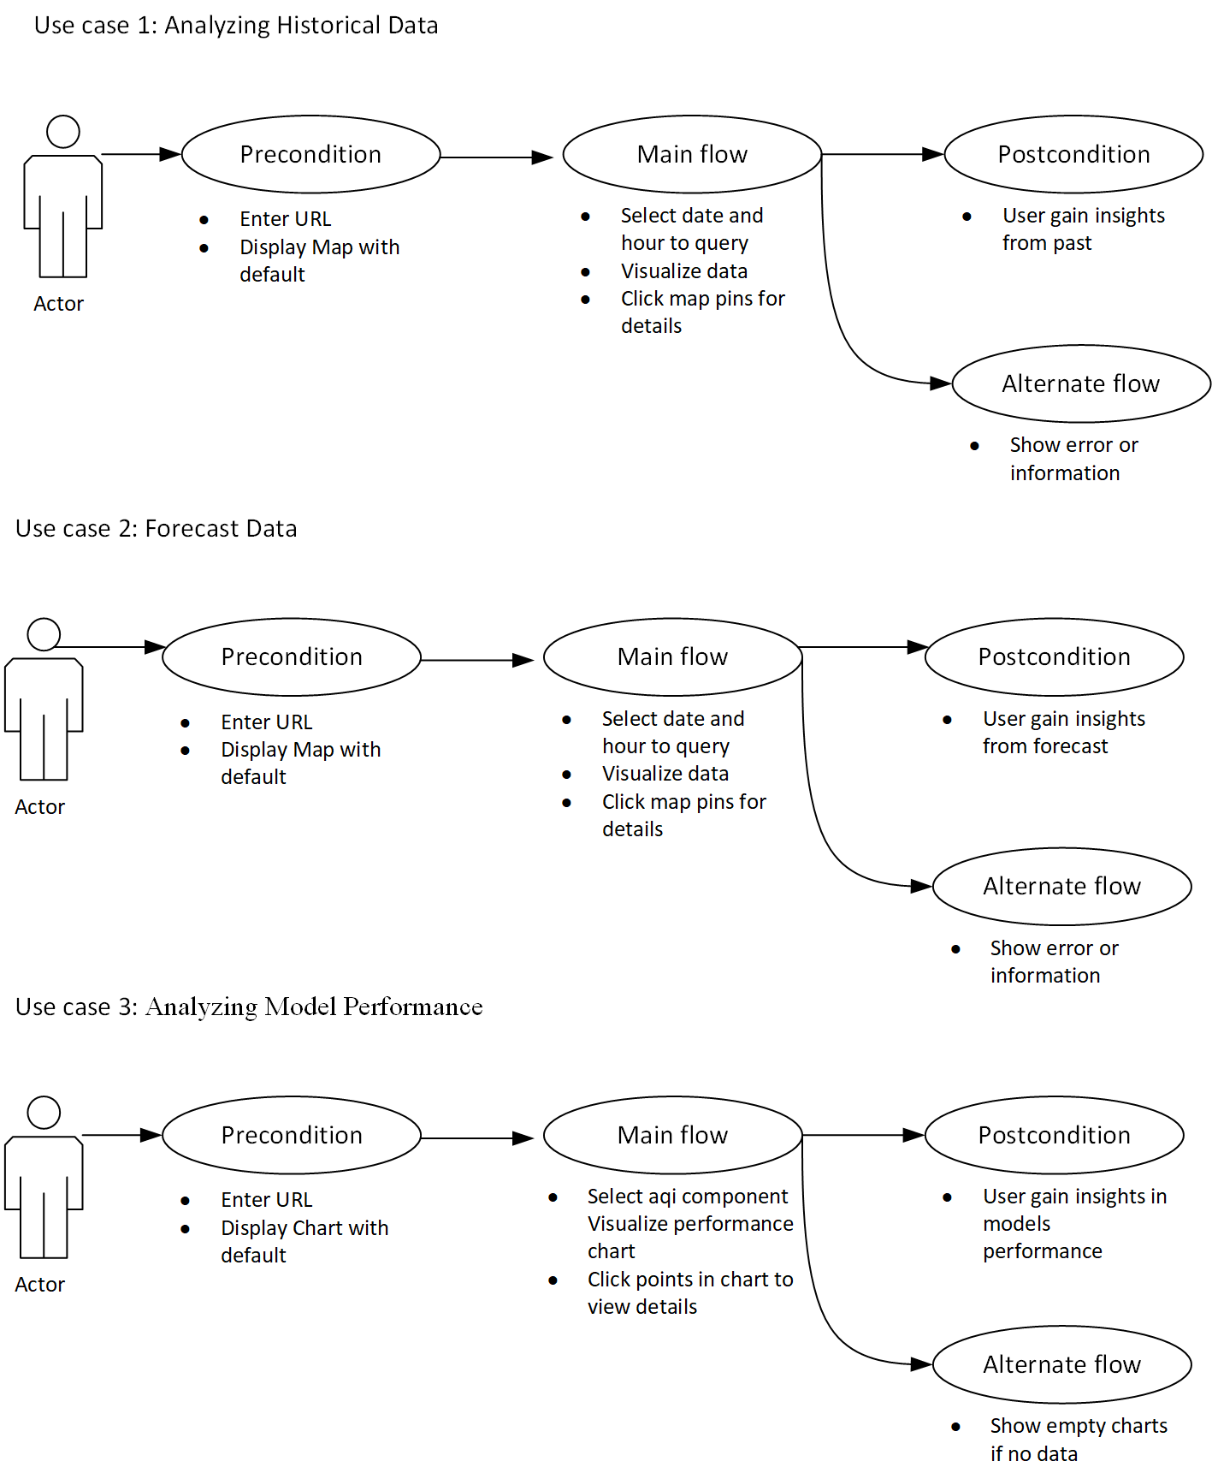

Figure 3.1.2 Use Case Diagram

1. Use Case: Analyzing Historical Data

* Actor(s): End User (e.g., city planner, analyst)
* Goal: View and analyze environmental and traffic data date and hour of the that date.

Preconditions:

* User enters the application URL navigates to the analytics page clicking Analytics Navigation Button.
* historical_data_view is populated on map and interacted.

Main Flow:

* Selects date or hour of the target date.
* System queries historical_data_view to retrieve matching records.
* Data is visualized on map (e.g., AQI trends, temperature vs traffic).
* User optionally can click on each entity on map to see details.

Alternative Flows:

* If no data is available for the selected range or the date range is not from past, show an appropriate message.

Postconditions:

* User gains insights from combined AQI, weather, and traffic data or individual views.

2. Use Case: Forecasting Data

* Actor(s): End User (e.g., city planner, analyst)
* Goal: View and analyze environmental and traffic data date and hour of the that date.

Preconditions:

* User enters the application URL and navigates to the forecast page clicking Forecast Navigation Button.
* forecast data is generated and is populated on map and interacted.

Main Flow:

* Selects date or hour of the target date and hour.
* System queries apis for forecast data for target date and hour, to retrieve matching records.
* Data is visualized on map (e.g., AQI trends, temperature vs traffic).
* User optionally can click on each entity on map to see details.

Alternative Flows:

If no data is available for the selected range or the date range is not current or future, show an appropriate message.

Postconditions:

User gains insights from combined AQI, weather, and traffic data or individual views.

3. Use Case: Analyzing Model Performance

* Actor(s): End User (e.g., analyst)
* Goal: View and analyze model performance that are used for synthetic data generation for traffic and forecasting aqi.

Preconditions:

* User enters the application URL
* Default dashboard is populated as chart and interacted.

Main Flow:

* User navigates to the dashboard page clicking Dashboard Navigation Button.
* Selects component from AQI or pollutant to see the line chart.
* Data is visualized on charts as line graph.
* User optionally can click on each point on chart to see the details.

Alternative Flows:

* If no data is available for the selected model show empty chart.

Postconditions:

* User gains insights of the models used for forecasting and traffic data generation.

### 3.1.3 Data Sources and Ingestion

The system integrates data from multiple live sources: Transport for London (TFL) for traffic flow, OpenWeatherMap for weather conditions, and pollution data from air quality monitors. These sources feed data into the system via **Apache Kafka**, which acts as a message broker, enabling decoupled, asynchronous communication between producers (data sources) and consumers (processing services). This setup supports high-throughput, real-time data handling essential for timely forecasting and analytics.

A set of **Kafka consumers** processes the incoming data, extracting and transforming it before storing it in two separate layers:

* **Redis**, which functions storage for predictors and targets to maintain sync while retraining of the model.
* **PostgreSQL**, which stores historical data used for training and evaluation of ML models and storing metrics for showing on dashboard.

### 3.1.4 Machine Learning and Prediction

The architecture incorporates a **retraining pipeline** that periodically updates model parameters based on recent trends. It uses **LSTM (Long Short-Term Memory)** models to synthetically generate traffic flow data based on pollution indicators and **XGBoost** for AQI forecasting based on structured, multivariate features. These models are trained offline using data pulled from PostgreSQL and are deployed as serialized artifacts ready for inference.

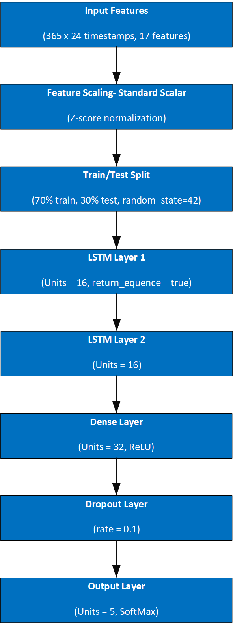

Figure 3.1.4 (a) A-LSTM Model Architecture

#### 3.1.4 (a) A-LSTM model Architecture for synthetic traffic data generation based on weather data with timestamps

**Input Sequence**

* Shape: **(24, 17)**
* Description: 24 time steps of features per sample, including AQI, weather, location, and temporal features.

**StandardScaler**

* Transformation: **Z-score normalization**
* Purpose: Normalize all features to zero mean and unit variance for stable training.

**Test/Train Split**

* Strategy: Random split using train_test_split.
* Training set: 70% of data used to fit the XGBoost model.
* Testing set: 30% held out to evaluate performance.
* Ensures generalizability and guards against overfitting.

**LSTM Layer 1**

* Units: **16**
* Configuration: return_sequences=True
* Purpose: Capture sequential dependencies across time steps and pass full sequence to next LSTM.

**LSTM Layer 2**

* Units: **16**
* Configuration: Returns only the final hidden state
* Purpose: Summarize temporal information from the sequence into a fixed vector.

**Dense Layer**

* Units: **32**, Activation: **ReLU**
* Purpose: Introduce non-linearity and learn high-level features from LSTM output.

**Dropout Layer**

* Rate: **0.1**
* Purpose: Regularization to prevent overfitting.

**Output Layer**

* Units: **5**, Activation: **Softmax**
* Purpose: Multi-class classification of traffic flow into one of five categories.

**Class Label Output**

* Categories: low, moderate_low, moderate, moderate_high, high
* Output: Most likely traffic flow class.

#### 3.1.4 (a) XGBoost model Architecture for forecast from traffic data and weather data with timestamps

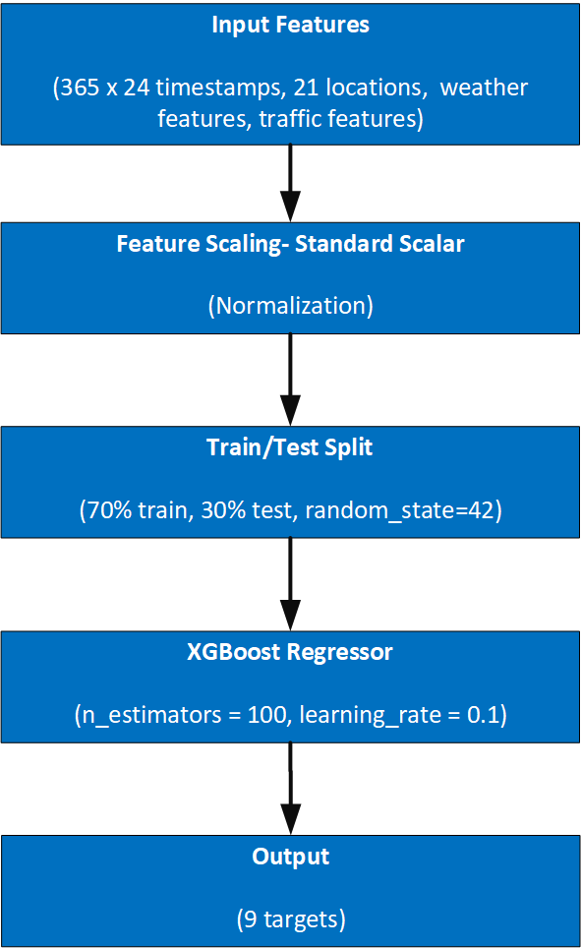

Figure 3.1.4 (b) :XGBoost Model Architecture

**Raw Input Features**

* Source: Preprocessed dataset after feature engineering.
* Features include AQI components (pm2_5, pm10, no2, so2, co, o3), weather metrics (temp, pressure, humidity, etc.), and time/location fields.
* Each target variable (e.g., pollutants) is modeled **independently** using its respective features.

**Feature Scaling (StandardScaler)**

* Method: **Z-score normalization** using StandardScaler.
* Purpose: Ensures features contribute equally by transforming them to have zero mean and unit variance.
* Preprocessing happens **before training**, and the same scaler is used during inference.

**Train/Test Split (70/30)**

* Strategy: Random split using train_test_split.
* Training set: 70% of data used to fit the XGBoost model.
* Testing set: 30% held out to evaluate performance.
* Ensures generalizability and guards against overfitting.

**XGBoost Regressor**

* Framework: XGBRegressor from the xgboost library.
* Hyperparameters:
  + n_estimators=100 – number of boosting rounds.
  + learning_rate=0.1 – controls contribution of each tree.
  + random_state=42 – for reproducibility.
* One model is trained **per target variable**.
* Handles missing values and captures non-linear feature interactions.

**Predicted Outputs**

* Model predicts **continuous values** for target features (e.g., pollutant levels).
* Predictions are stored in a dataframe indexed by test samples.
* Each model saves results for future scoring and evaluation.

Model inference is triggered by API requests to forecast future values of traffic or pollutant levels, which are served by a REST API layer built using **FastAPI**. FastAPI enables rapid and scalable deployment of endpoints for prediction, live queries, and hypothetical scenario simulations.

### 3.1.5 REST APIs and Service Layer

The REST API layer exposes three core services:

* **Dashboard Services**, providing summary views and visual performance trends.
* **Historical Data Services**, which allow querying past metrics for comparison.
* **Forecast Services**, enabling users to submit queries or hypothetical changes (e.g., road closures) and receive predictions.

These APIs interact with the feature store and trained models to compute outputs, returning results to the front end in real time.

### 3.1.6 Front-End Visualization

The front end is built using a .NET core MVC framework and **CesiumJS** for 3D geospatial visualization. The dashboard provides real-time overlays of traffic and air quality, historical playback, and scenario-based forecasting using RESTful data. Users can interactively simulate urban interventions and observe their effects spatially and temporally.

### 3.1.7 Database Design – ERD

Entity Relationship Diagram (ERD) shown in figure 1.2 shows the tables and relationships between them along with constraints like primary key, foreign key, unique constraint and datatypes of columns of each table. This presents the foundation for the data that will be ingested by building a pipeline.

#### **3.1.7.1 Data Ingestion Tables**

This stores the data from respective sources in the appropriate tables.

**site_table**

* **Primary Key:** (latitude, longitude) — marked with **violet** key icons.
* Stores data about monitoring sites: site_code, site_name, site_type, etc.
* **Referenced by:** aqi_table, traffic_table, weather_table.

**aqi_table**

* Contains air quality metrics (aqi, co, no2, etc.).
* **Foreign Keys:** latitude, longitude referencing site_table.
* **Also includes:** site_code, measurement_datetime.

**traffic_table**

* Records traffic statistics like traffic_flow and traffic_density.
* **Foreign Keys:** latitude, longitude referencing site_table.
* Includes measurement_datetime.

**weather_table**

* Holds weather readings like temp, humidity, uvi, etc.
* **Foreign Keys:** latitude, longitude referencing site_table.

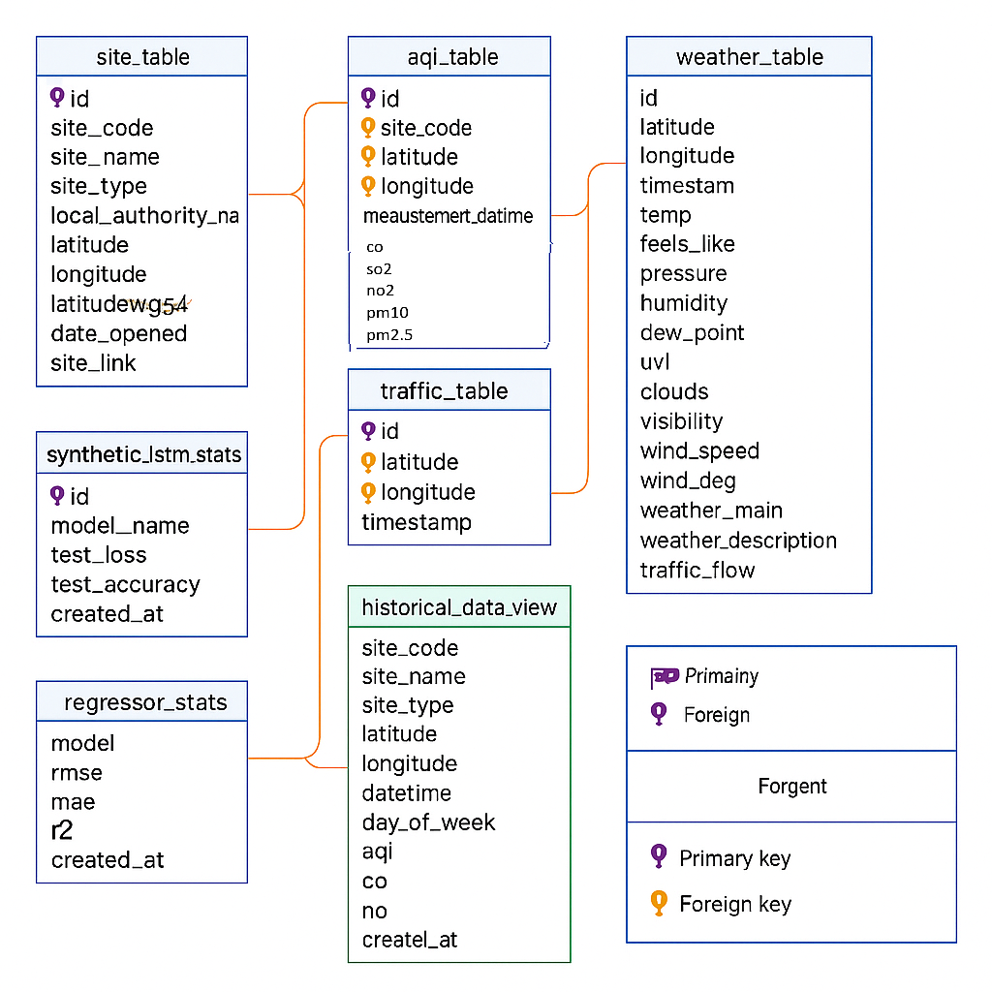

Figure 3.1.7: ERD – Entity Relationship Diagram

#### **3.1.7.2 Model performance data**

This saves log of model performance metrics everytime when it is run.

**synthetic_lstm_stats**

* Tracks LSTM model performance: model_name, test_loss, test_accuracy, created_at.
* **Primary Key:** id.

**regressor_stats**

* Stores regression model evaluation: rmse, mae, r2, created_at.
* **Primary Key:** model.

### 3.1.8 Supporting Infrastructure (Suggested in design but out of scope for the project)

Supporting components include **Docker** for containerization, **Prometheus and Grafana** for performance monitoring, and a **privacy module** aligned with GDPR. The architecture follows a modular microservices approach, where components interact via well-defined interfaces, promoting extensibility and independent deployment.

In summary, the architecture provides a robust foundation for a smart, adaptive digital twin capable of real-time forecasting and policy testing for Westminster’s urban environment.

## 3.2 Develop

The development of the solution highlights the code or scripts used in development of the components described in the design phase in the previous section [3.1 Design]. Components like Database creation, Kafka for streaming data real-time and Redis server for storing feature columns for maintaining consistency between model retraining is addressed first in this section. The detail development for the database (tables and views), data pipeline (containing producer and consumer for relevant topics and retraining of the model post data ingestion), API ( for middleware) and front-end (for presentation logic) will also be addressed to provide the clear understanding of the code structure to develop the solution.

### 3.2.1 Containers with required services

**3.2.1.1 Realtime Ingestion Service**

This component is required to ingest data in real-time from the respective sources. Kafka is built on publisher and subscriber design pattern where the publisher is responsible for extracting data from the sources and sending it to the designated Kafka topic. The respective subscribers listen to the particular que or topic on kafka for any data available and reads and saves in the database. The data pipeline code will be further explained in section [3.2.5].

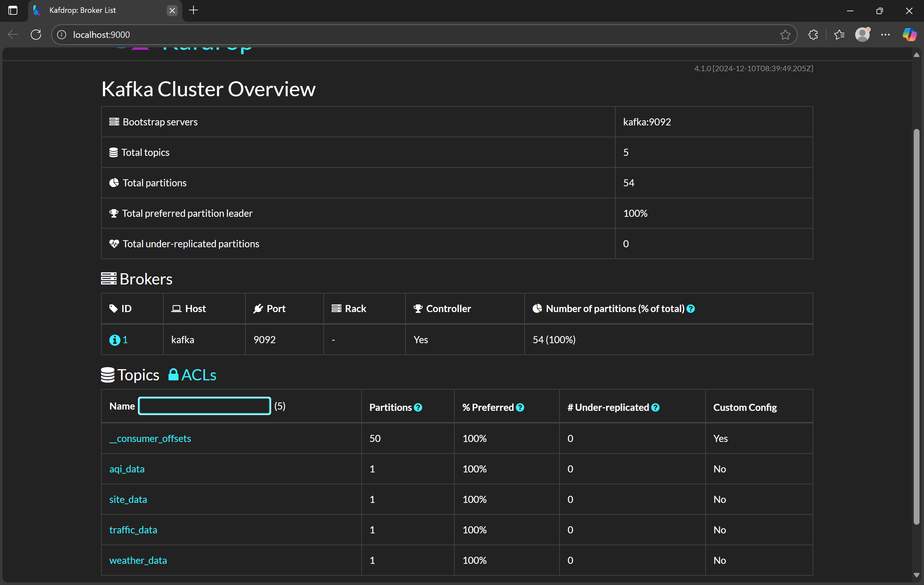

Figure 3.2.1.1: Kafdrop/Kafka with topics for streaming

**3.2.1.1(a) Kafka (kafka service)**

* **Image**: apache/kafka:latest
* **Container Name**: kafka
* **Ports**: 9092:9092
* **Environment Variables**:
  + Custom Kafka KRaft mode setup (no Zookeeper)
  + Key variables include:
    - KAFKA_NODE_ID=1
    - KAFKA_PROCESS_ROLES=broker,controller
    - KAFKA_LISTENERS, KAFKA_ADVERTISED_LISTENERS
    - KAFKA_CONTROLLER_LISTENER_NAMES=CONTROLLER
    - CLUSTER_ID=MkU3OEVBNTcwNTJENDM2Qk
    - KAFKA_AUTO_CREATE_TOPICS_ENABLE=true

**3.2.1.1(b) Kafdrop (kafdrop service)**

* **Image**: obsidiandynamics/kafdrop
* **Container Name**: kafdrop
* **Ports**: 9000:9000
* **Environment**:
  + KAFKA_BROKERCONNECT=kafka:9092
* **Depends On**: kafka

**3.2.1.1(c) Data Producer & Consumer**

* **Producer (main_producer)**
  + **Build**: ./ingestion_service
  + **Command**: python -u main_producer.py
  + **Depends On**: db, kafka, redis, main_consumer
  + **Environment**:
    - Kafka, PostgreSQL, Redis, API service and OpenWeather API key
* **Consumer (main_consumer)**
  + **Build**: ./ingestion_service
  + **Command**: python -u main_consumer.py
  + **Depends On**: kafka, db
  + **Environment**: Kafka + PostgreSQL connection details

**3.2.1.2 Feature Cache**

Feature cache is key in maintaining consistency between the models generated and the application by writing predictor and target features into the Redis cache. Redis is normally used as web server cache for faster retrieval of the data. The cache can be saved in json/binary format. For this solution binary format is selected because of faster storage and retrieval of the information as it does not requires data to be serialized before saving in the cache.

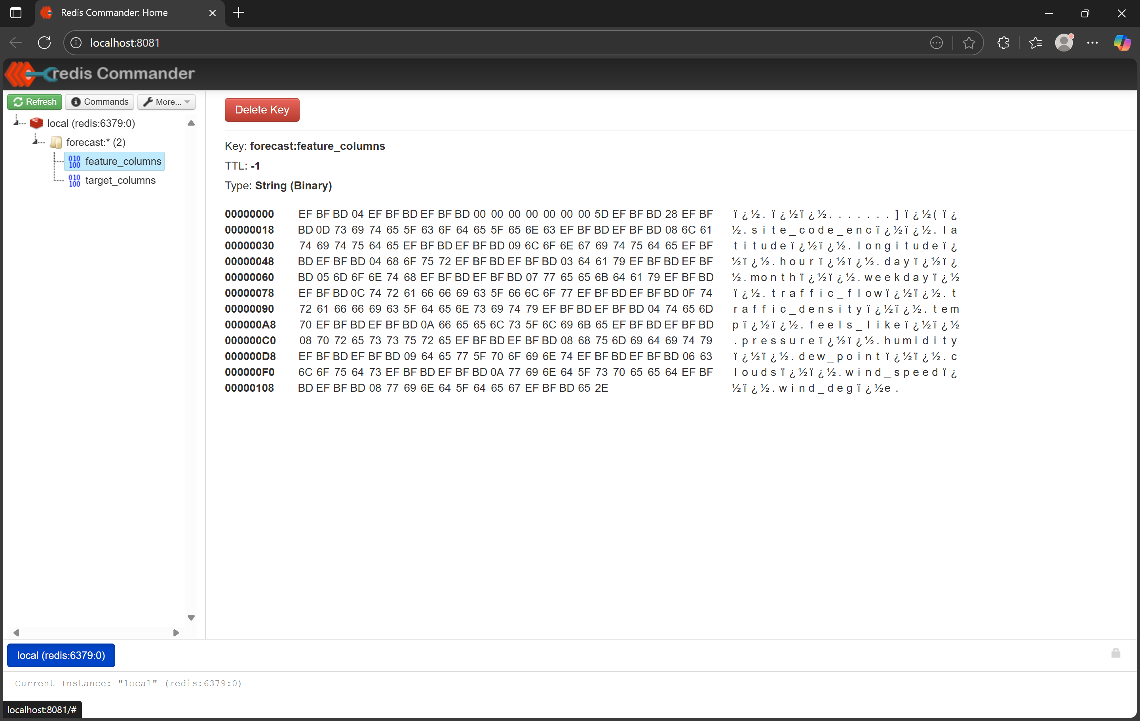

Figure 3.2.1.2(a) Redis store for Feature columns

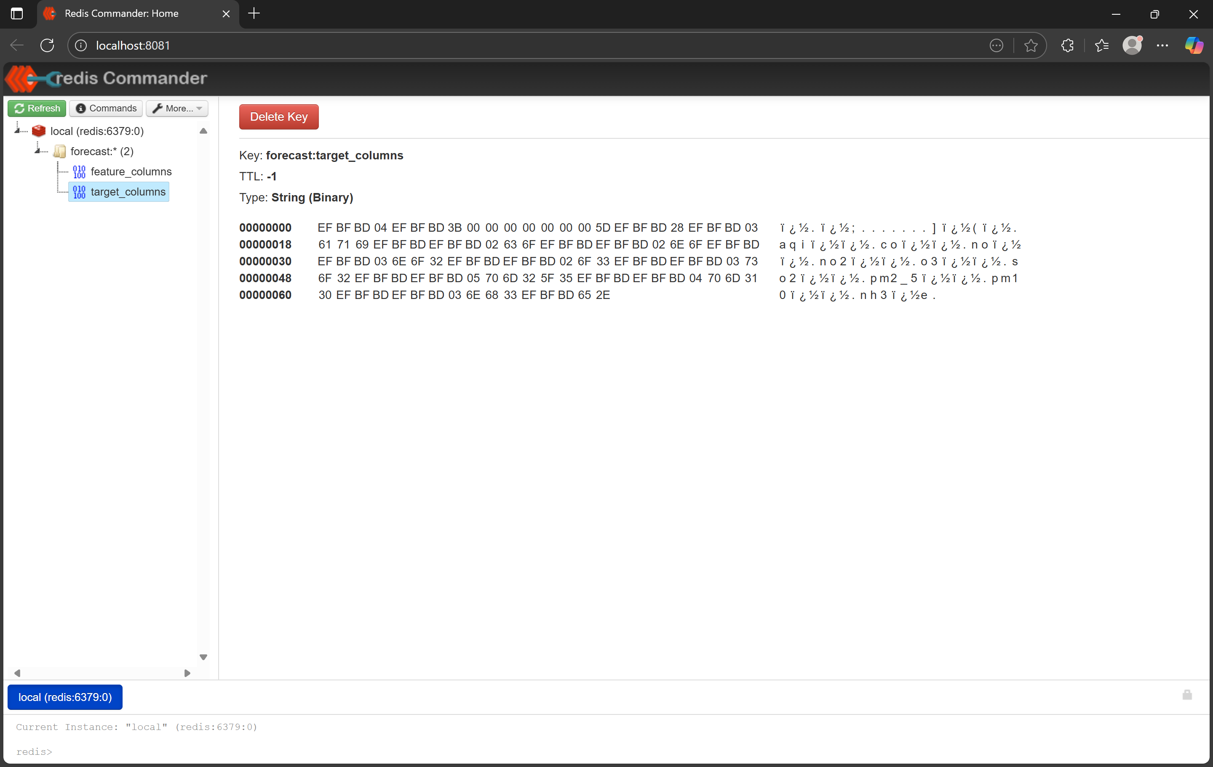

Figure 3.2.1.2(b) Redis store for Target Columns

**3.2.1.2 (a) Redis (redis service)**

* **Image**: redis:latest
* **Container Name**: my-redis-server
* **Ports**: 6379:6379
* **Volumes**:
  + redis_data:/data
* **Environment**:
  + REDIS_PASSWORD=Admin123

**3.2.1.2 (b) Redis Commander (redis-commander service)**

* **Image**: rediscommander/redis-commander:latest
* **Ports**: 8081:8081
* **Depends On**: redis
* **Environment**:
  + REDIS_HOSTS=local:redis:6379
  + HTTP_USER=admin
  + HTTP_PASSWORD=Admin123

### 3.2.2 IDE for development

**Visual Studio Code (VS Code)** is a lightweight, cross-platform, and highly extensible IDE, making it an ideal choice for full-stack projects that combine Python-based APIs with ASP.NET Core MVC frontends and JavaScript libraries.

**3.2.2.1 Unified Environment for Backend and Frontend**

* **Python Backend**:
  + Install the **Python extension** for syntax highlighting, IntelliSense, debugging, and environment management.
  + Use built-in terminal for running FastAPI or other Python services.
* **ASP.NET Core MVC Frontend**:
  + With the **C# extension (by OmniSharp)**, VS Code provides:
    - IntelliSense, debugging, and Razor syntax support.
    - Project scaffolding, code navigation, and build integration with the .NET CLI.
  + Debug support for both server-side (C#) and client-side (JavaScript/TypeScript).

**3.2.2.2 Productivity Features**

* **IntelliSense**, **code navigation**, and **refactoring tools** speed up development.
* **Git integration** for seamless version control.
* **Docker extension** allows container management from within the IDE.
* Multi-root workspaces allow API, frontend, and shared code to be managed together.

**3.2.2.3 Cross-Platform and Lightweight**

* Works equally well on **Windows**, **Linux**, and **macOS**.
* Suitable for collaborative environments and containerized development (e.g., Docker + DevContainers).

In summary, **VS Code** provides a cohesive development experience that bridges both the backend (Python) and frontend (.NET Core MVC + JavaScript), making it a powerful and efficient IDE for full-stack web applications.

### 3.2.3 Repository and version control

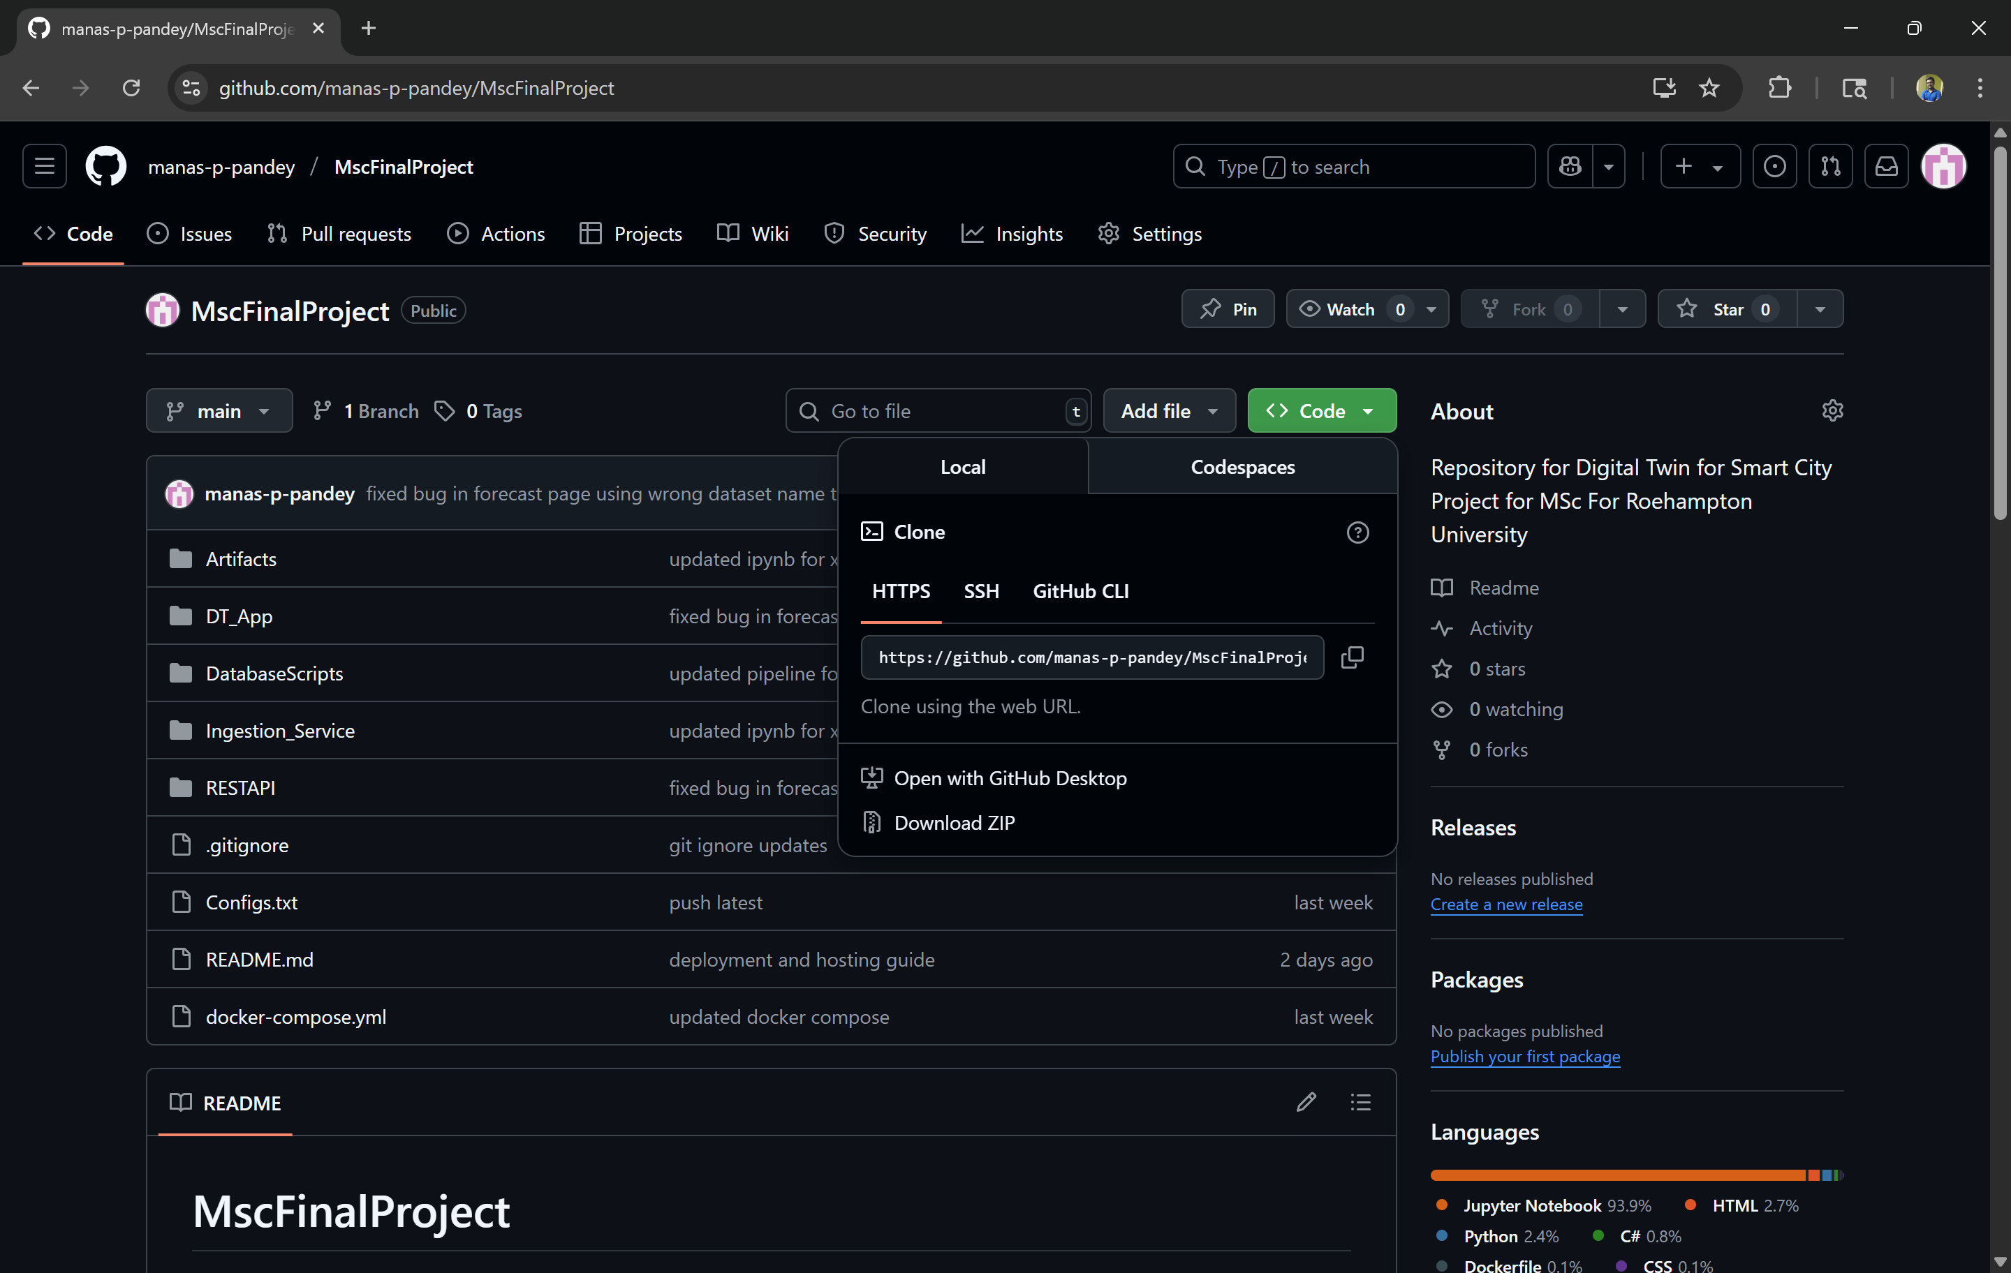

Figure 3.2.3 : Github Repository

**What is GitHub?**

GitHub is a cloud-based platform for version control using Git. It enables collaborative development by hosting repositories where code changes are tracked, reviewed, and managed.

**3.2.3.1 Setting Up a Repository on GitHub**

1. Go to <https://github.com> and register an account or login with credentials if already have an account.
2. Once logged in, click on **New Repository**.
3. Enter repository **name**, optional **description**, and choose:
   * **Public** (anyone can see) or **Private** (restricted access). For the solution, a public repository is created at

“https://github.com/manas-p-pandey/MscFinalProject”

* + Optionally **initialize with a README**

1. Click **Create Repository**.
2. The repository name used for this project is “MscFinalProject”.

**3.2.3.2 Cloning Repository in VS Code (Checkout Process)**

1. Open **Visual Studio Code**.
2. Open the **Command Palette** (Ctrl+Shift+P), then type and select Git: Clone.
3. Paste the **GitHub repository URL**

(https://github.com/manas-p-pandey/MscFinalProject.git).

1. Choose a local folder to save the repo.
2. VS Code will prompt: *"Would you like to open the cloned repository?"* – click **Yes**.

**3.2.3.3 Basic Git Workflow in VS Code**

* **Make changes** to your files.
* **Stage Changes**: Click **Source Control** icon → + next to files.
* **Commit**: Write a message and click the **Commit** button.
* **Push to GitHub**: Click the **...** menu → Push or use terminal:

### 3.2.4 Creating Tables in Database

Once the database setup as described in section [] is done, we can now create the tables for entities used in this project for persistent storage. The data saved in the tables created will be used for displaying analytics for historical data as well as provide data into the model training pipeline.

Below are the list of tables/views with their create scripts:

* **site_table**

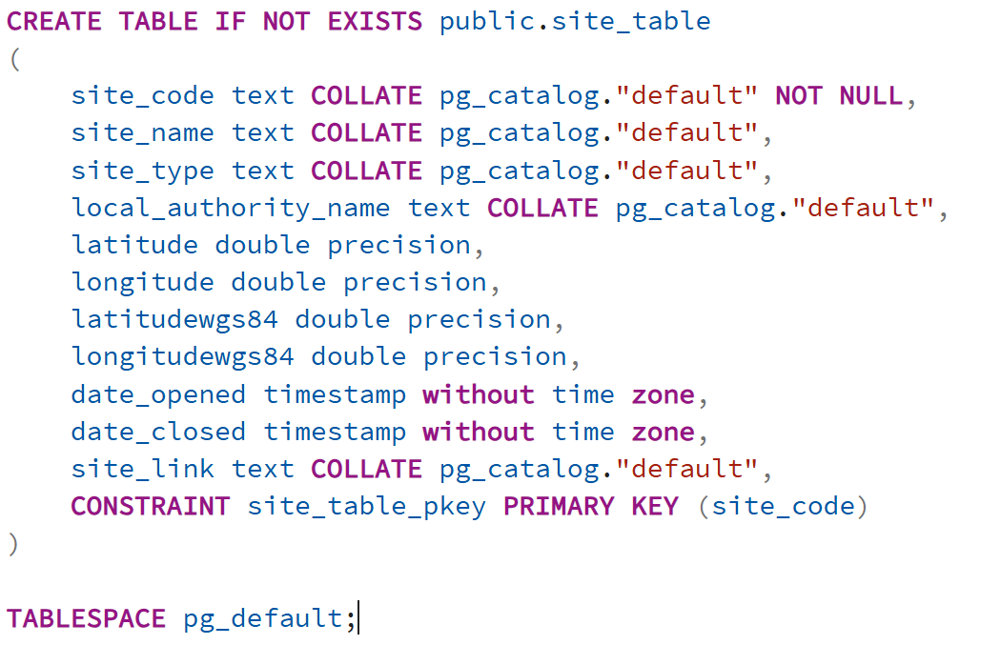

* **aqi_table**

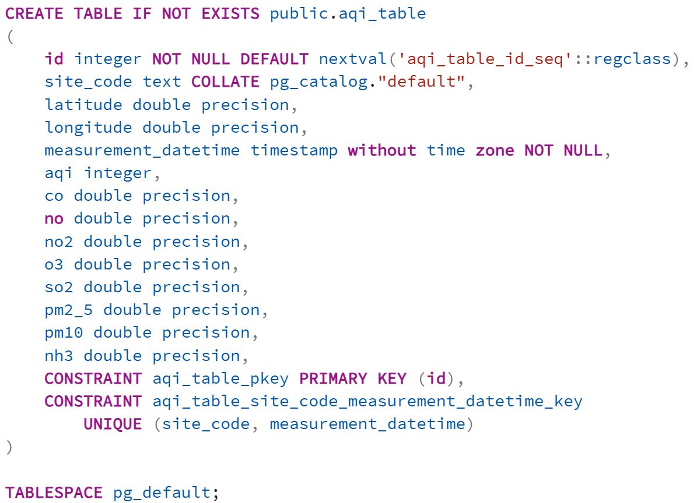

* **traffic_table**

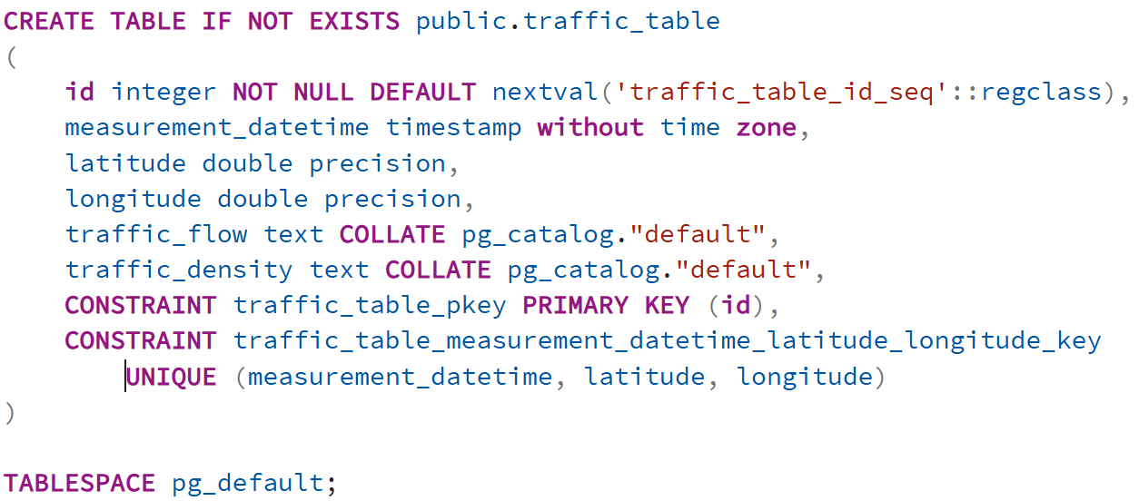

* **weather_table**

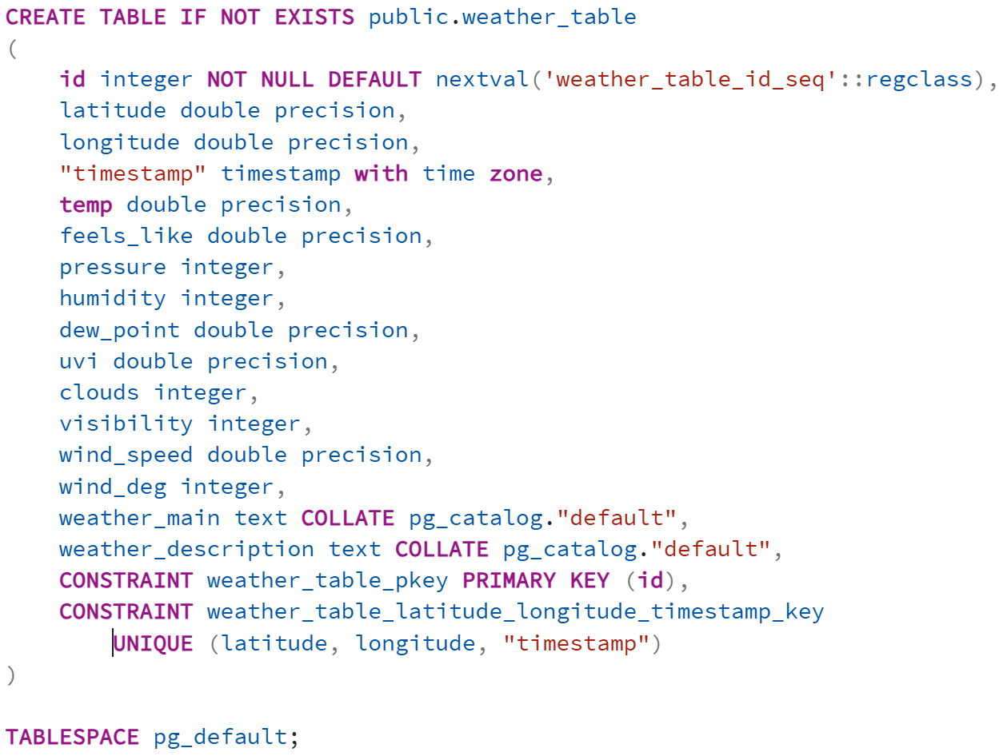

* **synthetic_lstm_stats**

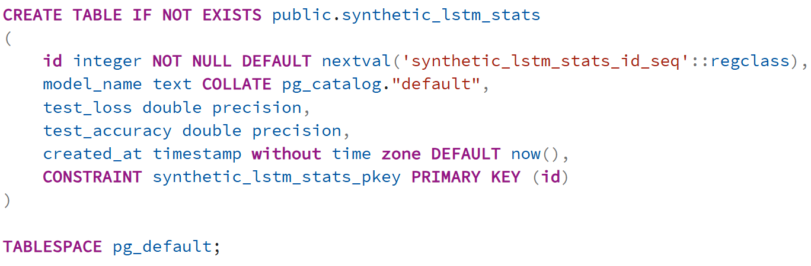

* **regressor_stats**

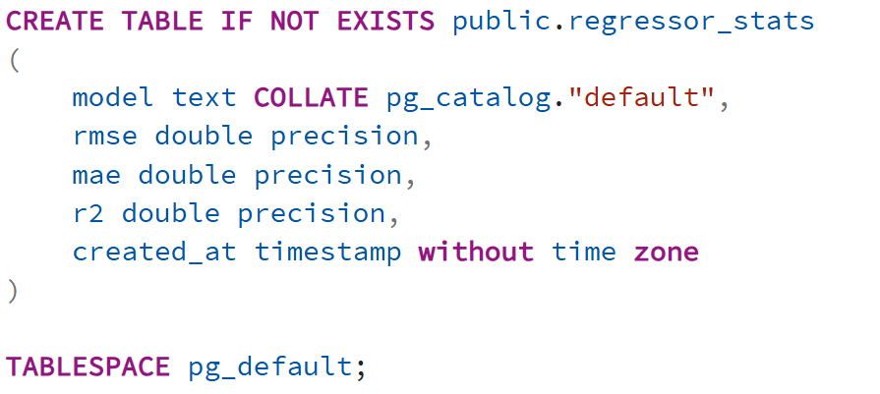

### 3.2.5 Data Ingestion Pipeline (Producer / Consumer)

The Ingestion_Service is a modular, Kafka-driven data ingestion system that processes real-time and synthetic data related to air quality (AQI), weather, traffic, and location metadata. It leverages **Kafka** for messaging, **PostgreSQL** for persistence, **Redis** for feature caching, and most importantly retraining A-LSTM model described in section 6 for generating synthetic data for traffic based on AQI and pollutant composition and XGBoost model retraining to be used by the forecast feature of the project.

**3.2.5.1 Producer Scripts**

**main_producer.py**

* **Purpose**: Entry script to sequentially run all producer modules.
* **Function**: Calls produce_site_data(), produce_aqi_data(), produce_weather_data(), produce_traffic_data(), and produce_forecast_data() in order.

**site_producer.py**

* **Function**: produce_site_data()
  + Loads static metadata for all monitoring sites.
  + Sends this metadata to the Kafka topic site_data.

**aqi_producer.py**

* **Packages**: requests, json, kafka
* **Function**: produce_aqi_data()
  + Fetches AQI data for each site via an external API.
  + Publishes the data to Kafka topic aqi_data.

**weather_producer.py**

* **Function**: produce_weather_data()
  + Fetches current weather data for each site using OpenWeatherMap API.
  + Sends results to Kafka topic weather_data.

**traffic_producer.py**

* **Packages**: pandas, tensorflow, joblib
* **Function**: produce_traffic_data()
  + Loads trained LSTM model and scaler.
  + Uses historical data to generate synthetic traffic forecasts.
  + Sends to Kafka topic traffic_data.

**forecast_producer.py**

* **Function**: produce_forecast_data()
  + Loads preprocessed features from Redis.
  + Applies an Attention-LSTM model to generate AQI forecasts.
  + Pushes predictions to Kafka topic forecast_data.

**3.2.5.2 Consumer Scripts**

**main_consumer.py**

* **Purpose**: Launches and manages multiple Kafka consumers.
* **Function**: Starts threads for each consumer: AQI, weather, traffic, site.

**site_consumer.py**

* **Function**: consume_site_data()
  + Consumes site metadata from site_data Kafka topic.
  + Inserts metadata into the site_metadata PostgreSQL table.

**aqi_consumer.py**

* **Packages**: psycopg2, json, kafka
* **Function**: consume_aqi_data()
  + Listens on aqi_data Kafka topic.
  + Writes AQI measurements into aqi_data table in PostgreSQL.

**weather_consumer.py**

* **Function**: consume_weather_data()
  + Consumes weather messages from Kafka topic weather_data.
  + Parses and saves entries into a weather metrics table.

**traffic_consumer.py**

* **Function**: consume_traffic_data()
  + Receives synthetic traffic predictions from Kafka.
  + Stores them into the traffic_data PostgreSQL table.

**3.2.5.3 Support Modules**

**config.py**

* Central configuration for environment variables and connections.
* **Functions**:
  + get_kafka_producer()
  + get_kafka_consumer(topic)
  + get_postgres_connection()
  + get_redis_client()

### 3.2.6 Deep Learning and ML Models

**3.2.6.1 A-LSTM Model for producting synthetic data for traffic (traffic_density and traffic_flow)**

The model simulates **traffic flow categories** (low to high) using a synthetic approach based on historical **AQI + weather** data. The predicted traffic data is sent to a Kafka topic named traffic_data.

The script implements a **stacked LSTM neural network** with classification output.

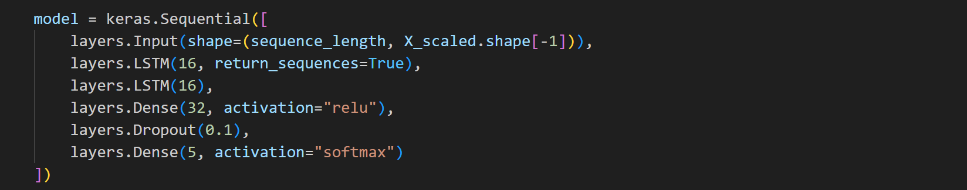

* **Input**: 24-hour time series of merged AQI, weather, and time features.
* **Two LSTM layers**: Capture temporal dependencies.
* **Dense + Dropout**: Introduce non-linearity and regularization.
* **Softmax Output**: Classifies into 5 traffic flow levels.

Data fetched from **PostgreSQL**

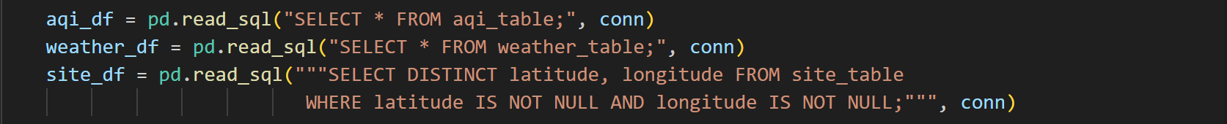

* Merged using merge_asof() on datetime and location.
* Features include AQI metrics (pm2_5, no2, etc.), weather metrics, time, and site coordinates.

**Custom AQI score** is computed, mapped to flow classes:

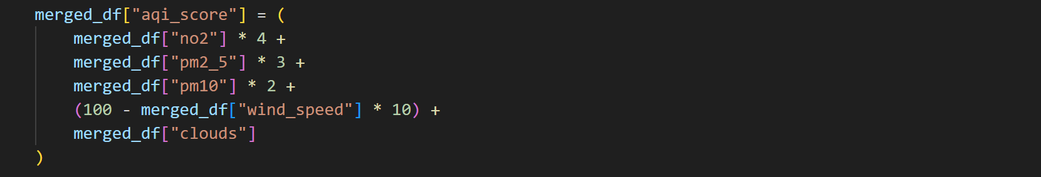

Flow Categorization

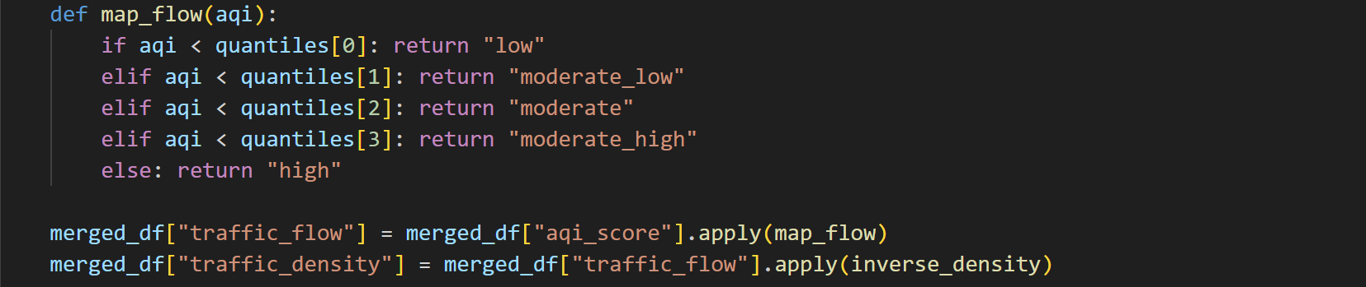

* Each AQI score is mapped to a **traffic flow class** which is then encoded for training.

Model Compilation and Training

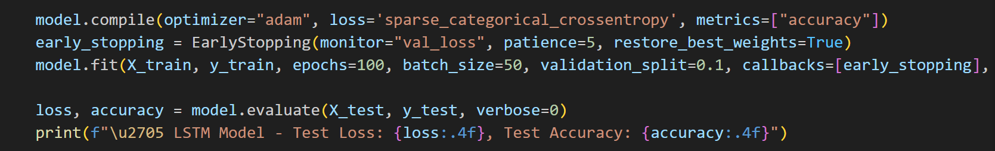

* Class weights handle imbalance.
* Early stopping avoids overfitting.
* Evaluation based on accuracy and loss

Saving the trained model and evaluation metrics



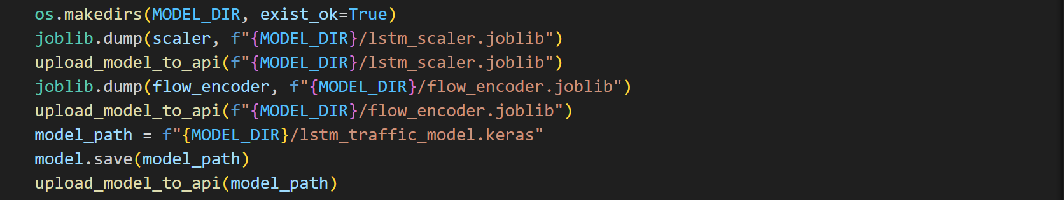

* Creates entry in synthetic_lstm_stats
* Saves standard scalar and trained model
* Uploads the model to the REST API to be used later for forecasting

Prediction and Kafka Integration

* For each site, checks for missing traffic data and fills it.
* Last known sequence is scaled and passed to the model
* Inferred traffic_flow and traffic_density are published to Kafka

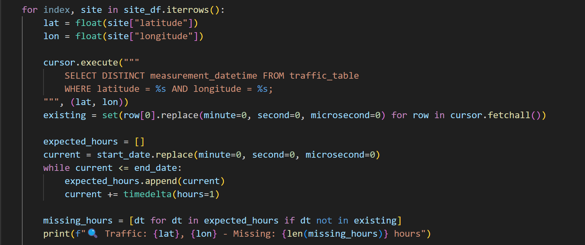

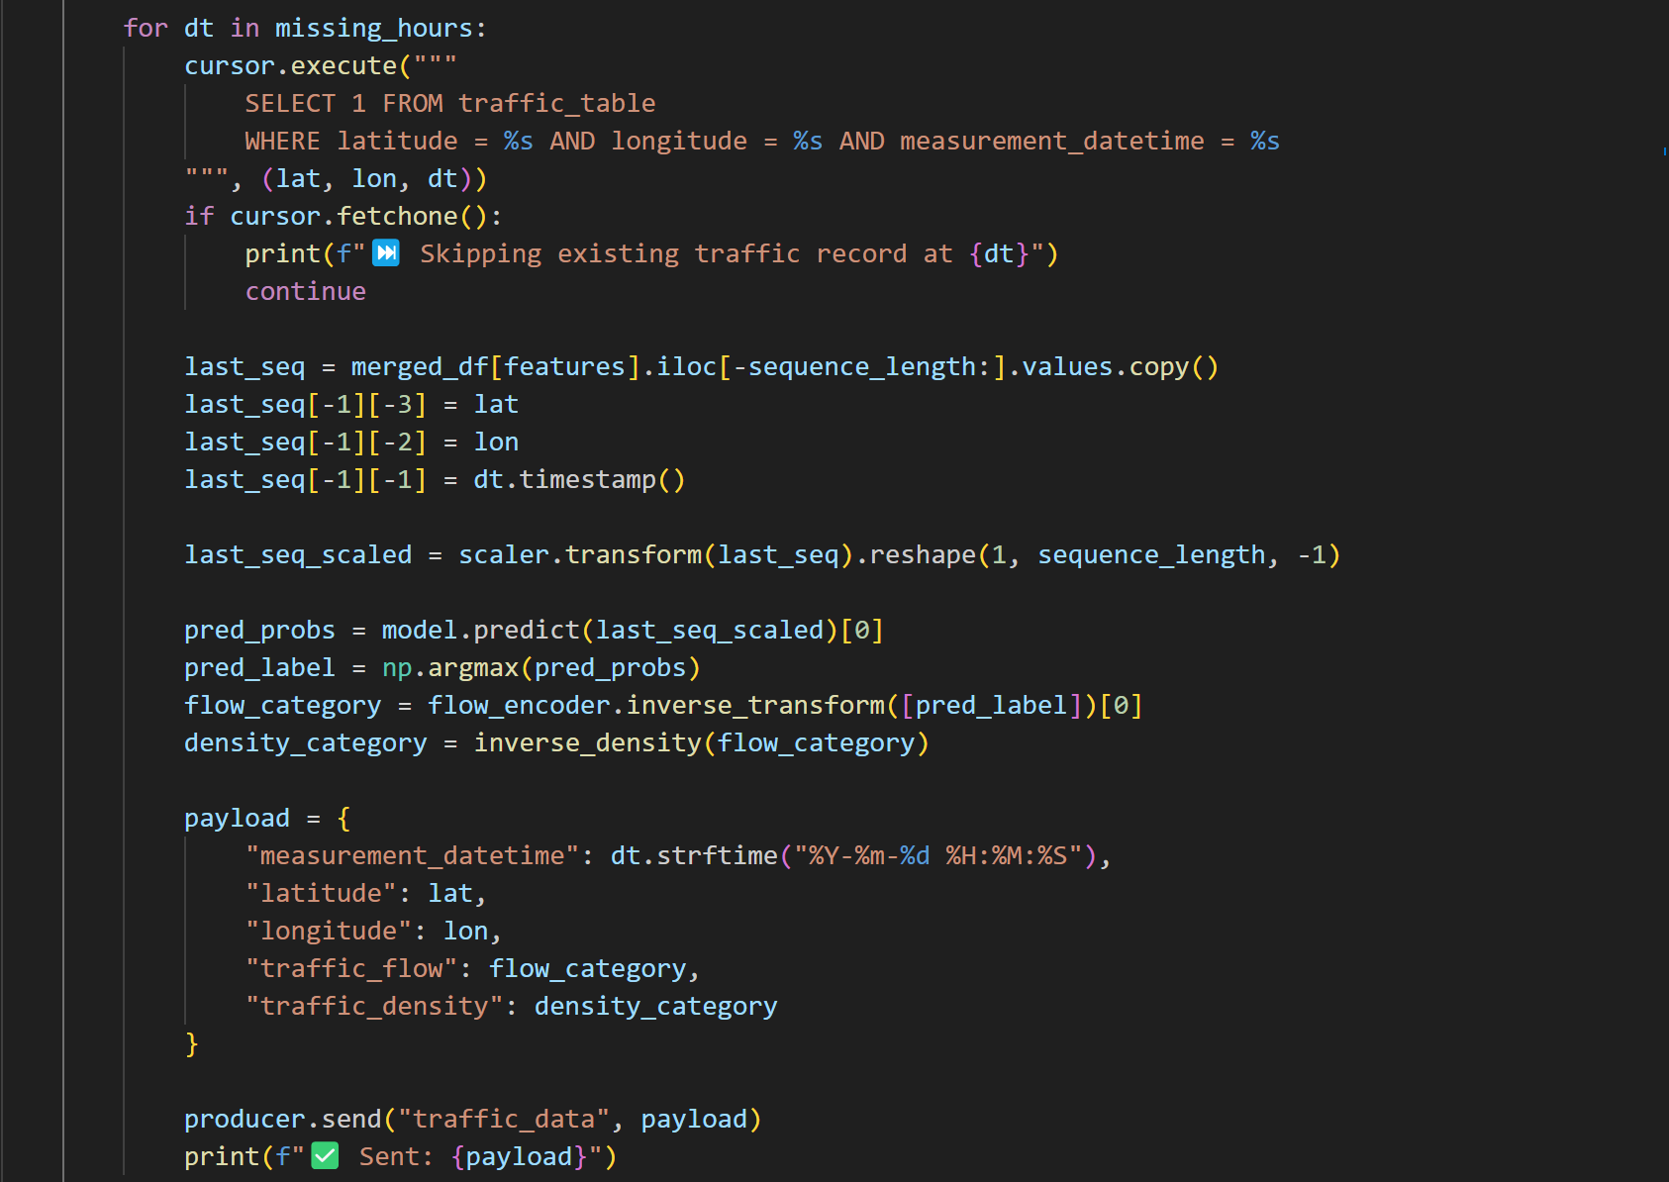

**3.2.6.2 XGBoost for forecasting AQI based on weather and traffic**

**(A) Initial Training**

Initial training model was created in a python notebook using data extracted and saved in csv from the Postgres database view using the query that follows.

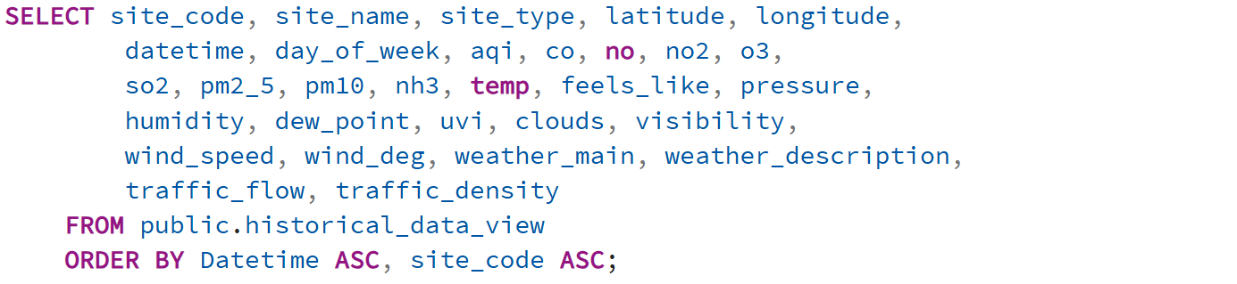

Below functionalities were implemented using the python notebook to train evaluate and save the initial model.

**Importing Required packages in ipynb**

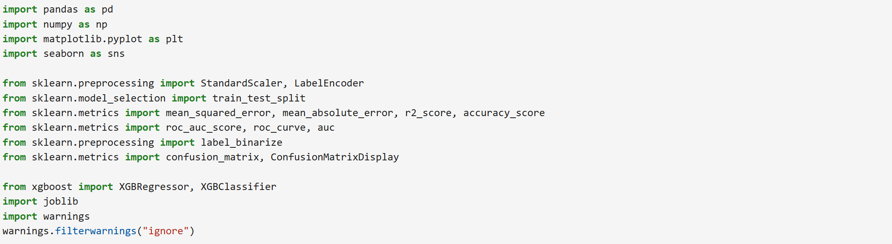

**Data Preprocessing**

* **Source**: data-1753054598583.csv, exported from historical_data_view.
* **Preprocessing steps**:
  + Convert datetime to pandas datetime type.
  + Encode categorical columns:





* + Drop columns with high nulls like uvi and visibility.
  + Add temporal features: hour, day, month, weekday.

**Feature Set**

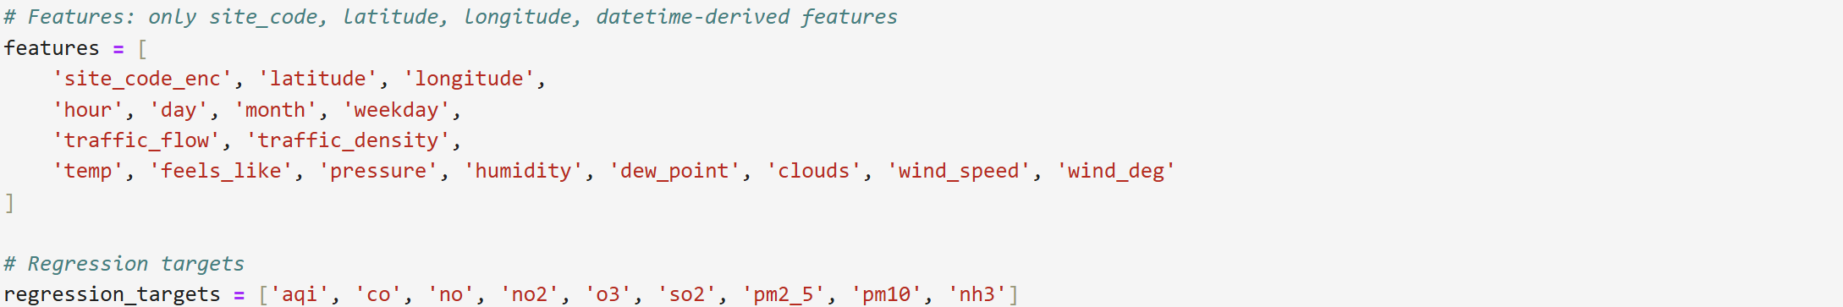

**Training and Evaluation**

* Scaled with StandardScaler and saving the scalar to be used during retraining process



* Each target variable trained and saved

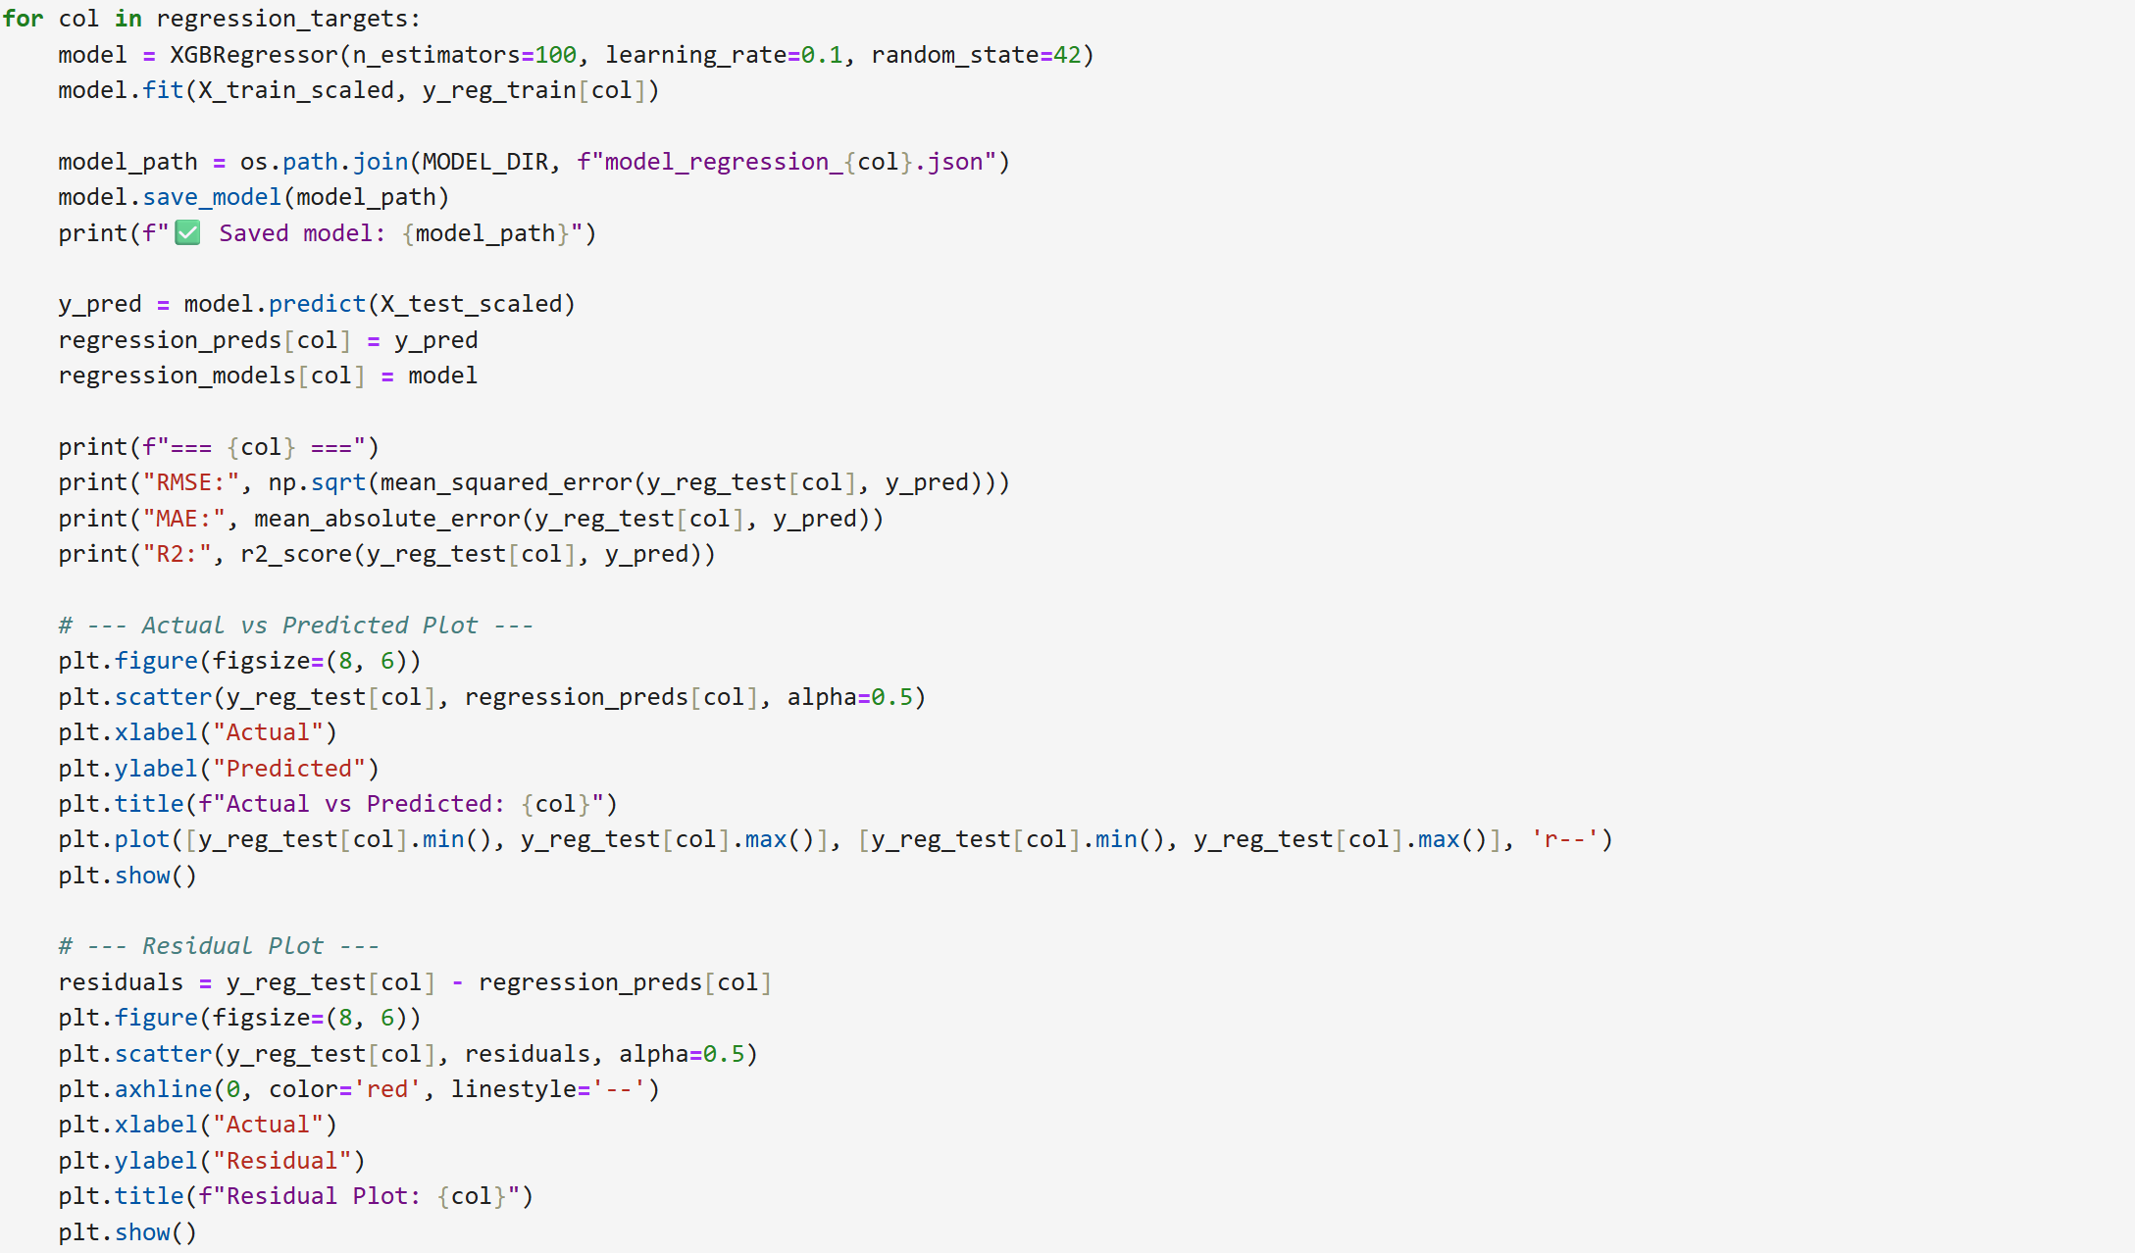

**(B) Retraining XGBoost model in forecast_producer.py**

**Load Data**

* Use live data and loading it in a dataframe

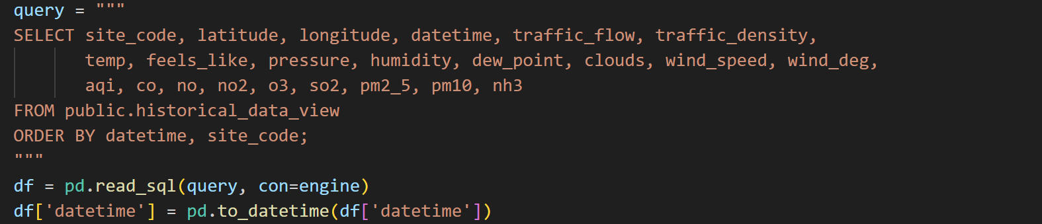

**Preprocessing**

* Matches the notebook logic:
  + Flow/density mapping
  + Encoding site_code
  + Temporal features

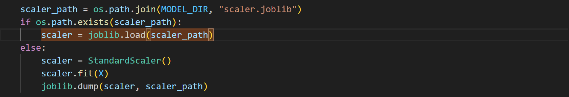

**Model Retraining**

* For each target the respective model file is loaded
* Model is retrained
* Evalution metrics like RMSE, R2 and MAE is saved with timestamp
* Retrained model is saved
* Saved retrained model is uploaded to REST API (method explained in the REST API section)

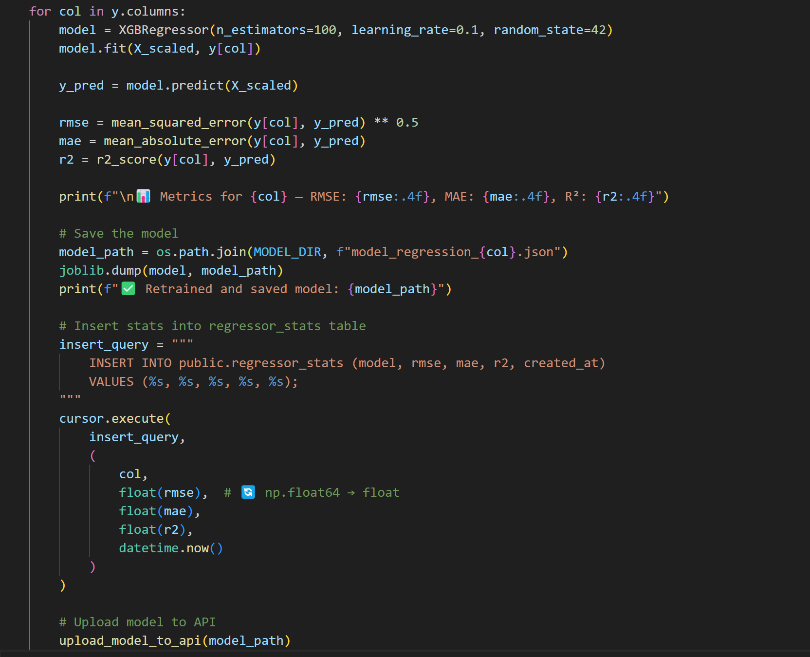

### 3.2.7 REST API (Python Fast API)

The REST API project provides endpoints to manage and access site, weather, air quality and traffic historical data, forecasting AQI data using weather, site and traffic data, along with ML model upload capabilities. It is container-ready with Docker support and PostgreSQL for persistence.

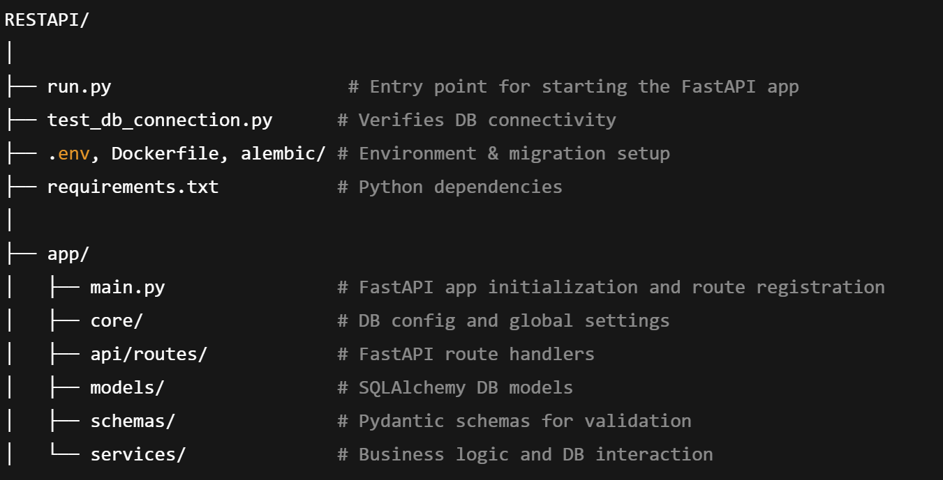

**3.2.7.1 Core Files and Functionality**

**run.py**

Starts the FastAPI application. Calls the app factory from main.py.

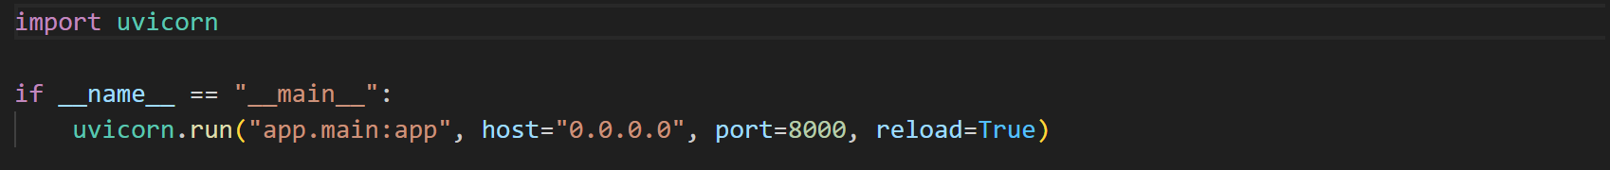

**3.2.7.2 API Routes (app/api/routes)**

Each route maps HTTP requests to service logic.

**dashboard_data.py**

* **Method**: @get("/dashboard")
* **Function**: Returns aggregated data for visualization on the dashboard.
* **Depends on**: dashboard_service.py

**forecast_data.py**

* **Method**: @get("/forecast")
* **Function**: Retrieves latest forecast values (AQI and pollutants).
* **Depends on**: forecast_data_service.py

**historical_data.py**

* **Method**: @get("/historical")
* **Function**: Serves historical AQI, weather, and traffic metrics.
* **Depends on**: historical_data_service.py

**site.py**

* **Method**: @get("/sites")
* **Function**: Lists all monitored sites with their metadata.
* **Depends on**: site_service.py

**model_upload_api.py**

* **Method**: @post("/models/upload-model")
* **Function**: Accepts and saves uploaded model files to server storage.
* **Usage**: Supports automated model deployment.

**3.2.7.3 Models (app/models)**

Defines database tables using SQLAlchemy.

forecast_data_view.py: Defines forecast output schema.

* regressor_stats.py: Stores RMSE, MAE, R² for each regressor model.
* synthetic_lstm_stats.py: Logs performance of LSTM-based traffic models.
* site.py: Metadata for physical monitoring sites.
* User_Details.py, User_Logs.py: User accounts and activity logs.

**3.2.7.4 Schemas (app/schemas)**

Defines validation models using Pydantic:

* Input and response schemas for API calls.
* Examples: forecast_data.py, site.py, regressor_stats.py.

**3.2.7.5 Services (app/services)**

Implements logic separated from route handlers.

Examples:

**forecast_data_service.py**

* Queries forecast_data_view, returns the latest forecast for each site.

**dashboard_service.py**

* Aggregates metrics (mean, median, mode) for dashboard visuals.

**historical_data_service.py**

* Retrieves daily or hourly summaries from historical tables/views.

**site_service.py**

* Provides utility functions to fetch and transform site info.

**user_service.py**

* Creates and validates user records, logs, and registration checks.

**3.2.7.6 Miscellaneous Utilities**

**test_db_connection.py**

Simple script to confirm if database connectivity is working using SQLAlchemy engine.

**3.2.7.7 Model Upload and Metrics**

Upload Logic (**model_upload_api.py**)

* Uses requests and FastAPI's UploadFile.
* Accepts .joblib, .json, .keras files and saves them in forecast_model/.

Metrics Logging (**forecast_data_service.py**)

Saves evaluation stats like RMSE, MAE, and R² into regressor_stats table.

**3.2.7.8 Dependencies**

Using the below requirements.txt file the dependencies are loaded in the environment to be used the python files of this project

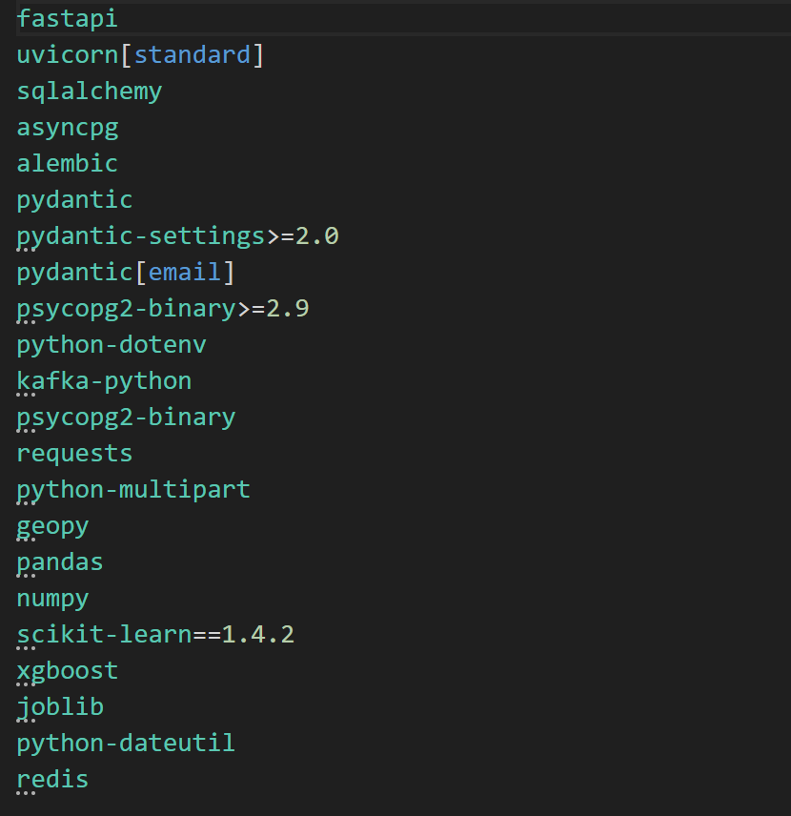

**3.2.7.9 Containerizing API using Dockerfile**

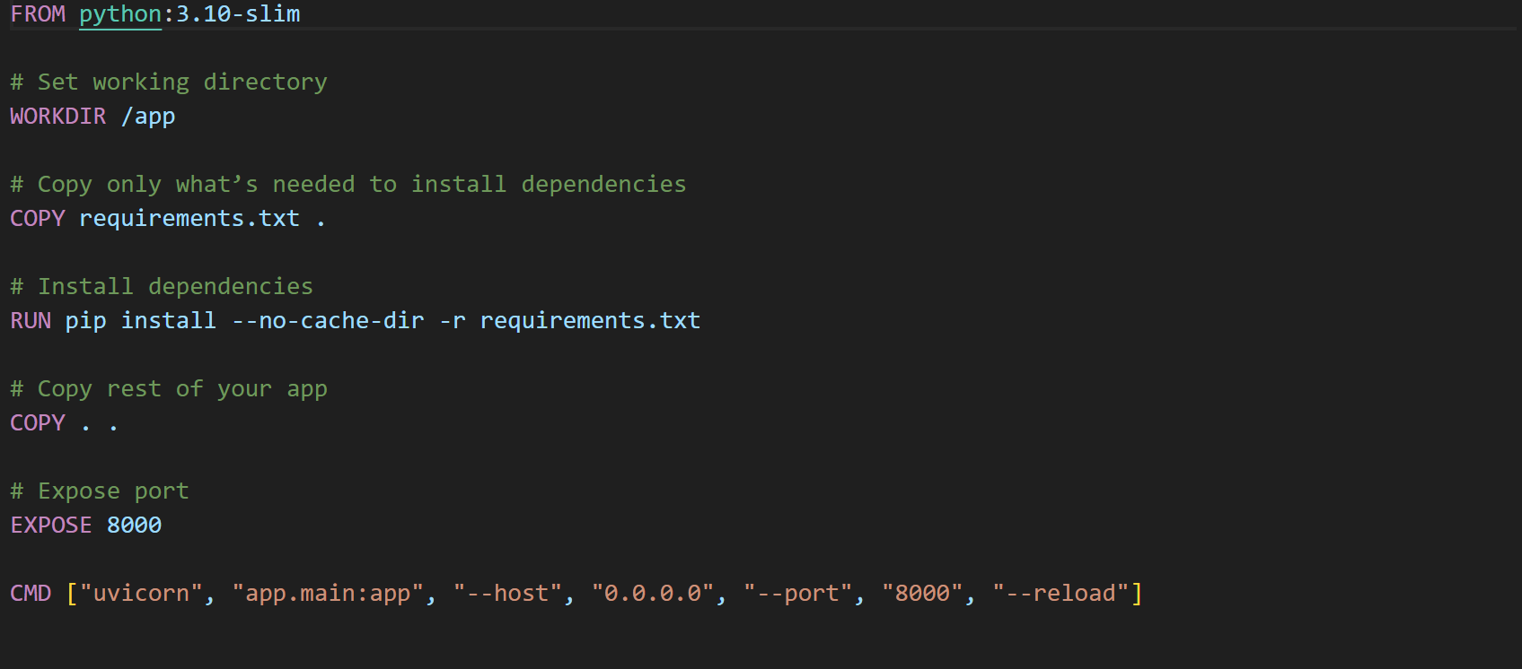

### 3.2.8 FrontEnd (ASP.Net core MVC with CesiumJS and ChartJS

This is a **.NET Core MVC web application** that functions as the frontend for a Digital Twin system. It consumes data via REST APIs, presents dashboards, and visualizes forecasts and analytics using CesiumJS, Bootstrap, and other JS libraries.

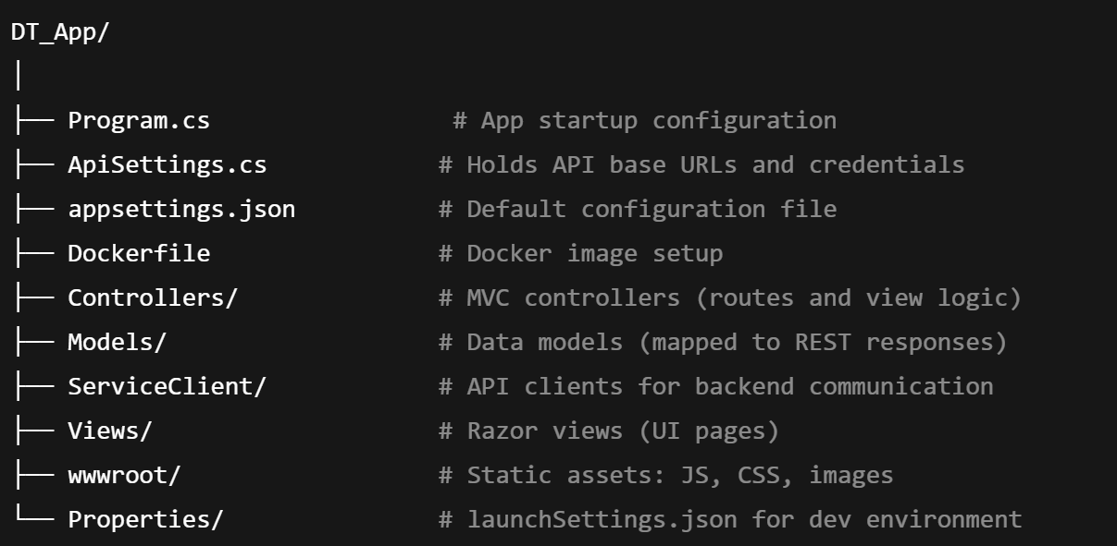

Figure 3.2.8: Frontend project directory structure

**3.2.8.1 Controllers**

**AnalyticsController.cs**

* Action: Index(DateTime queryDatetime)
* Functionality:
  + Calls Dashboard API and site API.
  + Loads AQI, traffic, and weather history for Cesium-based visualization.
  + Passes data to Views/Analytics/Index.cshtml.

**ForecastController.cs**

* Action: Index()
* Functionality:
  + Retrieves forecast data via DataClient.
  + Loads traffic and AQI forecast for display.
  + Uses CesiumJS map to display location-specific forecast data.

**HomeController.cs**

* Actions:
  + Index(): Loads landing page.
  + Privacy(): Static content page.

**3.2.8.2 Models**

Each model represents data structures received from the backend API:

* DataView.cs: Holds merged site/environmental/traffic data.
* SiteModel.cs: Defines a site (code, lat/lon, type).
* TrafficData.cs: Used for Cesium map overlay data.
* ForecastRequest.cs: Parameters for forecast queries.
* Lstm_Stats.cs / Regressor_Stats.cs: Track model performance.
* APIResponseModel.cs: Generic wrapper for REST responses.

**3.2.8.3 Service Clients**

**DashboardClient.cs**

* Method: GetDashboardData(queryDatetime)
* Fetches historical AQI, weather, traffic stats.

**DataClient.cs**

* Methods:
  + GetForecastData(): Latest forecast.
  + GetHistoricalData(queryDatetime): AQI/weather history.
* Used in ForecastController and AnalyticsController.

**SiteClient.cs**

* Method: GetSiteList()
* Returns all monitored sites metadata.

**3.2.8.4 Views**

**Views/Forecast/Index.cshtml**

* Displays CesiumJS-based map of forecast data.
* Uses Razor syntax + embedded JS.
* Calls API via controller and binds data to Cesium entities.

**Views/Analytics/Index.cshtml**

* Similar to Forecast, but loads historical AQI and traffic overlays.
* Handles color-coded ellipsoids, arrows, and points for:
  + AQI range
  + Wind direction/speed
  + Traffic density/flow

**Shared:**

* _Layout.cshtml: Master layout with nav bar, top bar, and site switcher.
  + This file is responsible for loading the CesiumJS for displaying historical or forecast data returned from API on MAP
  + It loads ChartJS for displaying model evaluation metrics
  + It also loads BootstrapJs javascript and css for look and feel and responsive UI

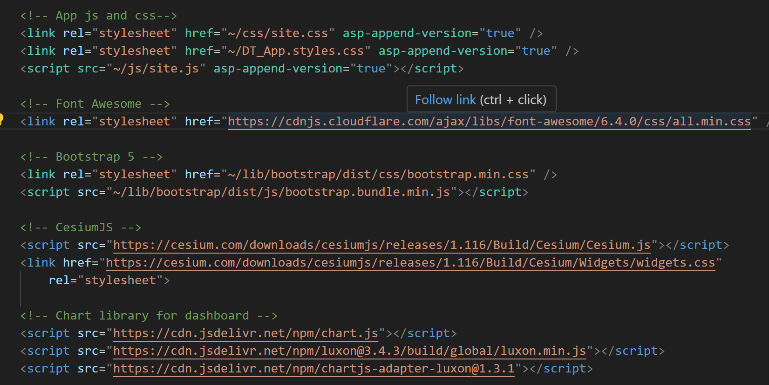

**3.2.8.5 Containerizing Frontend using Dockerfile**

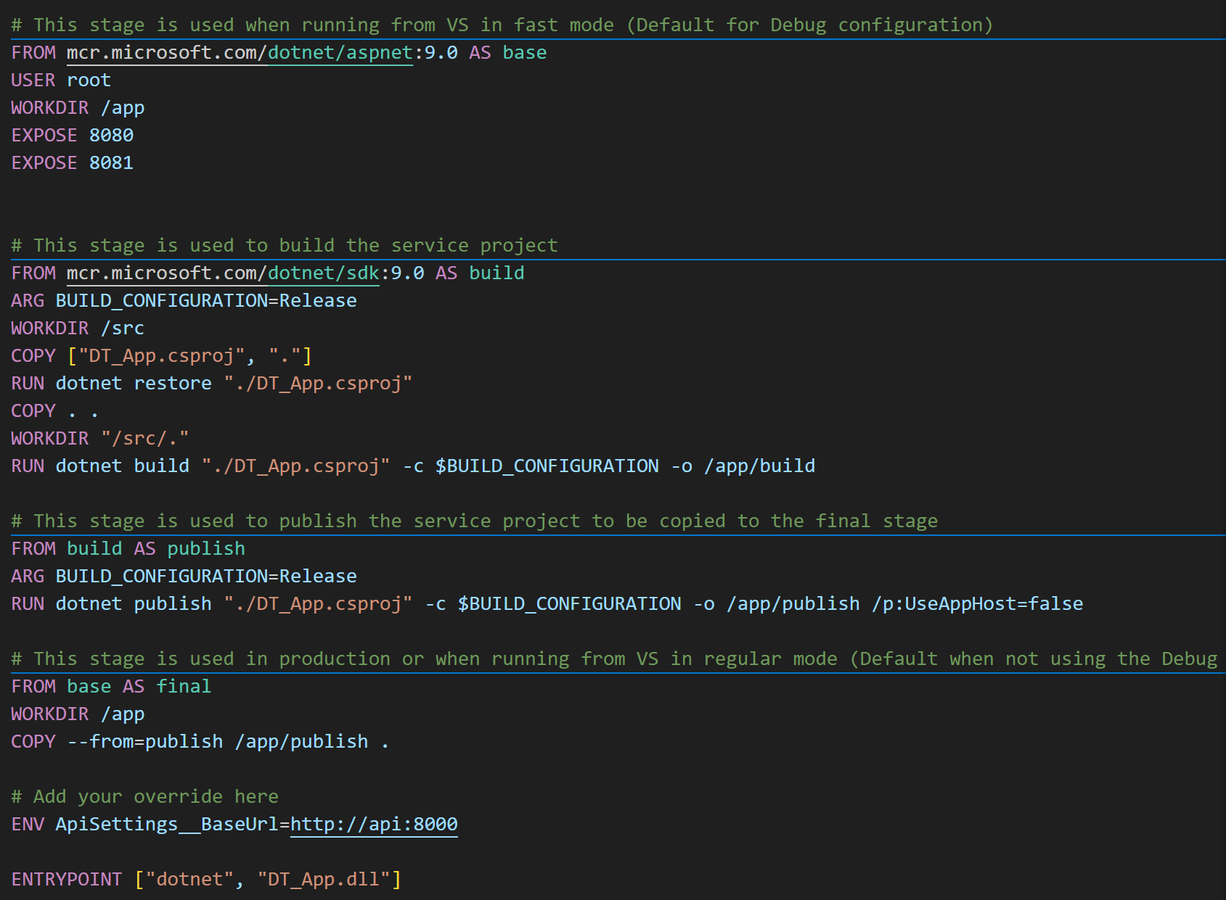

## 3.3 Deployment (On Premise)

This deployment orchestrates a full-stack data ingestion and analytics pipeline using Docker Compose. The system integrates database services, real-time data producers and consumers, API backend, frontend MVC application, message brokers, and visualization tools. Each component is containerized and coordinated using Docker's declarative syntax. The components described in this section with its configuration is deployed on docker as container using docker-compose.yml. This yml file can be used to deploy these services on cloud using AKS (Azure Kubernetes Services) or ACS (Azure Container Services). However, for this project docker is used and frontend is exposed using Cloudflare tunnelling as described in this section.

### 3.3.1 Running Core Services

**3.3.1.1 PostgreSQL Database (db)**

* Uses the postgres:latest image.
* Stores structured data such as traffic, AQI, and weather records.
* Configuration:
  + User: postgres
  + Password: Admin123
  + Database: mscds
* Data is persisted using a Docker volume named pgdata.

**3.3.1.2 PGAdmin (pgadmin)**

* Provides a GUI for managing the PostgreSQL database.
* Exposed on host port 5050.
* Uses pgadmin_data volume for persistence.
* Credentials:
  + Email: manas.p.pandey@outlook.com
  + Password: Admin@123

### 3.3.2 Running Messaging and Streaming Services

**3.3.2.1 Apache Kafka (kafka)**

* Based on apache/kafka:latest.
* Runs in KRaft mode (self-managed, no Zookeeper).
* Exposes port 9092 for internal communication.
* Automatically creates topics for ingestion services.

**3.3.2.2 Kafdrop (kafdrop)**

* UI for inspecting Kafka topics and messages.
* Connected to Kafka at kafka:9092.
* Exposed on port 9000.

### 3.3.3 Running Real-time Ingestion Services

**3.3.3.1 main_producer**

* Built from ./ingestion_service.
* Executes main_producer.py which:
  + Fetches external AQI/weather data.
  + Generates synthetic traffic using LSTM/ALSTM.
  + Pushes results to Kafka topics.
* Depends on kafka, db, redis, and main_consumer.

**3.3.3.2 main_consumer**

* Also built from ./ingestion_service.
* Executes main_consumer.py, which listens on Kafka topics and stores data in PostgreSQL.
* Depends on kafka and db.

### 3.3.4 Caching and Feature Store

**3.3.4.1 Redis (redis)**

* Provides fast in-memory storage for features, models, and intermediate values.
* Exposed on port 6379.
* Uses volume redis_data and has password set via REDIS_PASSWORD.

**3.3.4.2 Redis Commander**

* Web interface for managing Redis.
* Accessible via port 8081.
* Authenticated using admin/Admin123.

### 3.3.5 API Backend and Frontend UI

**3.3.5.1 REST API (api)**

* Built from ./RESTAPI with a specified Dockerfile.
* Exposes endpoints on port 8000.
* Loads environment config from .env file and supports:
  + Forecast retrieval
  + Model upload
  + Site/user management
* Communicates with Redis, Kafka, and PostgreSQL.

**3.3.5.2 MVC Web App (mvcapp)**

* Built from ./DT_App.
* ASP.NET Core MVC frontend served on port 8080.
* Calls REST API (api) to visualize historical and forecast data using CesiumJS.

### 3.3.6 Volumes

Declared named volumes for persistent data:

* pgdata → PostgreSQL
* pgadmin_data → pgAdmin
* redis_data → Redis

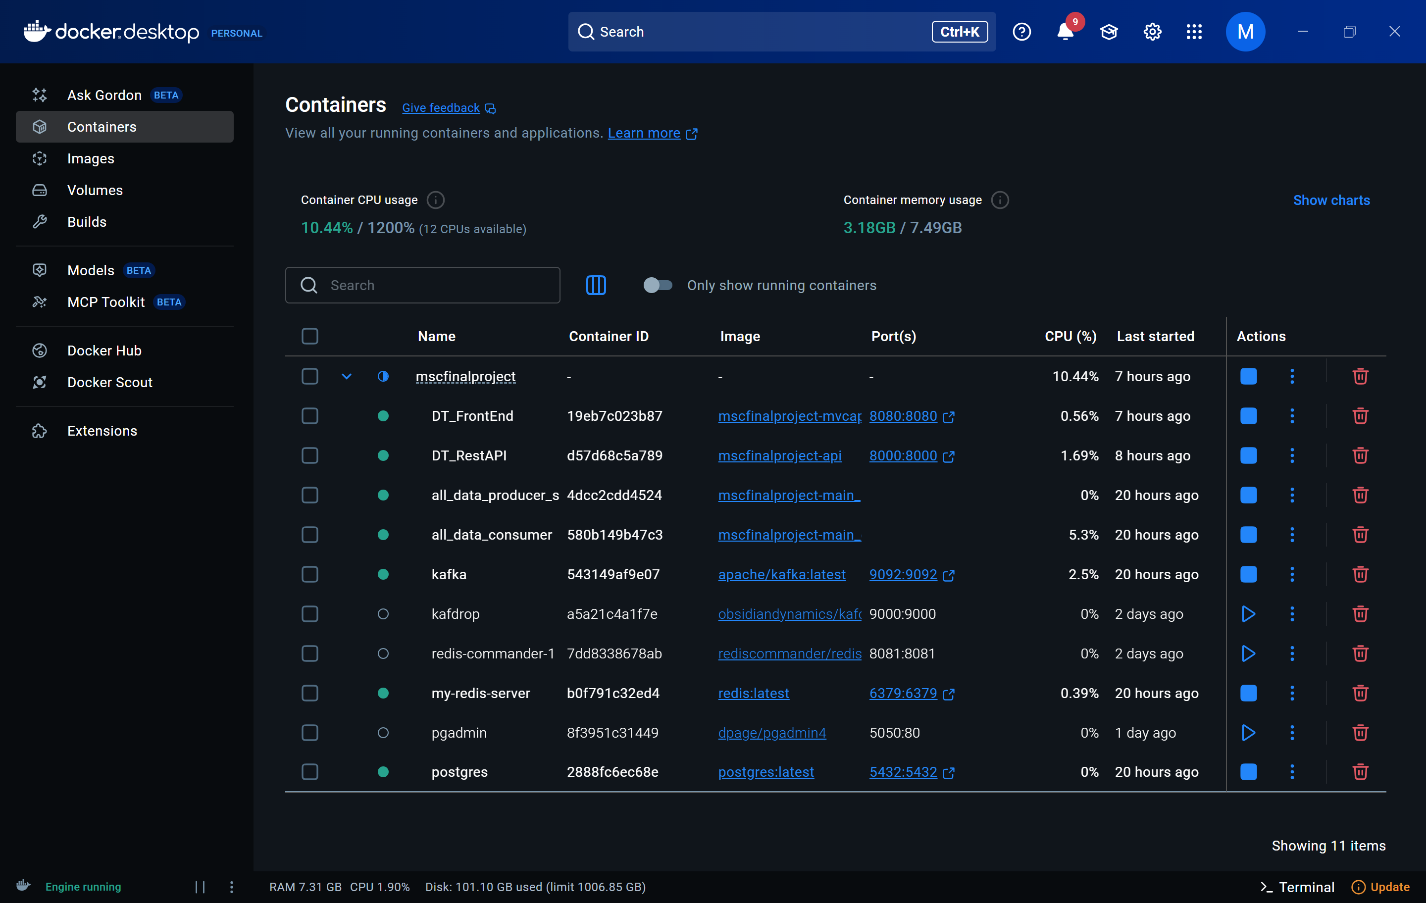

Figure 3.3.6: Running components as containers in docker using docker-compose.yml

### 3.3.7 Exposing FronEnd Port from Docker to Web using Cloudflared Tunnelling

This section describes how to expose the application running on docker to web using Cloudflared tunnelling which helps redirect request coming to a domain on Cloudflared to the localhost port using a tunnel. The requests are secures using HTTPS which is installed as certificate by the Cloudflared service on creation.

**Step 1. Install and Verify Cloudflared**



**Step 2. Authenticate Cloudflare Tunnel**



This will open a browser window to authenticate with your Cloudflare account.

**Step 3. Test Tunnel Locally**



You should see:  
**“Your tunnel is live!”**  
But this is temporary and not yet associated with a domain.

**Step 4. Create Persistent Tunnel and Domain**

Create named tunnel:



Map domain to this tunnel:



**Step 5. Create Tunnel Config File**

Navigate to:



Create a file called config.yml with the following content:

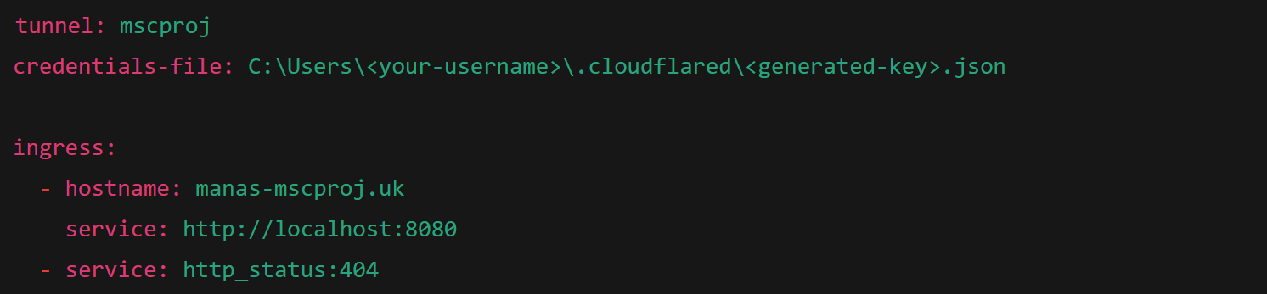

Replace <your-username> and <generated-key>.json with your actual user and key filename.

**Step 6 Run Tunnel manually, or using a run.bat file as shown below**

To run manually



To run as a service

Create a bat file and register a service with reference to the bat file with elevated privileges

Run.bat



Following the steps mentioned in this section we will be able to access the application using a domain name which in this case is

<https://manas-mscproj.uk>

# Chapter 4 - Evaluation and Results

## 4.1 Related Works

The evaluation results align closely with several contemporary research efforts in urban AI and Digital Twins. For example, Raheja and Malik [10] showed that Adaptive LSTM outperforms LSTM and SVR in predicting pollution trends—a claim substantiated here with the high test accuracy (79.27%) observed in the A-LSTM implementation.

Similarly, García and Ortega [5] demonstrated that XGBoost could forecast AQI with high accuracy across noisy urban datasets. In this project, the XGBoost model reached R² values above 0.93 for key pollutants like CO and NO₂, confirming its suitability for complex multivariate forecasting.

From a systems perspective, the simulation framework shares similarities with that of Teutscher et al. [2], who employed a web-based Digital Twin to simulates pollution dispersion and allows testing of planning scenarios. This project extends their approach by including traffic synthesis via ML and exposing real-time forecasts in a 3D environment.

The integration of machine learning, Kafka streaming, and CesiumJS visualization represents a novel contribution in terms of real-time responsiveness and simulation interactivity. This places the project at the intersection of smart city research, geospatial intelligence, and interpretable AI for policy modeling.

Together, the related works validate the design decisions made and confirm the academic and practical relevance of the evaluation outcomes.

## 4.2 Evaluation Strategy

The evaluation of the Machine Learning-enhanced Digital Twin developed for Westminster, London was approached through a combination of model performance metrics, scenario-based testing, and usability validation. The intention was to thoroughly assess the accuracy, scalability, and usability of each component of the system, including backend models, data handling pipelines, and the frontend user interface.

The primary focus of evaluation was three-fold: first, to quantitatively assess the prediction accuracy of the A-LSTM and XGBoost models for traffic generation and air quality forecasting respectively; second, to evaluate the functional integration of those predictions within a live, user-accessible simulation dashboard; and third, to consider user-facing outcomes such as the interpretability of data visualization and responsiveness of the simulation tools.

The methodology employed was designed to reflect real-world urban management use cases. Rather than relying solely on theoretical metrics or offline datasets, the evaluation pipeline was based on real-time data flow from OpenWeatherMap API. These were ingested continuously and processed through Kafka, with outputs logged and visualized within PostgreSQL tables and CesiumJS maps. Each model's output was cross-validated and logged for performance trend analysis.

In addition to internal metrics, simulations were conducted under different urban scenarios. For example, simulated traffic congestion or weather changes were used to assess the model’s capability to generate plausible, real-time forecast adjustments. Informal walkthroughs of the user interface were also conducted to assess its intuitiveness and interpretability by city planners or data analysts.

Taken together, these multi-faceted evaluation strategies provided a robust assessment of system functionality, predictive reliability, and stakeholder utility.

## 4.3 Evaluation of Machine Learning Models

The Digital Twin system includes two key predictive models: an Adaptive Long Short-Term Memory (A-LSTM) model for generating synthetic traffic flow data, and an XGBoost regressor model for forecasting air quality index (AQI) and associated pollutants. These models were evaluated using appropriate metrics reflecting classification and regression domains respectively.

The A-LSTM model was developed to overcome the challenge of sparse traffic data in Westminster. By learning temporal patterns from AQI and weather datasets, the model was capable of predicting one of five categorical traffic flow states: low, moderate_low, moderate, moderate_high, and high. Training was conducted on 24-hour sequences with 17 features, using z-score normalized inputs and dropout layers to prevent overfitting. Evaluation results revealed the updated A-LSTM model achieved an accuracy of 79.27% on the test set, significantly outperforming the LSTM model baseline which reached only 39.16%. This marked improvement supports prior literature indicating that A-LSTM outperforms traditional LSTM and hybrid SVR models in sequence forecasting.

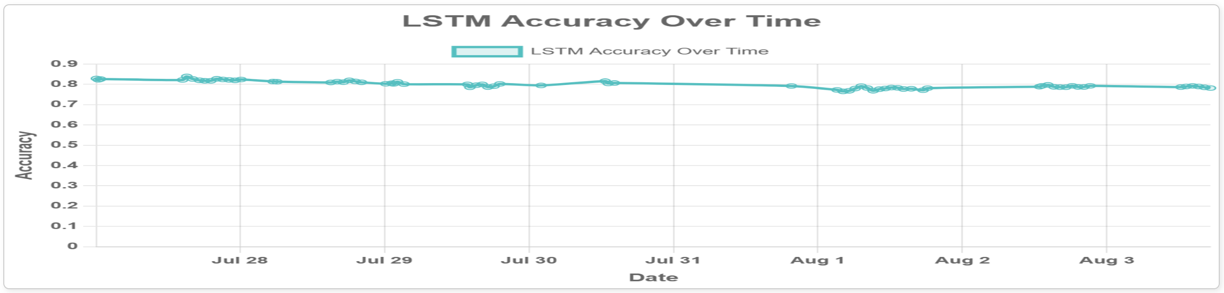

Figure 4.2(a): A-LSTM classification metrics

The XGBoost model was employed to forecast AQI and pollutant levels for pollutants including PM2.5, NO₂, CO, and O₃. Each target pollutant was modeled using its own independent regressor with weather, temporal, and synthetic traffic features as inputs. Evaluation metrics used were RMSE, MAE, and R², recorded directly in the regressor_stats PostgreSQL table. The R² values exceeded 0.88 for most pollutants and reached as high as 0.994 for NO₂, validating the model's ability to generalize well to new data. MAE and RMSE scores were also within acceptable error margins, with AQI forecasting showing particularly consistent results. The retraining pipeline ensured these metrics remained up-to-date, reinforcing the model’s adaptability.

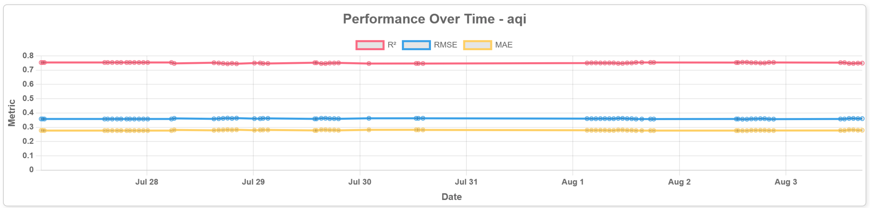

Figure 4.2(b) XGBoost regressor metrics for AQI

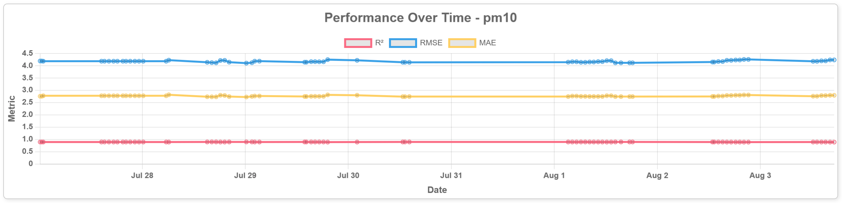

Figure 4.2(c) XGBoost regressor metrics for PM10

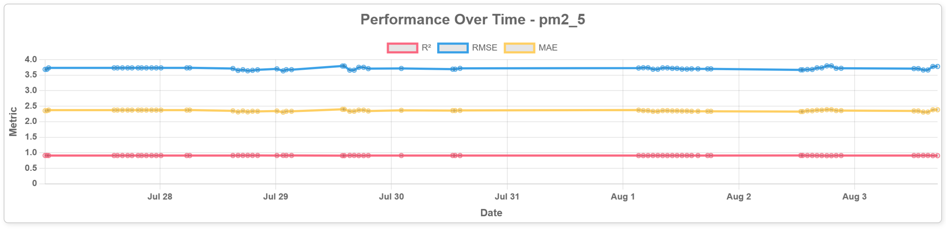

Figure 4.2(d) XGBoost regressor metrics for PM2.5

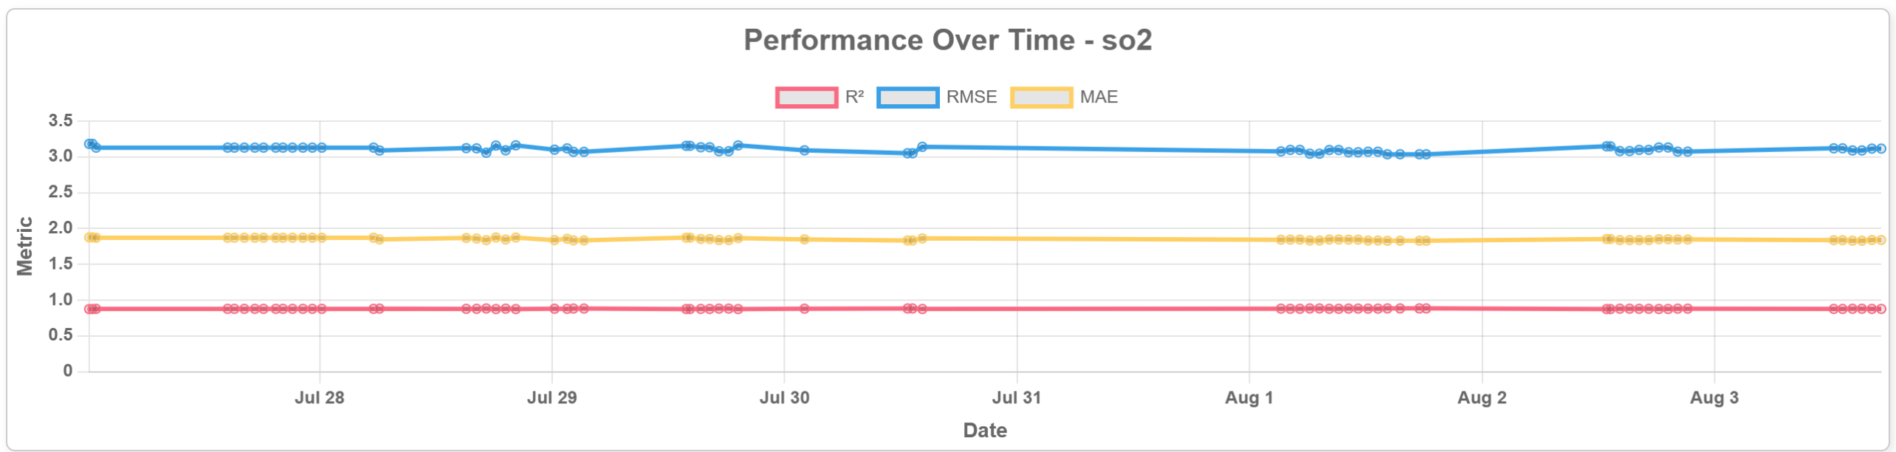

Figure 4.2(e) XGBoost regressor metrics for SO2

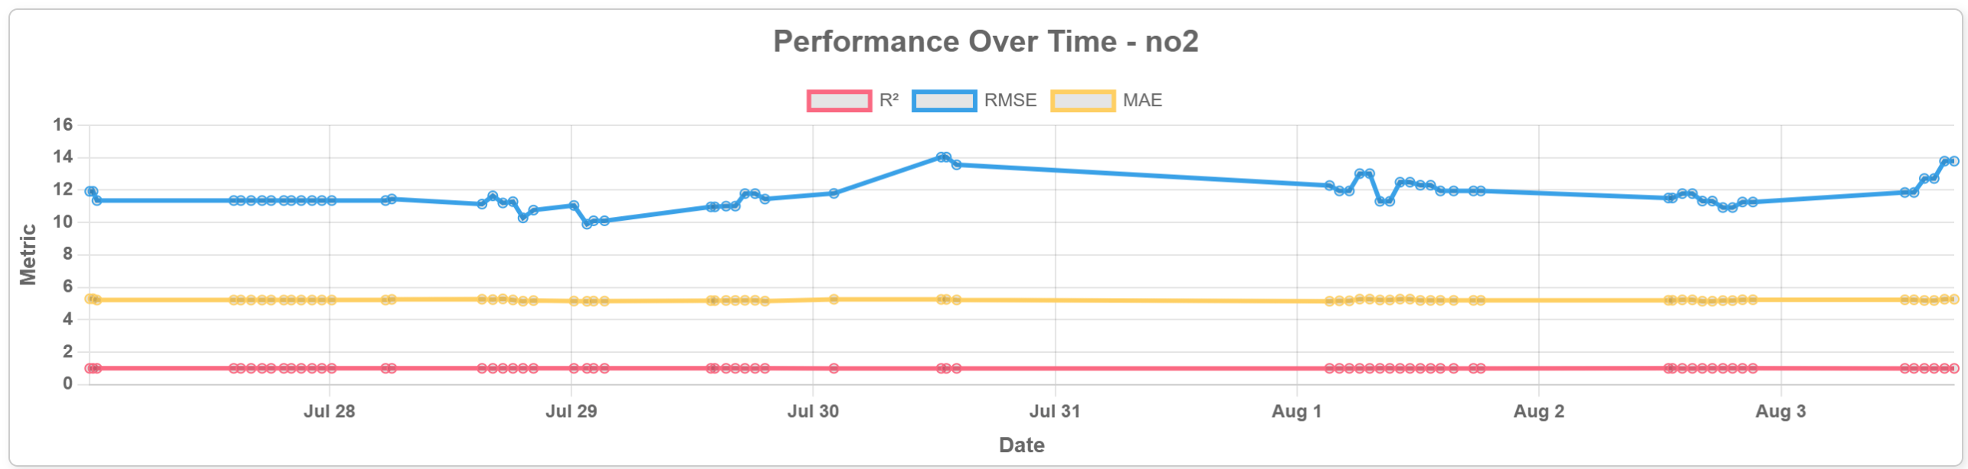

Figure 4.2(f) XGBoost regressor metrics for NO2

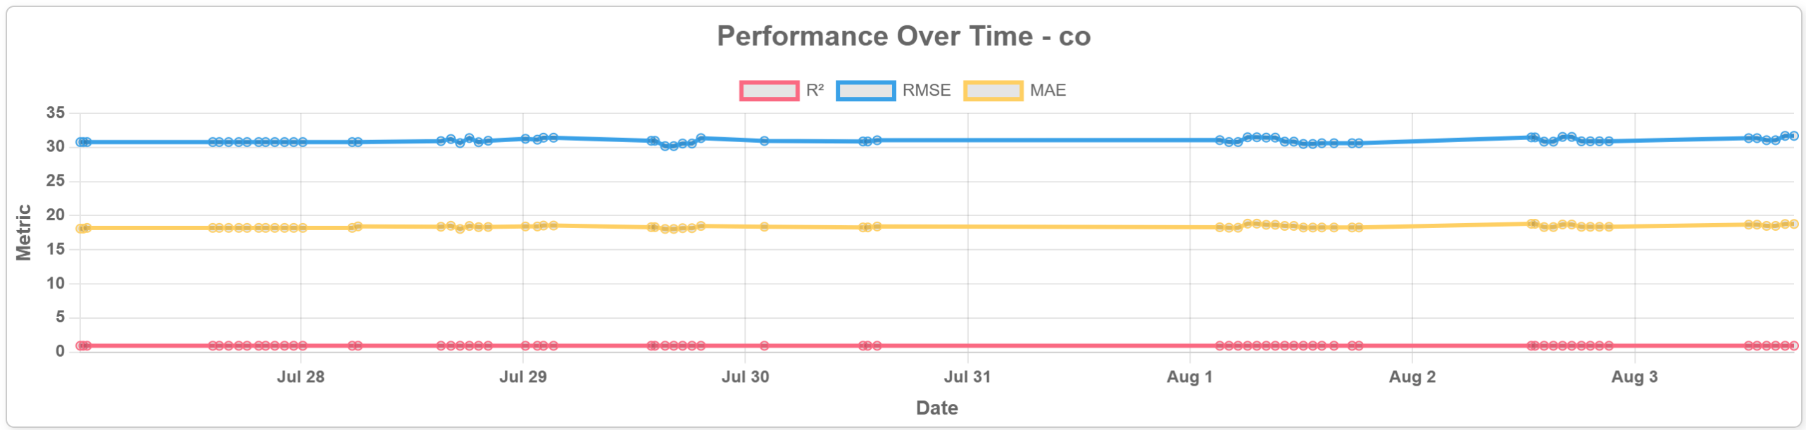

Figure 4.2(g) XGBoost regressor metrics for CO

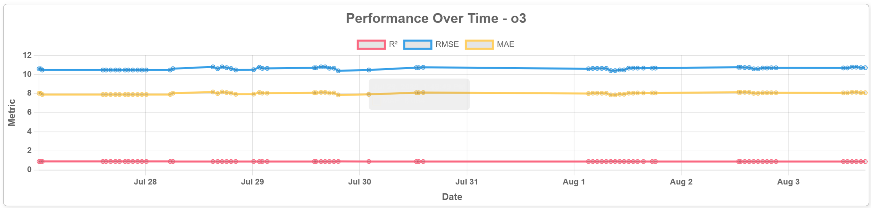

Figure 4.2(h) XGBoost regressor metrics for O3

These results confirm that the combination of A-LSTM and XGBoost provides an effective pipeline for simulating urban traffic and predicting environmental impact in near-real time.

## 4.4 Scenario Simulation and Forecast Validation

To validate how the models operate in practice, scenario simulations were conducted using the Digital Twin frontend. The web-based interface, developed using ASP.NET MVC and CesiumJS, enabled users to explore historical data overlays, real-time forecasts, and simulated interventions through an interactive 3D map interface.

In the simulation framework, traffic levels at each site could be altered by the user, serving as a primary controllable parameter for AQI forecasting. Conversely, weather data—including temperature, humidity, wind speed, and pressure—was sourced in real-time from the OpenWeatherMap API, offering up to four days of fixed forecasts. This hybrid input design allowed realistic scenario modeling, where traffic conditions could be adjusted while weather patterns remained anchored in externally validated projections.

For instance, one test scenario involved artificially increasing traffic flow at Oxford Street during peak commuting hours. Upon submitting this change, the Digital Twin recomputed AQI forecasts using the XGBoost model and returned elevated NO₂ levels at Oxford Street and surrounding sites. The predicted increase in NO₂ concentrations—ranging from 12% to 15% compared to the baseline forecast—was consistent with established literature on the impact of traffic emissions on urban air quality. This confirmed that the model responded accurately to modified traffic inputs while holding meteorological influences constant.

In contrast, weather conditions could not be directly manipulated. For example, during one evaluation window, OpenWeatherMap reported incoming low-pressure and high-humidity conditions for the Victoria Embankment area. Without user intervention, the system forecasted higher PM2.5 retention due to atmospheric stagnation—an effect that was visualized as denser ellipsoids on the CesiumJS map. This scenario highlighted the influence of weather on AQI levels while demonstrating the system’s ability to integrate third-party forecast data dynamically.

Visual overlays on the map provided an intuitive interface for analyzing these simulations:

* Color-coded ellipsoids represented AQI intensity zones.
* Directional arrows and its length indicated wind direction and speed, respectively.
* Labeled circular markers conveyed traffic flow density, which changed dynamically based on user input.

The successful execution of these simulations demonstrated several key capabilities of the system:

* The model pipeline was robust and responsive, with altered inputs reflecting forecast updates within seconds.
* The separation of static (weather) and dynamic (traffic) inputs made the interface both realistic and user-controllable.
* The visual feedback on traffic interventions provided urban planners with an intuitive tool to assess short-term environmental outcomes.

Overall, these evaluations reinforced the predictive reliability, architectural robustness, and user-facing clarity of the system, validating its application as a real-time planning and decision-support tool in the context of urban mobility and environmental health.

## 4.5 Usability and Functional Evaluation

Although no formal usability study was performed, the functionality of the frontend interface was validated through structured testing and feedback sessions with prospective users such as urban analysts and research supervisors. The goal was to determine whether the CesiumJS map-based simulation environment allowed for intuitive exploration and decision-making support.  
  
Key usability features included:

Ellipsoids represented AQI ranges, wind direction arrows conveyed meteorological data, and dots encoded traffic density. These visuals were dynamically refreshed using REST API data, ensuring up-to-date information.

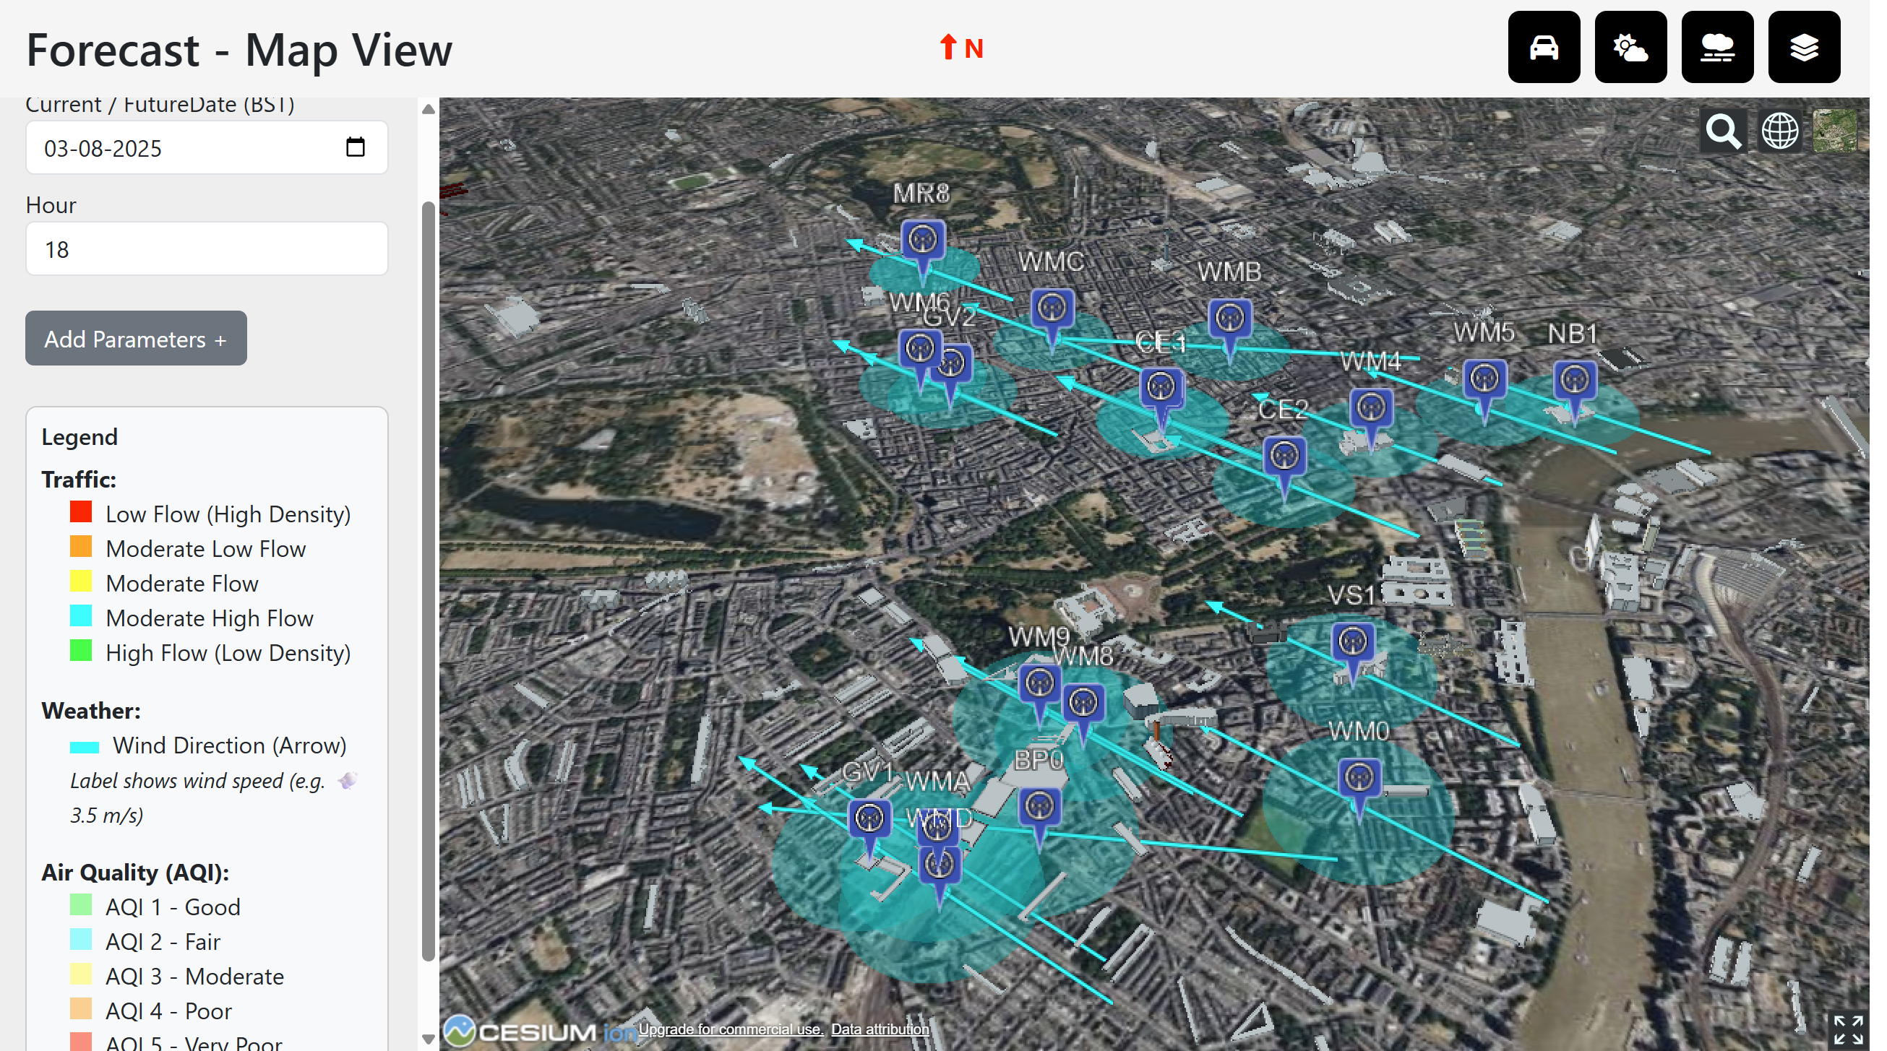

Figure 4.4 Forecast Screen with elements

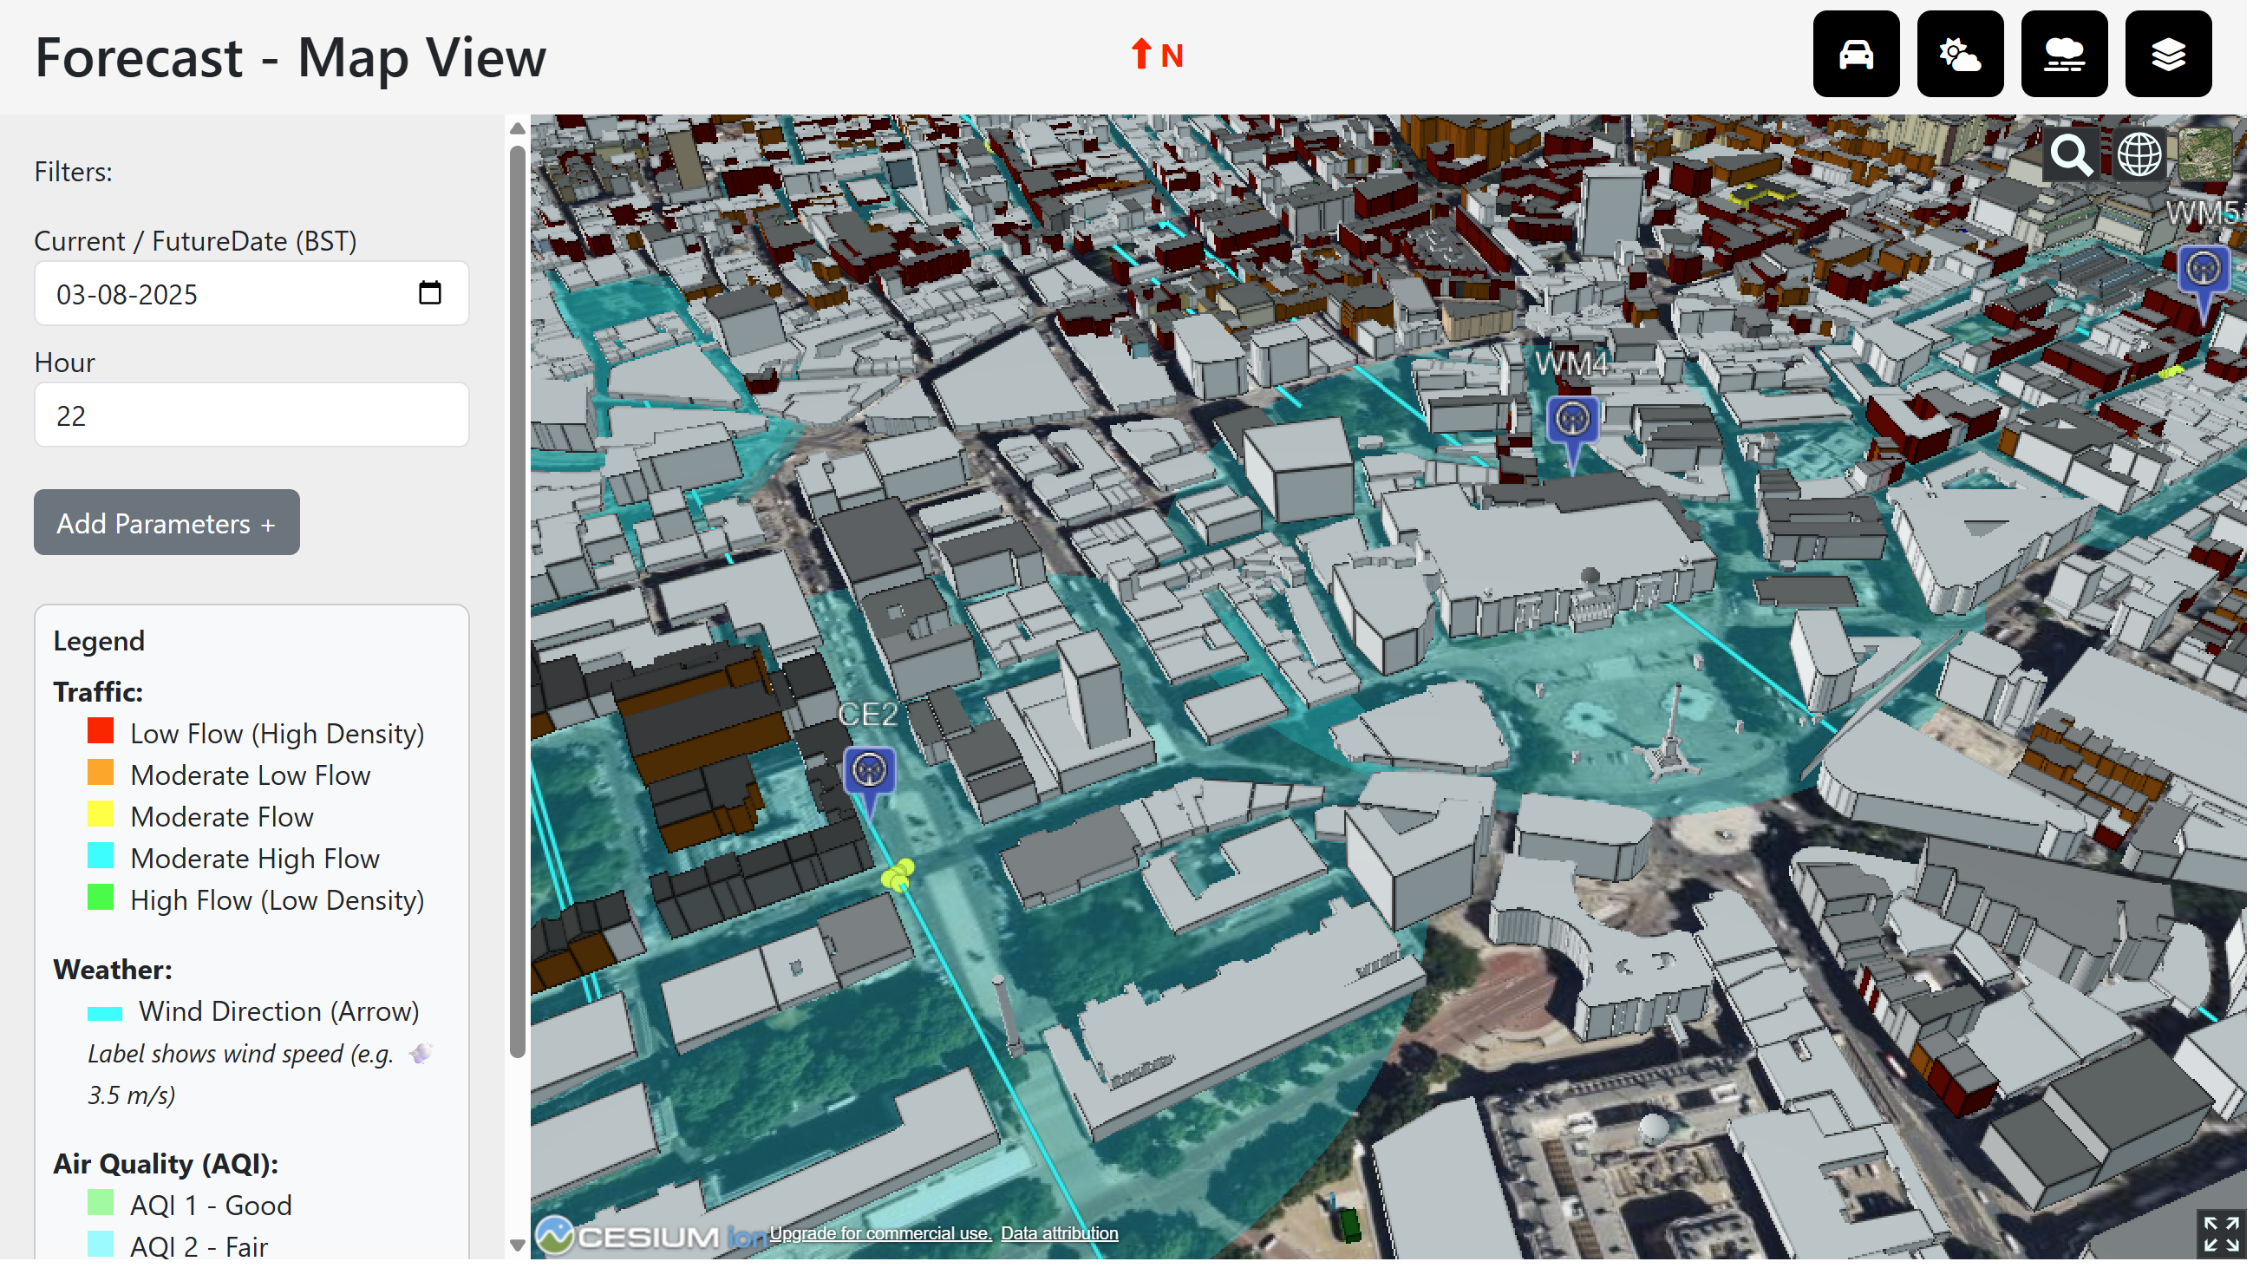

Figure 4.4 Forecast screen with traffic density as yellow dots

Users could specify traffic categories and forecast targets, triggering new inference calls. Results were reflected within seconds on the visualization panel.

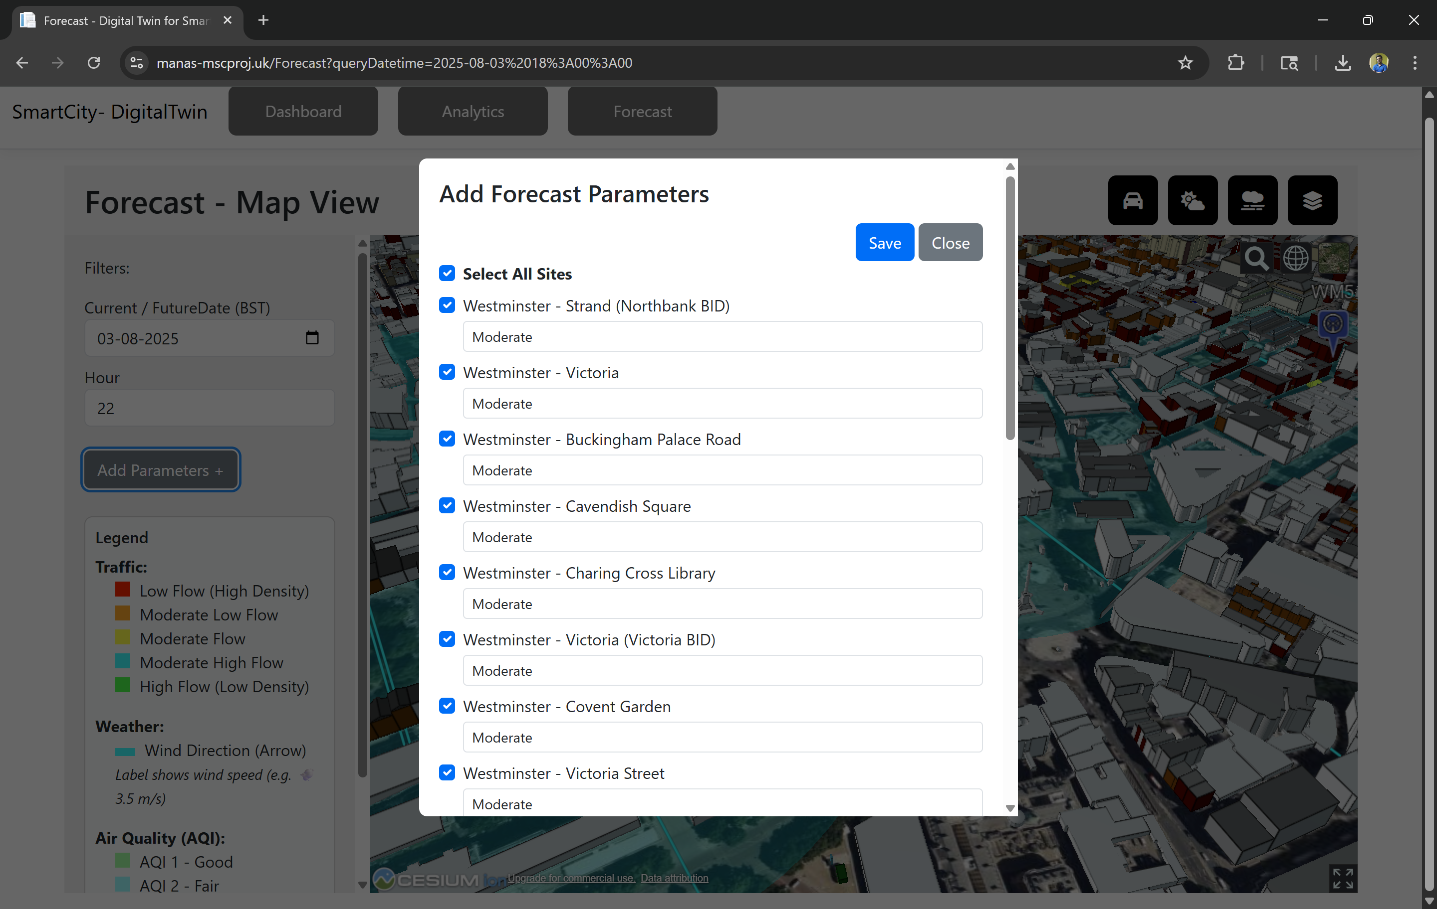

Figure 4.4 Forecast parameters to guide scenarios

Using ChartJS, model performance metrics were presented as line charts with interactive tooltips showing historical changes in RMSE, MAE, and classification accuracy. This view enabled quick monitoring of retraining quality.

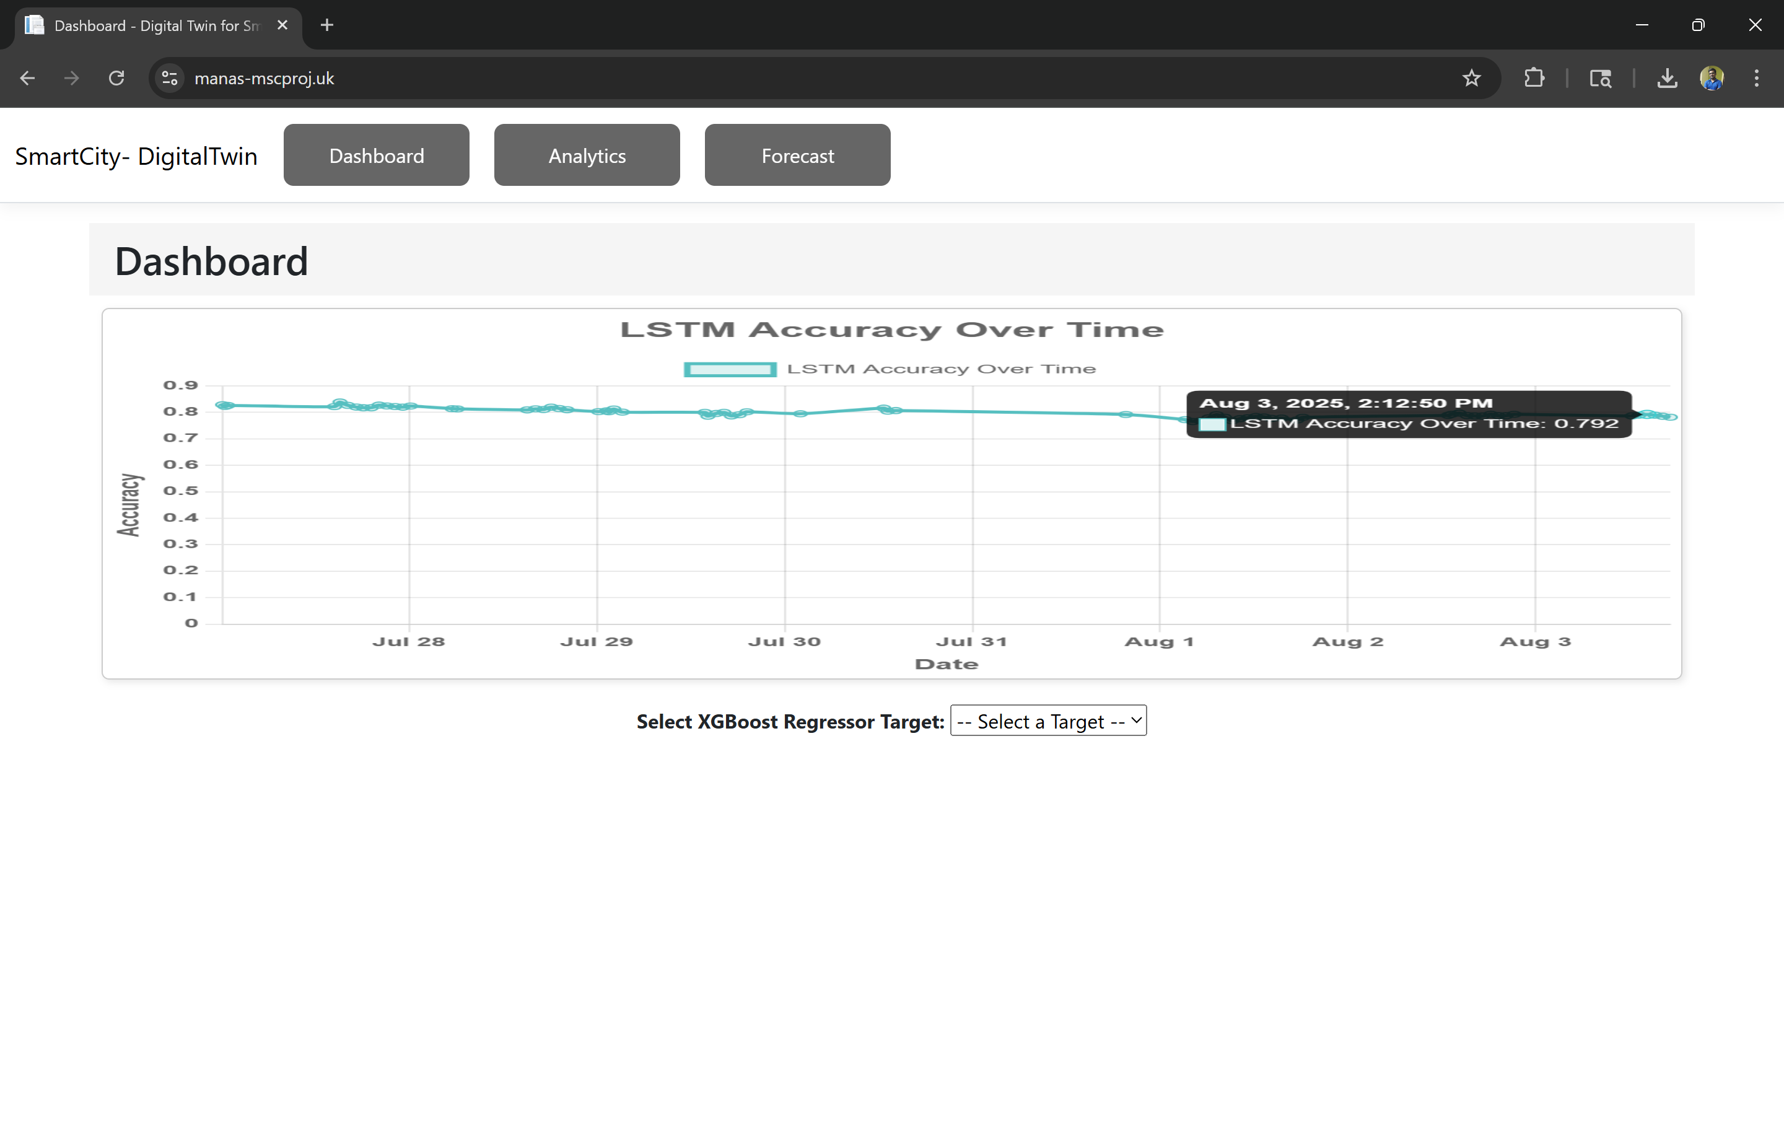

Figure 4.4 A-LSTM metrics on chart for interative visualization

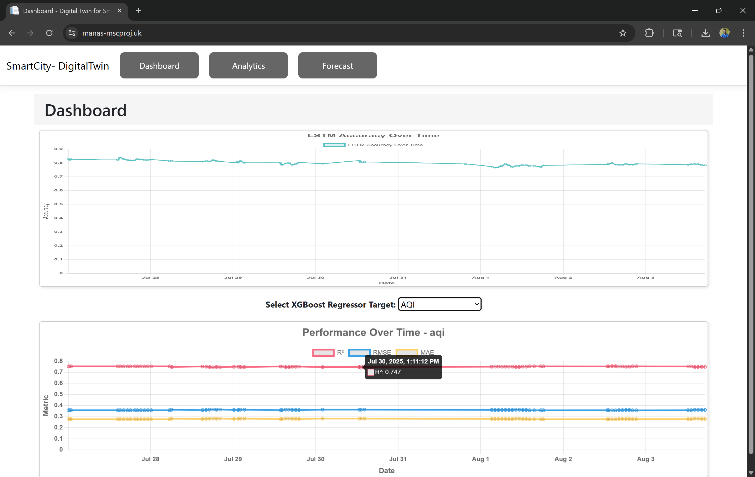

Figure 4.4 XGBoost regressor metric chart for interactive visualization

The top navigation bar provided direct access to historical views, forecast simulations, and model performance dashboards. Components such as spinners and alert boxes ensured feedback loops for user actions.



Figure 4.4 Navigation buttons for the application

The system was successfully deployed using Docker Compose and made publicly accessible using Cloudflare tunnels with HTTPS support. This made it possible to conduct evaluations on real browsers over internet connections, ensuring consistent cross-platform compatibility.  
  
In informal walkthroughs, users reported that the color-coded overlays and interactive site selection helped them understand complex urban dynamics more easily. This indicates that the frontend achieved its objective of making sophisticated ML forecasts accessible to non-technical stakeholders.

## 4.6 Limitations

Despite promising results, the project encountered several limitations:

**Sparse Ground Truth Traffic Data**

Synthetic traffic data was generated via ML models rather than real sensors, which limited its validation against actual conditions. Although the A-LSTM model performed well on internal metrics, its accuracy in edge-case scenarios remains uncertain.

**Computational Overhead**

CesiumJS visualizations, particularly with 3D buildings and layered entities, introduced rendering lag on older devices. The system may require performance optimizations or fallback modes for broader accessibility. However, compared to GPU intensive maps for native window application this is more flexible and renders on browser and doesn’t need multi-core GPU to render it.

**Model Drift**

While retraining pipelines were established, they were still reactive rather than proactive. Unforeseen changes in weather patterns or road policies could cause the models to degrade before retraining triggers.

**Data Quality Fluctuations**

Open APIs occasionally returned incomplete or delayed data, introducing inconsistencies in training inputs. This issue was partly mitigated using Redis for temporal smoothing, but some noise remained.

**Evaluation Constraints**

The absence of formal usability testing limited the project's ability to quantify human factors or user satisfaction. Future evaluations should include structured usability studies with stakeholders like planners or citizens.

These limitations reflect broader challenges in deploying real-time urban Digital Twins and present opportunities for future enhancements.

# Chapter 5 – Conclusion

This project set out to develop a real-time, machine learning-enhanced Digital Twin for Westminster, London, integrating smart mobility and environmental data for predictive urban decision-making. Through the combination of Adaptive Long Short-Term Memory (A-LSTM) networks for traffic synthesis and XGBoost regressors for air quality prediction, the system demonstrates a robust end-to-end solution that encompasses data ingestion, real-time forecasting, and interactive 3D visualization.

The Digital Twin architecture—comprising Kafka-based data pipelines, Redis caching, PostgreSQL storage, FastAPI for RESTful services, and a CesiumJS-powered frontend—was successfully implemented and deployed using Docker containers. Cloudflare tunnelling enabled secure, internet-accessible visualization.

The project met all its defined objectives:

* **Data acquisition and integration**: Successfully ingested real-time traffic, weather, and AQI data from TfL, OpenWeatherMap, and LondonAir APIs.
* **System architecture and backend**: Developed a modular, containerized backend with retrainable ML pipelines.
* **ML model implementation**: Integrated A-LSTM for synthetic traffic classification and XGBoost for pollutant forecasting, with performance metrics stored and visualized dynamically.
* **Interactive frontend**: Designed a 3D dashboard enabling historical analytics, real-time forecasts, and user-defined scenario simulations.
* **Scenario testing and validation**: Demonstrated the impact of traffic adjustments on AQI levels in a controlled, reproducible environment.
* **Evaluation and usability testing**: While formal usability studies were not conducted, walkthroughs and informal tests confirmed the system’s responsiveness, accessibility, and interpretability.

Ultimately, the system has proven that integrating real-time mobility and environmental data into a unified Digital Twin framework—enhanced with interpretable ML models—can significantly aid city planners and stakeholders in scenario-based decision making. The separation of dynamic traffic input and static weather forecasts further contributed to a realistic, responsive forecasting engine that reflects real-world constraints.

## 5.1 Future Work

Although the current system is functional and impactful, several avenues for future work have emerged:

**1. Integration of Real-Time Traffic Sensors**

While the A-LSTM model effectively synthesizes traffic data, real-time traffic sensors or computer vision systems could provide more accurate ground-truth measurements. Integration with live feeds would improve validation and reduce reliance on synthetic generation.

**2. Proactive Model Adaptation**

Currently, the retraining pipeline is triggered manually or on schedule. Future iterations could implement anomaly detection or concept drift monitoring to proactively trigger model retraining when performance deteriorates.

**3. Expansion of Environmental Parameters**

The AQI model focuses on key pollutants like NO₂ and PM2.5. Future expansions could include noise pollution, pollen concentration, or vehicular carbon footprint metrics to provide a more holistic environmental model.

**4. Support for Policy Simulations**

While the frontend allows for adjusting traffic levels, additional modules could simulate policy interventions (e.g., congestion charges, bus-only zones, or green corridors), integrating their long-term environmental and economic impacts.

**5. Mobile and AR Integration**

A companion mobile app or Augmented Reality (AR) integration could increase public engagement. Citizens could explore pollution data and traffic forecasts in situ, enabling participatory planning.

**6. Formal Usability and Stakeholder Testing**

Engaging with local councils or urban design consultants for structured usability tests could validate the system’s real-world utility. Eye-tracking studies, A/B testing, and interviews would provide insights for further improvements.

**7. Cloud-Based Scalability**

Though Docker containers served well for development and testing, scaling to larger areas or integrating with external urban platforms would benefit from Kubernetes-based deployments or migration to cloud platforms like Azure or AWS.

## 5.2 Reflection

Reflecting on the project lifecycle reveals a steep learning curve, significant personal development, and areas where hindsight offers valuable lessons.

**What Went Well:**

* **Technical Mastery**: Proficiently orchestrating a full-stack system using Kafka, Redis, PostgreSQL, FastAPI, CesiumJS, and Docker was a highlight. Each tool was integrated in line with best practices.
* **Model Performance**: The use of A-LSTM and XGBoost demonstrated solid predictive power, with the A-LSTM model improving classification accuracy from 39% to over 79%.
* **Scenario Simulation**: The interactivity and realism of the CesiumJS-based frontend surpassed initial expectations. This makes presentation of data intuitive and informative.
* **DevOps and Deployment**: Automating deployment using Docker Compose and exposing the frontend via Cloudflare tunnels made the application easily testable across devices and networks.

**Challenges and Limitations:**

* **Data Gaps**: Lack of real-time, high-resolution traffic data led to reliance on synthetic generation. This introduced assumptions that could affect model generalizability.
* **Formal Evaluation**: Without structured usability studies, conclusions about user engagement remain qualitative rather than empirical.

**Lessons Learned:**

* **Planning and Modularity Matter**: The modular architecture allowed parallel development and easier debugging. This confirmed the importance of clean interfaces and separation of concerns.
* **Interdisciplinary Thinking**: Bridging geospatial systems, real-time data engineering, and ML required adopting a multi-disciplinary mindset.
* **User-Centric Design**: Complex systems must still be intuitive. Designing with the end-user in mind (urban planners, analysts) helped focus the frontend development.

**In Hindsight:**

* A more data-driven approach to frontend UX design (e.g., heatmaps of user interaction, structured feedback forms) could have yielded deeper insights.
* Greater emphasis on CI/CD pipelines and container orchestration (e.g., Kubernetes) would have enhanced scalability.
* Early collaboration with local authorities or academic partners could have added domain-specific realism and opened avenues for deployment.

In conclusion, this project represents a comprehensive, interdisciplinary effort to harness machine learning and digital twin technologies for urban foresight. It underscores the power of predictive analytics when embedded in interactive, real-time systems and lays the groundwork for smarter, more sustainable urban governance in the era of data-driven cities.

# References

[1] Y. Bai, W. Zhou, Y. Shi, J. Yang, and J. Yu, “Digital Twins of Urban Air Quality: Opportunities and Challenges,” *IEEE Communications Magazine*, vol. 59, no. 10, pp. 68–74, Oct. 2021, doi: 10.1109/MCOM.001.2000876.

[2] R. M. Taylor, M. A. Osborne, and C. L. Brunsdon, “A Digital Urban Twin Enabling Interactive Pollution Predictions,” *Environmental Modelling & Software*, vol. 160, pp. 105297, Mar. 2023, doi: 10.1016/j.envsoft.2023.105297.

[3] C. M. Flack, H. Smith, and J. Williams, “Navigating Urban Complexity: The Transformative Role of Digital Twins in Smart City Development,” *Cities*, vol. 135, pp. 104087, Feb. 2023, doi: 10.1016/j.cities.2022.104087.

[4] M. Sharma and A. Jain, “Machine Learning Applications in Vehicular Traffic Prediction and Congestion Control,” *Journal of Big Data*, vol. 8, no. 1, pp. 1–25, Apr. 2021, doi: 10.1186/s40537-021-00444-2.

[5] M. S. Darbandi and H. T. Shahraki, “Machine Learning Algorithms to Forecast Air Quality,” *Environmental Science and Pollution Research*, vol. 28, pp. 46348–46363, Oct. 2021, doi: 10.1007/s11356-021-14845-1.

[6] N. K. Verma and S. Mahajan, “Overview of Machine Learning-Based Traffic Flow Prediction,” *Transportation Research Procedia*, vol. 48, pp. 3318–3331, 2020, doi: 10.1016/j.trpro.2020.08.123.

[7] Y. Steimberg, A. Khubchandani, and B. Bulut, “Predicting Urban Air Quality Using Machine Learning Techniques,” *Cornell University Technical Report*, Dec. 2024. [Online]. Available: <https://www.researchgate.net/publication/387460670>.

[8] N. U. Khan, M. A. Shah, C. Maple, E. Ahmed, and N. Asghar, “Traffic Flow Prediction: An Intelligent Scheme for Forecasting Traffic Flow Using Air Pollution Data in Smart Cities with Bagging Ensemble,” *Sustainability*, vol. 14, no. 7, p. 4164, Apr. 2022, doi: [10.3390/su14074164](https://doi.org/10.3390/su14074164).

[9] M. Su, H. Liu, C. Yu, and Z. Duan, “A Novel AQI Forecasting Method Based on Fusing Temporal Correlation Forecasting with Spatial Correlation Forecasting,” *Atmospheric Pollution Research*, vol. 14, no. 3, p. 101717, Mar. 2023, doi: [10.1016/j.apr.2023.101717](https://doi.org/10.1016/j.apr.2023.101717).

[10] S. Raheja and S. Malik, “Prediction of Air Quality Using LSTM Recurrent Neural Network,” *International Journal of Software Innovation*, vol. 10, no. 1, pp. 1–17, Jan. 2022, doi: 10.4018/IJSI.297982.

# Appendices

Appendix A: Project Proposal

Updated Project Proposal submitted to the University and approved by supervisor, can be found at the link below:

[A00014692_Project_Proposal-Updated.pdf](https://github.com/manas-p-pandey/MscFinalProject/blob/main/Artifacts/A00014692_Project_Proposal-Updated.pdf)

Appendix B: Project Management

Gantt Chart for project delivery timeline is attached below

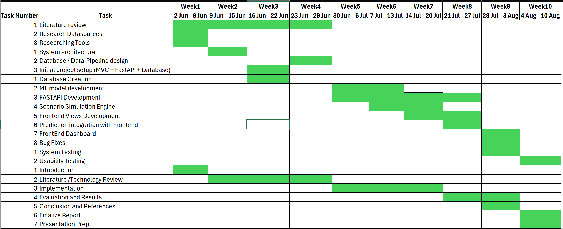

Kanban Board screenshot and link is attached below from Trello

[Link](https://trello.com/b/gCxlxyuH/msc-project-board)

Screenshot

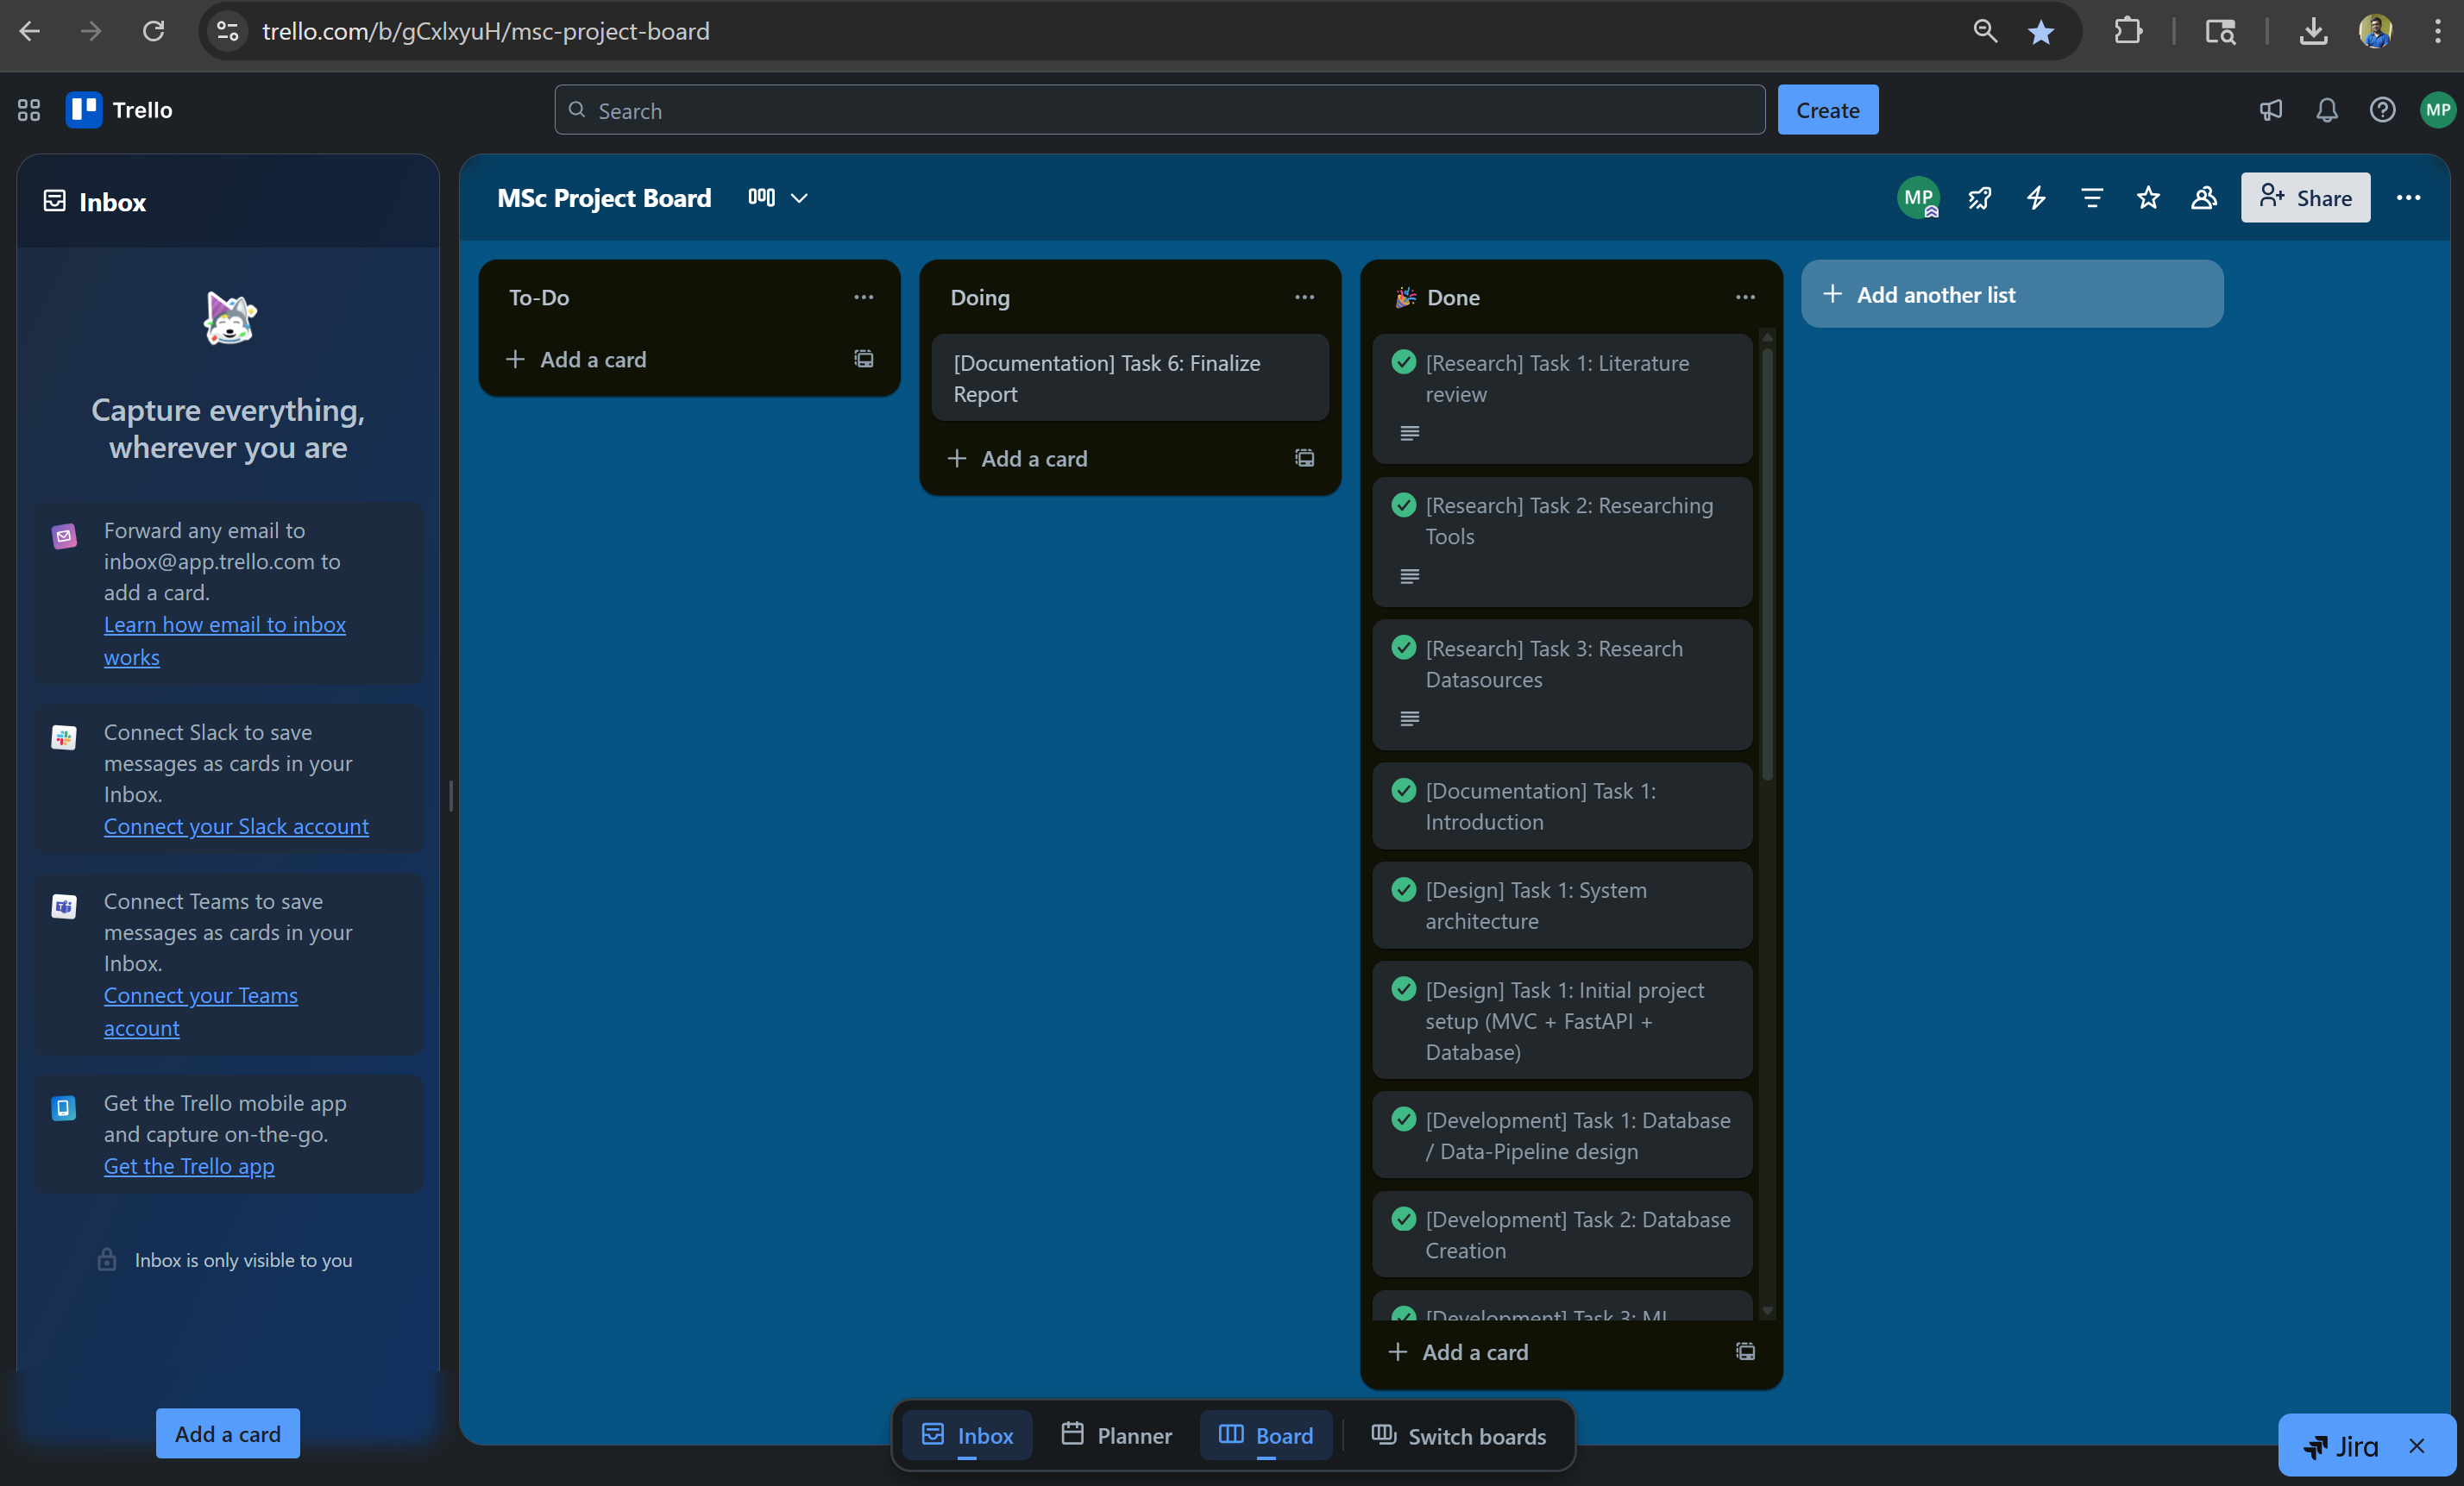

Appendix C: Artefact/Dataset

* For Initial XGBoost Model training

Link initial XGBoost model creation and training python jupyter notebook is attached below:

[XGBoost_Forecast_Initial_Model_Creation_Notebook_Link](https://github.com/manas-p-pandey/MscFinalProject/blob/main/Artifacts/InitialAnalysisAndModelCreation.ipynb)

* + The dataset used for training and validation in the above attached script was exported from PostgresSQL mscds database into below csv file attached

[Dataset_Link](https://github.com/manas-p-pandey/MscFinalProject/raw/refs/heads/main/Artifacts/data-1753054598583.csv)

* API Use for ingesting historical data for AQI given a location and datetime

[Documentation Link](https://openweathermap.org/api/air-pollution)

Sample Request Endpoint:

http://api.openweathermap.org/data/2.5/air_pollution?lat={lat}&lon={lon}&appid={API key}

* API for Weather given location and datetime

[Documentation Link](https://openweathermap.org/api/one-call-3)

Sample Request Endpoint:

https://api.openweathermap.org/data/3.0/onecall/timemachine?lat={lat}&lon={lon}&dt={time}&appid={API key}

Appendix D: Screencast

Below is the link to Screencast video uploaded to YouTube.

Link [Yet to create]